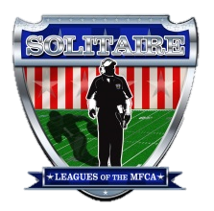
Solitaire Illustrated
Official OnlinePublication of the Solitaire Leagues of the MFCA
Volume 2 Issue 2 November 18, 2013

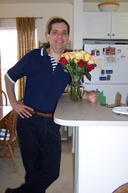
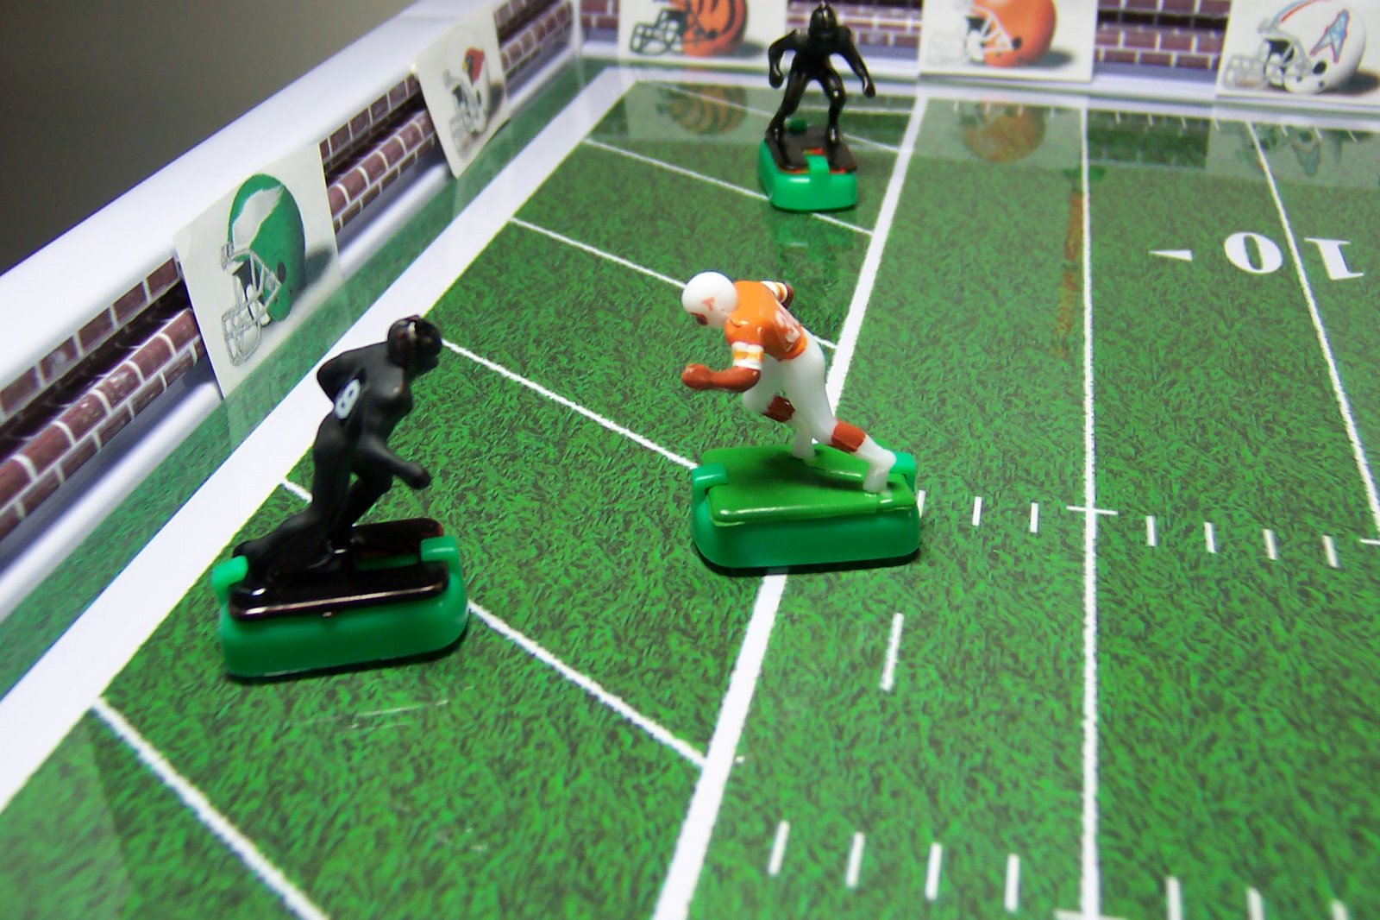
“Buzzin Brine’s Electric Football Brainstorming Blog”

From the Desk of the Editor Chris Lemay

The wonders of the Internet

In browsing the internet and doing research for this magazine, I often run across websites that are still active on the web but haven’t been updated in a while for whatever reason the author may have.

This issue’s cover story is just such a case.

I found the reference to this website on a post from the Tudor Community forum.

Some of the things you can do by accessing member lists and member profiles from the Tudor Community Forum and the MFCA Forum is how many threads someone has started and how many posts someone has made.

I could not find Brian’s name on the MFCA member lists so apparently he never joined the MFCA but on the Tudor forum his username is simple enough “Brian McAtee” and he joined the Tudor Forum in March of 2006.

His statistics indicate that he started 21 threads and has a total of 118 posts (or 0.04 posts per day). He is 44 years of age and was born on June 25, 1969.

His first post was on 4/8/2006 and the last post was on 1/9/2010 which was the post where I found the reference and link to his blog.

Brian has some interesting insights to playing electric football and solitaire electric football, football and life in general.

According to one posts Brian moved to Oklahoma City during the summer of 2006 and after doing a “Google” search, I found a link to the First Baptist Church of Oklahoma City and a page about Brian and his Ministry at this Church.

“As our Minister with Global Peoples, Brian works with the refugee community, focusing on the Chin/Burmese, Sudanese and Hispanic ministries that we partner with. He is also involved with various aspects of missions education and empowering the laity in missional opportunities.
2

Previously, Brian, and his wife, Claire, served among international students in Boston, Massachusetts and Athens, Georgia. He is a graduate of the University of South Carolina and Southwestern Baptist Theological Seminary in Forth Worth, Texas. Brian enjoys playing golf, watching American football, writing, and finding silly things to do with his little girl.”

In doing more searching, I found this article and picture of Brian:

http://www.okgazette.com/oklahoma/article-16282-taking-refuge.html

Here are some excerpts from that article:

A substantial number of foreign refugees from nations all across the globe have found a new home in the Sooner State.

Their backgrounds differ as much as the regions from which they’ve come, but they are linked by their quest for political and religious freedom.

“They’re looking for the same things our forefathers were when they came here,” said Brian McAtee, minister with Global Peoples for the First Baptist Church of Oklahoma City. “These people represent the American dream.”

“You’re trying to find them a job with benefits and the things that will give them an opportunity to be self-sustaining and contribute to this community,” McAtee said.

But starting a new life doesn’t happen overnight. The challenges facing refugees are many, but they tend to revolve around three things, according to McAtee: language, jobs and medical care.

The first difficulty is learning English and doing so swiftly enough to accomplish myriad other goals, such as getting a driver’s license, attending school and finding a job.

“There’s a vicious chicken-and-egg cycle here,” McAtee said. “Once you get a job, the challenge is having time for your 10- to 12-hoursa-day job, trying to learn English, taking care of your family and then making enough money to start paying your bills and paying back what you owe the agency that brought you over here.”

“Hard-working immigrants” are part of the grand American tradition, McAtee said, and evidence seems to support him.

“These people have been in countries where they are unwelcome. The government does not want them,” McAtee said. “And if they come here and hear the same thing, then we haven’t done anything different than a number of nasty places. We haven’t shown them that America is any different than Burma or Iraq or Sudan.”

Hope you enjoy this issue!!!
Page 2 From the desk of the Editor
3
In this Issue

Page 4 Buzzin Brine’s Electric Football Brainstorming Blog

Page 15 “Got your email about my Blog”

Page 17 “IN THE LIGHTS”
The World League of American Professional Football (WLAPF)

Page 27 “Mid States Land Rush” TOC

Page 33 the SCPC Season One Trophies

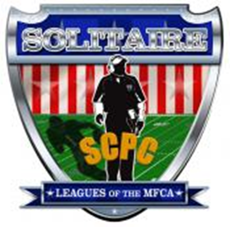
SEASON 2

The MFCA is a not-for-profit organization the purpose of which is to promote the hobby of miniature football and to encourage participation of coaches across the country. The MFCA shall not be responsible for or in any way liable for the content of images, articles or any other information furnished by its advertisers. Said liability to include defamation in any form, copyright, trademark or patent infringement, license violations or other legal theories.

Solitaire Illustrated
Official Online Publication of the Solitiare Leagues of the MFCA
Volume 2 Issue 1 November 1, 2013

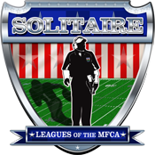

EDITOR
Chris LeMay
CONTRIBUTORS
Solitaire players, coaches and owners of the
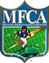

Customer Services
eflfanatic@charter.net

to join the MFCA and the Solitaire Leagues of the MFCA
www.miniaturefootball.org

SCPC RULES COMMITTEE
Commissioner
Chris LeMay
Rules Committee
Derrick Gross, Chairman
Al Dunham
Ed Morgans

Buzzin Brine's Electric Football Brainstorming Blog
Simple ideas to refine your electric football experience

Brian is an ordained Baptist minister who has spent much of his time ministering to international peoples living in the USA. He is also committed to global mission efforts, especially among those who have never heard of Jesus. He is married with one child. His hobbies include his own college football poll, golf and writing.

The official pronunciation is "Bri-un." But back home in the South, folks call him "Brine."

Me, EF and What I have to Offer
4

Let me make this simple. When it comes to electric football (miniature football or whatever else you want to call it), I am quite simple. I have little to no mechanical skill or artistic ability. Therefore, I don't build boards, paint players in mass, tweak the freak out of bases, or make field covers, lest I cut off fingers, shock myself or over expose myself to paint fumes. I am also a devoted solitaire player. I'm not in a league, largely because I am nowhere near a league. My life and circumstances prevent me from traveling great distances to leagues and conventions. It just ain't happening in this season of life. But here is what I am; I like to go home and relieve my mind from the worries of my life, for an hour or so in the evenings, over a metal board that vibrates plastic football figures in somewhat coordinated fashions against each other, in a competitive way. These players bear some resemblance to actual teams. I'm also cheap; ain't a whole lot of cash to dump into this. My gift to this hobby is my crave for re-inventing stuff. What I offer are ways to play and simple materials I use to enjoy the game. For all of those who enjoy the more advanced modes of EF, I salute you and your talents more than you will ever know.

To me, EF is a sweet snack at the end of a hard day, not another load to bear. Enjoy the sweetness with me.

My Own EF History
(Originally posted March 11, 2009)

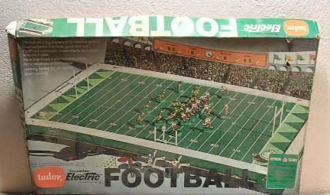

As with so many others my age, my history with electric football began as a small boy on a Christmas morning, in the early 1970’s. My Tutor made board was just a green field with white lines, and alternating triangles in the end zone. I think I had a green team and a yellow team. I think I made the mistake of trying to paint them. I have continued to make the mistake of trying to paint them even to this age! Some fools never know how to quit.

Like so many my age, I grew frustrated with the electric part; the erratic motion of the players, a vibrating clock that did not work, not enough room in the end zone to run plays from five yards in, etc. In dealing with my frustrations, I quickly uncovered one of my chief spiritual gifts; that of a re-inventor. Fewer games leave themselves open for so much re-invention.

So, I took matters into my own hands . . . literally. I never plugged the board in. I lined the fellers up, took both hands and crashed the two sets of linemen into each other. If there was a whole up the middle, I’d guide the running backs up the middle and assist those remaining defensive players still standing in tackling the running back. I had real tackles; not just base

touching. You had to knock the running backs on their bums just like you do in real football. If there wasn’t a whole up the middle, the quarter back got to throw the ball to an open receiver. And I didn’t use that crazy lookin’ kicker/qb thing; I used one of the ‘real’ players for that.
5

This way, I had real fumbles. When your receivers are really getting crashed into, they really do drop the ball. Oh, and I re-invented the ball. My first set had these dumb magnet-shaped balls. How the heck do you throw a led ball? Lord knows you’ll fumble something that heavy all the time. Besides, you’d break the receiver’s arm trying to stuff under his armpit. I made my own balls. I cut out cardboard small strips from Kleenex boxes, folded them in half, and that was my football. That’s still how I make my balls! It looks like the guy has a King James Bible under his arm, but it works! At least it doesn’t look like I had a snow squall during the game from all of the lent shredding from all of those fumbles, incomplete passes, errant kicks, etc.

When I did not use my board for football, it became a grazing pasture for all of the little farm animals I had with my toy farmhouse. I had a white fence that went with the farmhouse. I’d build it around the sidelines and call that my de-fence; it kept the cows from wandering off during bedtime. Speaking of bedtime, one night my Father stepped on my board while coming in the bedroom to tuck me in for the evening. A few cows were tipped or killed but Dad still walks through my house a bit nervous, lest he run through another defense . . . he knows these days those fences might have voltage running through them . . . ow.

I always like to be the broadcaster for my games. I always thought the old Tutor plugs looked like a microphone. I’d run that cord up my shirt and I’d be the broadcaster for my games. Yep that’s right. I’d have two metal prongs just inches from my mouth, nose and eyes. And to think that my Dad was, and still is, an electrical engineer. Yeah, the whole town has lights but his own kid is about to light himself up in the imaginary booth, just two feet above the de-fense.

The cool thing about my games is that we’d

have snow storms. I had a bag of shredded Kleenex (yep, Kleenex was an important element of my early EF experience. Shoulda gotten a sponsor from them, right? As far as I know, the Kleenex were unused), small bits of Styrofoam, and who knows what else. I’d drop that stuff from above before and during a game on my board, then I’d play tackle football in it with my guys. Boy, it sure was trouble when there was a fumble. We’d have to call in the Tonka dump truck and haul some snow off to find the darn thing, then we’d have another pile up of men trying to recover it. Try the snow thing some time and see how that works for ya.

Somewhere along the way that first board was sold. Then when I was about ten, I got another one. I think it’s about the same size as the current Miggle 620’s. I actually still have it at my parent’s house. It hasn’t made it to mine yet since we live a great distance from each other. The two teams that came with it were my beloved Dallas Cowboys and those hated Pittsburgh Steelers. I used to just marvel at all of the other NFL teams Tutor had pictures of in their sales book, dreaming of having all of them someday, but we were tight on cash at the time. I managed to order the Philadelphia Eagles, and the home and away St. Louis Cardinals. I got the Cardinals because they so greatly resembled my beloved, South Carolina Gamecocks. My first love has always been college football. So, I also got about three blank teams and painted them. Again, my painting skills were poor, but it got me some generic colors I could use for multiple college teams. My imaginations did the rest.

I even had my own way of doing logos back then. I never liked that my college games had “NFC” and “AFC” in the end zones and that the NFL logo was on the 50. So, I’d cover them up with my homemade field covers. All I needed was some construction paper and crayons. I draw them out freehand based on what was in a preseason football magazine on hand (yes, given my artistic ability, they were frightful looking). Then, I’d get some plastic-tacky and plop those suckers on the end zones and the 50 yard line. All was rectified in the Land of Imaginary Football.

Like so many of you, I “outgrew” electric

football along about the 9th grade. Somehow sitting in the floor calling your own games seemed a bit childish back then. I didn’t even have the “Atari/video game” excuse back then because, once again, my family really didn’t have the money to buy something like that, and quite honestly, I wasn’t even all that good at video games. I did get caught up in computer based football games. At any rate, the game board then went into a constant state of storage for the next 20+ years. I never even had a clue Tutor had gone out of business.
6

My interest in computer based football games finally evolved (or, as some might say, de-volved) into mastery of EA Sports NCAA College Football series over the past five years. Then, about a year ago, I’d finally played all of that I wanted. I got tired at looking at screens all day; the computer screen at work and at home, the TV in the living room, and then the TV screen with the Playstation. “Something’s gotta give,” I concluded. It was time for the PS2 to leave the house. I pondered to myself, “What could I find to replace this interest with?” I thought of several things, then I meandered back to my childhood and thought, “Wonder whatever happened to electric football?” Heck, I never really played electric football. I played “cram your players into each other” football. Maybe I’d have more patience for it now. I do still have my game board and all of my players at my parents’ home. I wonder if it still works? I wonder if anyone still plays this game at all?! Does Tutor still exists?” Hmm.

Enter, Google. If God doesn’t know it, or can’t reach you, Google does know and can reach you. I entered “Electric Football” into the search bar. I was shocked. Among plenty of other sites, up pops a news article from the February 3, 2005 Washington Post by Jeff Turrentine which chronicled how these guys had gotten together for this Electric Football Super Bowl Convention. It filled me in on what had happened these last 20 years with the game (or dare I say, “sport”) that my board had been in the closet. Then I clicked on the Miggle link in the article, and there it all was; game boards, teams (and college teams at that!), field covers not made of construction paper or crayons, bases, everything! Then I went and visited some EFL solitaire pages and couldn’t

believe how much these guys put into this thing, and the paint jobs! Amazing! And then I went to eBay and was even more stunned at how much I saw being sold there. I was laughing myself silly.

My problem was that I wanted back in the game but my game board was at my parents, and I did not know what kind of condition it was in. So, being still rather strapped for cash, I ordered cheap, not knowing totally how this re-introduction would go. I got the $50 Original Electric Football. I was so stoked when it showed up a few days later. I opened it up. I loved it. It was smaller than I thought it would be, but it was great. I had a blast with it for a few weeks. I made a trip back home to my parents, and to my amazement, my board was in outstanding shape. I drug out all of those old teams I had; the NFL ones I bought and the sad sack paint jobs I made. I brought them all home. I couldn’t get the big board home with me so I ordered a new 620.

So, that’s my story; my journey back to my childhood. It’s good to be back. Time to buzz off, Brian

My Attitude about Electric Football
(Originally posted March 13, 2009)

I don’t know what your attitude is about hobbies but this is mine; life is challenging and hard sometimes. Hobbies should give me a break from that. That’s my attitude about this, my college football polls, golf and other such things. With that in mind, this is how I try to approach the buzzing board.

First of all, I try to remember that what we have is a metal board moving, by vibration no less, plastic pieces shaped in the guise of football players, carried by little green bases, propelled by even smaller shreds of plastic lacing underneath them. None of these pieces of plastic, to my knowledge, has a heart, brain, soul, will or set of emotions. None of them get paid. By nature of the game, they can do just about anything at any time.

Another well taken point; it’s a child’s game. It’s just that most of the children who played it first are 30 years and older now.

Can you get my drift? This isn’t something to get too serious or worked up over. It is, at best, serious amusement. The beauty of the game, as documented by many, is that it is so simple and whimsical. It fosters the opportunity for good community; good clean fun. Most of those participating seem to practice this, and those who lose sight of it are typically brought back down to earth by those who understand this best.
7

Therefore, I don’t get too hung up on the rules. I’ll change the rules in the middle of a game. I realize I don’t have to consult the teams (remember, they are plastic) and I am the commissioner.

Also, a team can be anyone I want them to be. My set of St. Louis Cardinals can be my beloved South Carolina Gamecocks, Mississippi State, Harvard or anyone bearing resemblance to garnet jerseys, while pants and white helmets. All that keeps it from happening is my imagination. Sure saves a lot of bad paint jobs and money, anyway.

I don’t get hung up on ‘the right formations.’ Just line those suckers up, flip on the switch and see what happens. The way I figure, the vibrations make each play unique anyway; a player’s route, from play to play, is never the same. No real need to tweak bases, spin dials, glue BB’s, etc.

I like playing seasons, tournaments, etc. But you know what? It’s cool just coming home and whipping out a couple of teams and chilling out.

This isn’t to criticize anyone for all the detail they bring to the game. That’s great if you have all of that artistic ability, attention to detail, etc. I love going to the chat boards and reading what you do and the pictures you crank out. I’m just a simple person with little artistic skill, and not a lot of energy left after a work day to deal with the details of base tweaking. The beauty of the game is that even someone like me, can get a kick out of it.

I hope one day I get to go to an EF convention and see how the ‘real experts’ get it done. Til then, I’ll just keep buzzin’ along.

Buzzin’ Brine

Building a New Board!
(Originally posted March 24, 2009)

Well, our family has decided to build a board!!! My Dad will be the chief engineer. My wife will design and paint the field. My Mom will bake cookies and my three year old will ask, "What are you doing?" "Can I help?" "I wanna do it!"

Here are the board design concepts I have in mind.

1. My Beloved South Carolina Gamecocks only.

2. My Gamecocks in one end zone and my wife's beloved Texas Longhorns in the other.

3. A tribute to those who are building it and our family heritage; We'll call it the McAtee Highlanders with the Scottish, St. Andrews cross somewhere on the field, maybe in the end zones.

4. A tribute to my Father who is really doing much of the work on this board. His nickname in high school was "Savage." We'd call it, "Savage Stadium."

5. Since I'll be flying the college pigskins on this thing primarily, we can call it by it's name, "Electric College Football League (ECFL).

6. "A tribute, I say a tribute to ME, BOY! THE FOGHORN, OF COURSE!!! We'd call it Foghorn field, put my handsome face on the 50 yard lines, call ourselves the fightin' Foghorns and buzz that ole dawg right out of the roost!"

7. Or, an old school, green field with a simple end zone design.

Homemade Game Accessories
(Originally posted March 13, 2009)
Logo Boards
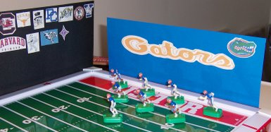

All I did here was print off some logos from a place like The Logo Server and used some plasti-tac (you can find it at a place like Office Depot) to adhere them to a piece of cardstock. Then, I took some binder clips and bound them to the side of the board. On the 620, you can just slip them into the groove that runs along the perimeter of the field, so long as what you have is not too top heavy.

Wall Art for your 620
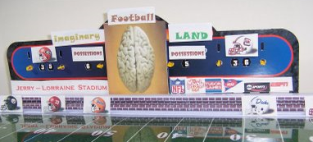 Here, I stuck some of the logos on the wall of my 620, for a very cool feel. You can also see what I have done to spruce up the scoreboard a bit.

Tissue Box Football!
Tired of ordering foam footballs for no good reason at all? When I was a kid, I had a hard time sticking that magnetic football under my guy's arm. So, I just grabbed a tissue box, clipped a slot off of the opening, folded it in half, and boom, a football! It can also double as a playbook for your running back if he breaks free and has time to read.

Practicing Multiple Team Disorder
8
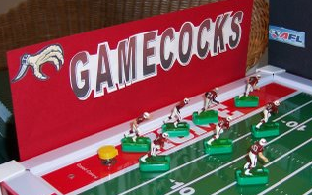

Don't quite have enough money to buy all of those teams you want? These St. Louis Cardinals from my childhood have spent most of their time playing as my beloved South Carolina Gamecocks. The Steelers can be Iowa, Missouri, or any number of such teams with similar color schemes.

Rules
How I Play Now on my 620 and 660
(Originally posted on March 13, 2009)

1. Both teams get four possessions.

2. Like baseball, the visiting team goes first and the home team goes second. This gives a home field advantage similar to that of the college football overtime.

3. There is no kickoff to start the game. The visiting team gets the ball at their 30 yard line. After each score, the other team begins its next possession at its own 30.

4. Game play proceeds as usual. If there is a punt, it is measured 40 yards from the line of scrimmage. If it is inside the 50, it is measured half the distance to the goal, plus 10 yards. The other team begins their possession at that spot.

5. The games end after each team has had four (alternating) possessions.

6. If there is a tie after 4 possessions, each team gets a 5th possession. Whoever scores the most points, or drives the furthest, wins the game.

How I Play Short Board College Football

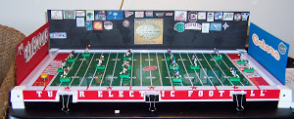

Soon, I will start something new. I am combining elements of Arena Football with college football. I am using the board pictured above. Here's the specifics:
9

1. I am using a 100 yard field instead of the standard 50 yard field of arena ball. The little guys don't know the difference. Plus it fits better with kicking game I am using from Pizza Box Football.

2. I am using 40 downs total; 10 per quarter.

3. Each team has 4 downs to score.

4. 7 players on each team.

5. Failed field goals turn into punting situations.

6. This will be a 4 round, Tourney-Season with 16 teams.

7. Teams must run on 1st and 2nd down, and may pass on 3rd and 4th down.

8. Fumbles are determined by using the fumble rules from Pizza Box Football.

Standard Rules for All Games

Here are basic function rules I use for all games:

1. Each team must run at least one running play, typically on first down. All other plays can be passing plays.

2. Passing sticks are used for passing. Defense can use one player for the purposes of intercepting. Defensive players may pivot when the stick is placed on the board and after the receiver catches the ball. Only the receiver may pivot and does so after catching the ball.

3. A tackle takes place when a defensive player strikes the ball carrier's base. The defensive player must be moving towards the offensive player and must strike him with the front, or a front corner, of his base. When chasing an offensive player from behind, the defender must obviously alter the movement of the offensive ball carrier in order for it to count as a tackle.

4. The only penalties are defensive pass interference and defensive "hooking." Hooking is when a defensive player grabs the ball carrier by the arm in a hooking fashion, altering the ball carrier's route. The offense simply gets to repeat the previous down at the spot of the foul.

5. The kicking game from Pizza Box Football is used for all kicking procedures.

What is a Tourney-Season?
(Originally posted on May 6, 2009)

I have a discovered a new way to play a season while still having a tournament. I am calling it a "Tourney-Season." You basically play a tournament format with 16 teams. All winners in the first round go to the Championship Tier, while all of the losers go to the Consolation Tier. Then, all of those teams play in their respective tiers so that you wind up with a tournament champion (4 rounds) as you always would, but the other teams still have something to play for. Follow the current Short Board season to see how this develops.

Short Board Schedule for Round 3
(Originally posted on June 4, 2009)

Consolation Tier:
#16 Georgia Tech (0-2) vs. #13 Dallas (0-2)
#15 Nebraska (0-2) vs. Green Bay (0-2)
#12 Kansas State (1-1) vs. #5 Texas (1-1)
#11 Clemson (1-1) vs. Houston Oilers (1-1) *Clemson automatically awarded win since these teams met in Round 1, and won that contest.
#10 Florida (1-1) vs. #7 Duke (1-1)
#9 Georgia (1-1) vs. #8 Iowa State (1-1)

Title Tier:
#4 Missouri (2-0) vs. #1 S. Carolina (2-0)
#3 Alabama (2-0) vs. #2 Florida State (2-0)

NOTES:
1. Teams are ranked based on number of wins, then their total margin of victory/loss, and then the number of possession sets they won.

2. This demonstrates how the Tourney-Season works. In the Title Tier, winners continue to

advance like they would in a tournament, to determine a champion. But in the Consolation Tier, the losers still get to play against each other in a seasonal format.

What is a Possession Set?

A possession set consists of each team having the ball once. The team that scores the most points in that set wins the set (kind of like a baseball inning). There are four Possession Sets in a game.

Short Board Tourney Underway
(Originally posted March 24, 2009)

Well, I have started a 16 team Tourney-Season for Electric Arena College Football. Alabama upset Texas in a 28-27 thriller while Baylor tested heavily favored South Carolina before falling, 41-29. The teams participating are:
South Carolina (old, Tutor St. Louis Cardinals)
Alabama (Miggle)
Georgia (Hand Painted)
Kentucky (Old Tutor Dallas Cowboys)
Florida (Miggle)
Clemson (Hand Painted)
Duke (Hand painted as a child)
North Carolina (Miggle Houston Oilers)
Florida State (Miggle)
Georgia Tech (Miggle)
Texas (Miggle)
Baylor (Miggle Green Bay Packers)
Nebraska (Miggle)
Kansas State (Miggle)
Iowa State (Hand Painted)
Missouri (Old Tutor Pittsburgh Steelers)

Tigers Trip Tarheels 50-44 in OT
(Originally posted March 25, 2009)

Clemson forced the game's only fumble in overtime, then scampered 80 yards for the winning TD to beat North Carolina 50-44. The Heels forced OT on their last touch in regulation with a short run up the middle, tying the game at 37. The Tigers join South Carolina and Alabama in the second round of this season's EACF tournament.

Missouri Stuns Florida, 20-17
(Originally posted April 1,2009

The Missouri Tigers used a ferocious defense to build a 17-3 lead on the heavily favored Florida Gators, going into the 4th quarter. Florida responded by ripping an 80 yard touchdown run, holding Mizzou to a 4 and out, then running another 63 yard touchdown play to tie the game with three plays to go in regulation. The Tigers then marched the ball down to the Florida 20 on two plays and ended the game, on its last play, with a game winning field goal.

'Noles beat back UK Cats, 17-10
(Originally posted April 10, 2009)

The Kentucky Wildcats ripped a long TD on the 8th play of the 4th quarter and converted an onside kick, but were unable to overcome the Seminole lead late in the game. FSU's win was keyed with a long run for a TD on their second play of the game. Kentucky blocked an FSU field goal on the Nole's first possession of the second half, but were unable to make anything of it, in the most lack-luster game of the season so far.

K-State Out-claws UGA, 38-37
(Originally posted April 11, 2009)

In a game of alternating, long touchdown runs, the game was decided when KSU blocked a Georgia extra-point, after UGA ran it 80 yards on the third to last play of the game, giving UGA the lead, 37-31. Kansas State returned the favor with their own 80 yard TD run on the next play, and nailed the doghouse shut with the extra-point, securing the 38-37 win.

10
Cyclones Ground Yellow Jackets, 35-23
(Originally posted April 12, 2009)
The out-classed Georgia Tech Yellow Jackets hung with the streaking Cyclones until a failed fourth down conversion in the fourth quarter while down, 28-23. The high-octane Cyclones then blew past the Jackets with a game sealing touchdown.

Dawgs Claw Huskers, 30-24
(Originally posted May 6, 2009)

Georgia completed an 81 yard bomb on the game's final play to outlast Nebraska, 30-24, in the first game of Round 2 in the Consolation Tier, in the current Short Board season. The Dawgs also made hay of the Huskers in the third quarter with a 92 yard bomb. Nebraska picked off a Georgia pass and returned it to the UGA 6, to set up a TD for a 24-24 tie late in the 4th, before the game's last play heroics.

Texas Smashes Yellow Jackets, 33-13
(Originally posted May 8, 2009)
Last place Georgia Tech found some additional talent and hung with Texas through the early downs of the second half. However, a failed short field goal on their first drive of the second half, followed by an 80 yard TD run by Texas, sealed their fate, in this second round game in the Consolation Tier.

Teams Re-Nenamed
(Originally posted May 9, 2009)

Three teams are being re-named to who they actually are, due to sentimental reasons and for added realism. They are: Baylor reverting back to the Green Bay Packers. Kentucky reverting back to the Dallas Cowboys, North Carolina reverting back to the Houston Oilers.
11

Gators Snap Packers, 9-3
(Originally posted May 16, 2009)

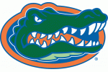
Florida produced just enough offense to set up three successful field goals, and overcame a relentless defensive effort on the part of the Green Bay Packers. The key play of the game came in the second quarter when Green Bay decided to go for it on forth down from the Gator nine. A Gator defensive linemen stepped up and stopped the running attempt at the five, in what would be the resulting difference in the game. No TD's were scored in this game; the first such occurrence in recent memory.

Oilers Drain Cowboys' Comeback Attempt, 30-21
(Originally posted May 17, 2009)

The Houston Oilers defense made havoc of the Dallas Cowboys on their first two drives and exploded offensively to build a 17-0 lead. Dallas, however, was unfazed, railing off 21 points to pull within two of the Oilers in the fourth quarter, 23-21. However, two big defensive hooking(holding) calls against the Cowboys, on the Oilers last drive of the game, set up an easy fourth down attempt for a touchdown at the Dallas one, pushing Houston to victory, 30-21.

Tide Cools off Devils' Hot Streak, 16-7
(Originally posted May 24, 2009)
When Duke pinned the Tide back on the Bama two with a failed field goal/punt, it looked like the Tide was stemmed. But Bama's dominating offensive line and a steady running game marched down the field for a TD, and set the tone early. Duke's quick runners simply did not execute, exacting only one big play for its lone TD, in the first Short Board game to use a 4 Possession-Set format.

Gamecocks Skin Wildcats, 21-7
(Originally posted May 25, 2009)
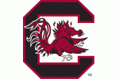
South Carolina showed why they are considered the best, as their powerful offensive line cleared the lanes three times for long TD runs, as they easily caged KSU, 21-7. The Wildcats started the second half with a long TD run of their own, hinting at a possible rally, but the Gamecocks spurred that effort with a game-sealing 80 yard TD that sends them on to the semi-final round of this first Short Board season.

Seminoles Skin Clemson Tigers, 21-12
(Originally posted May 30, 2009)
Clemson overcame an initial 14-0 surge by Florida State, with a 42 yard field goal and a TD, followed by a two-point conversion, on consecutive possessions, cutting the FSU lead to 14-12. However, FSU responded on the first down of its third possession with an 80 yard TD run, sending the 'Noles into the semi-finals in the current Tourney-season.

What it Means (to me) to be a Gamecock
(Originally posted August 21, 2009)
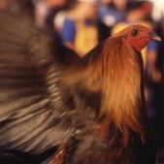
All of us are handed designations and identities that we inherit from birth. For me, this is one of them. My parents met on a blind-date at the 1965 football game between the University of South Carolina Fighting Gamecocks and the Duke Blue Devils, at Carolina Stadium, now known as Williams-Brice Stadium, in Columbia, South Carolina. They would marry two years later. My Father would earn two degrees at the school and take me to Gamecock football games at the early ages of 3 and 4 years old.
12
I was a Gamecock from the start. I led the cheers. Dad tells the story of how one time, when the Gamecocks were getting thumped in a football game (which was often . . . and still is), I stood up and admonished all of the Gamecock fans around me, "Come on everybody, get up and yell for the Gamecocks!" Everybody did. At that age, I remember going home and crying while I went to bed, because the Gamecocks had lost . . . again. At a young age, I embodied the spirit of our mascot; I fought to the death . . . and then some. In 1987, I would choose, on my own volition, to become a student at South Carolina, as well. I graduated in 1991; my graduating class would be the winning-est senior class in Gamecock football history. I don't know for sure, but that honor (or lack thereof) may still stand.

It is NOT easy being a Gamecock. For one thing, we share names and initials with two other major programs. We are 'Carolina.' People in Chapel Hill, NC, who are known as Tarheels, turn their blue-blood noses down at us and call us the 'other Carolina.'

We are USC. We were the first USC, the University of South Carolina, founded in 1801. But there is this other USC in Los Angeles who has a much better team than we do, and they are the ones everyone calls 'USC.' Never mind, we beat their tales badly the last time we played football, in 1983, on our field. They have not played us since. Last year, they sued our baseball team for using the 'SC' letters on our ball caps. They won their case but we are still using our hats. I still haven't heard if the case settled or not, but we are still playing in our 'SC' hats and they are selling like ice trays in a heatwave.

Even one of our cheers, found in all of our major fight songs, has been hijacked by people whose perspective on life begins in their underwear. I shouted, "Go, Cocks" from the tender age of 3. I didn't know there was anything wrong with it until I got to college. We can't even cheer, or sell merchandise, without eliciting the censors.

That leaves us with two distinctive names; 'South Carolina' and 'Gamecocks.' The first one is geographic. But it is that last one that the fight is over . . . literally. PETA and other leftest

groups have tried to force the NCAA to make USC scrap the mascot and replace it, because in their mind, it is an endorsement of the illegal practice of cock fighting. While the NCAA did go on purging of un-endorsed, native-american mascots in 2005, it left the animal business alone. But still, average Americans will still scoff and draw ire over the mascot. I've experienced that as well.

We haven't even gotten to the football field, where the school's 100+ years of playing has yielded an all-time winning percentage that moves back and forth from the .500 mark. It didn't win its first bowl game until 1994 and lost the first seven before that, dating back to the first Gator Bowl ever played, in the 1940's.

Recently, I have taken pause over all of this; Is it worth being a Gamecock? And more specifically, are we really endorsing an illegal sport that is disgusting and nauseating to even consider? What have I been calling myself all of these years?

In religious circles, we call this a 'crisis of belief.' In psychological terms, we call it questioning your identity; you either cash in or get stronger.

It took an even-minded poultry expert, from a rival school no less, to talk sense back into me. When I asked him if our mascot represented an animal that had been tortured and twisted from its God-given creation he said . . .

"Please do not stress about your noble mascot. Chickens were first domesticated about 7,000 yrs ago in SE Asia specifically for entertainment. In other words, because the males fought one another. So chickens naturally have that disposition. Certainly aggressiveness, like other behaviors, can be enhanced or diminished by breeding or training, and has been for what you and I would consider less than humane reasons. But do not lose your love for your mascot. The game cock is a proud and courageous creature and is a wonderful representation of steadfastness. Exceptional qualities for an athletic team. Seriously, chickens are very admirable and fascinating animals. Their history of fighting is, fortunately, over in most of the world. But that history, as repugnant as it is, still

brings honor to the bird. You should be grateful to have such a wonderful mascot."
13

And what does it mean to be noble? It means high character or impressiveness. And 'steadfastness?' Try "firm in belief and determined; "loyal and faithful."

Pretty good stuff. Not to mention what a rooster typically does all day. He guards the roost. He makes sure that all of those trusted to him, are protected. He's not one to pick a fight, but he will closely guard, with those steely eyes, and defend his turf, and those he is called to protect, to the death.

Additionally, as my wife said wisely, most animals are abused by people, at some point in their history. Further research showed me that Bulldogs have had a similar history as roosters, through a sport called Bull-Baiting. The only difference is that the English outlawed it, but seemed to let the tradition of cockfighting persist, where upon it was brought to the colonies.

So, what does it mean to me to be a Gamecock? Well, I know that there are plenty of other animals who will guard their families just a well, but a rooster probably takes the farm on this one; he does it all of the time and does it faithfully. And as a new father, that is a wonderful symbol to latch onto.

And as for that whole, cockfighting thing? The story of how USC got this mascot is far more honorable, and of the level set forth in the adjectives described previously. The university does not condone cock fighting. The gamecock, in the picture above, that appears at USC football games, is an animal of grace and pride. If anything, our mascot restores the dignity of this grand fowl from it's unfortunate history, and celebrates the characteristics endowed upon the school, its alumni and supporters.

Being a gamecock is in the heart, it's in the spirit and as Dad says it, "It's in the DNA." All other scoffers, be chased from the roost.

Go, Gamecocks.

Brian

“Got your email about my Blog …”
14
In preparing this article, I sent an email to Brian about his current involvement in electric football.

Hi Brian,

My name is Chris LeMay. I am an electric football hobbyist and editor of "Solitaire Illustrated" an online magazine devoted to solitaire electric football.

I ran across a reference to you blog "Buzzin Brine's Electric Football Brainstorming Blog" and would like to do an article for the magazine using info from this blog and also would like to know if you are still involved in electric football or would like to do an article for the magazine or contribute to this in any other way.

If interested or have any questions please let me know.

Thanks,
Chris

… and his reply…

Hi Chris,

Got your email about my blog. Feel free to use whatever you wish from the blog. No, I do not play regularly anymore; very sporadic at best. Life is just too busy and demanding at this point. I do have all my stuff nearby and drag it out on a rare occasion. So, I'm probably not the best person to ask to write anything at this point.

I do remember your name, though. Thanks for the invitation and for all you do for EF. If my life changes and I can do some of this, I'll let you know.

Take care,
Brian McAtee

Brian does several other blogs not related to electric football. One is “Quality Champions” in which Brian has developed a system to rank college football teams by a “Quality Win %”

Here is how Brian calculates the “Quality Wins National Champion”

How The Quality Champions System Works

If team A beats team B, team A takes team B’s winning percentage (.700) and multiplies it by ten (to get 7 points). If team A later loses to team C, it only takes team C’s winning percentage as its points (for example, .500). The sum of these two (7 and .5) is then multiplied by Team A’s current winning percentage (say, .500) to arrive at a “Qualified Winning Percentage.” See the details below:

i. 7 (for beating team B) + .5 (for losing to team C) = 7.5

ii. 7.5 *.500 (team A’s winning percentage) = 3.75 (Qualified Winning Percentage)

iii. 3.75 would now be Team A’s Qualified Winning Percentage through two games of the season.

That's all there is to it!

UNIQUE CHARACTERISTICS

Several things are accomplished in this system;

1. This system is so simple. There are no tangents and co-tangents in this formula. All you have to do is set up your spreadsheets, collect schedules and go for it.

2. There are no point spreads, picks, or power ratings.

3. There’s no influence by pre-season predictions since everyone is starting with a zero winning percentage.

4. There’s no regard for the final score, eliminating the effect of ‘running up the score.’

5. There are no home field considerations. This makes keeping up with schedules much easier.

6. Bookkeeping is reduced to just punching in who won or lost each week and multiplying victories by 10. The only drawback is you might wear out your ‘1’, ‘0’, ‘=’ and ‘*’ keys on your keyboard.

7. This system could really be used with any sport at any level!

8. You don’t have to sit in front of the TV and watch gobs of football to keep up with the games. You just need to know who won or lost. This is great for people who are busy on Saturdays and people living out of the country.

SPECIAL RULES AND FEATURES TO THE SYSTEM:
15

Winning the title with a lower Qualified Winning Percentage than the #1 team:

As much as I believe in this system, I don’t want the national champion to be determined by the math. I have a high regard for what happens in head-to-head competition on the field. Therefore, a team with a lower Qualified Winning Percentage can win the national title if it has played and beaten everyone ranked ahead of them.

For example, let’s pretend Texas finished the year in the #1 position with a Qualified Winning Percentage of 60.555. Miami’s #2 with 58.072 and Florida is #3 with 55.342. Let’s say Florida beat Miami in the regular season, and beat Texas in a bowl. The title could be given to Florida since they beat the two teams ahead of them. The same goes for Miami had it beaten Texas.

However, if Florida had beaten Miami but had not played Texas, and Miami had beaten Texas, Florida would not win it on the basis of Miami’s result against Texas. This is in order to avoid the ‘who beat, who beat, who beat’ syndrome we hear about in silly conversations about who should win the national title. In other words, you have to play and beat everyone in front of you to claim a national title with a lower Qualified Winning Percentage. Such a team would be called a ‘Declared National Champion.’

Policy on Games against 1-AA opponents:

During the 2001 season, 1-A schools were awarded one victory over a 1-AA opponent on their schedule. This was in large part due to the scheduling fiasco caused by the events of September 11. However, both the QC Retro Series and normal process will not include wins over 1-AA opponents. Losses to 1-AA will be included in a team’s winning percentage.

QC counts multiple games against the same opponent:

Hey, if a game is played, we count it. If Nebraska plays Texas during the season and for the Big-12 title and wins both games, Texas’ winning percentage will be counted twice towards Nebraska’s Qualified Winning Percentage.

Placings Instead of Rankings During the Regular Season:

During the season, QC polls will assign teams to a ‘place,’ not a ‘ranking’, as is the practice in most polls. As the season progresses, I view this system somewhat like a developing photograph in a dark room. Weekly polls during the season are just stages in the developing process. The final poll is our final ‘picture,’ where we can place teams in accordance to each other as rankings imply. I believe you have to play all the games to know where a team is truly ranked among all the rest.

THE EBB AND FLOW OF THIS POLL DURING THE SEASON:

It seems that the polls following the fifth and eighth week of the season are good indicators of where the season is headed. After five weeks, most teams have played at least three games. This gives you an idea of who the early leaders, Cinderella’s, slow starters and fast starters are. In other words, an initial pace is set. After the eighth week (about mid-way through the season) we have set ourselves up for the back half of the run. When we hit mid-November, we find out who really wants it, as teams that are further back in the pack can make a break towards the top.

For your team to be successful in the QC system, you want two simple things to happen; first, you want your team to win; second, you want your team’s opponents to win when you are not playing them. If two of your opponents are going head-to-head and you beat one and lost to the other, pull for the team you beat since it will add more to your Qualified Winning Percentage, because their winning percentage will go up. If you beat (or lose to) both of them, it really does not matter who wins.

Quality Values

There is a disturbing trend in college football. With each passing season, we are dismayed with escalating reports of the things which harm the game we love and those we love who participate in it. Big-time football should mean big-time fun and excitement, but it should never mean big-time trouble.

That being said, Quality Champions wishes to state what we value. We hope that you can join us in affirming these values, and help promote, these good things. That way, we can all be, Quality Champions.

Quality Champions’ Values:

Good sportsmanship on the part of players, coaches, officials and fans, free of taunting, abuses of language and substance, fighting and all other harmful behavior, but consisting of, a genuine respect for the players, coaches and fans of other institutions and behavior that fosters healthy competition.

Of university presidents, athletic directors coaching staffs and other responsible parties we value, and expect you to exhibit, a primary concern for the overall well-being of the student athlete which includes:

- Ethical and moral personal conduct,

- The avoidance of a ‘win at all cost’ mentality,’ especially at the expense of academic achievement and moral character development.

- Taking the pursuit of ‘big money making’ out of the equation for success.

We believe that sports of all kinds should be played in order to have fun and that it should be only one component of a student’s overall college experience, not the dominant one. We believe coaches should enjoy coaching without undue pressure to win. We believe fans should cheer wildly for their school, but not at the expense and enjoyment of fans from other schools.
16

This is what we value. We hope you do too. This way, we can all be Quality Champions!

For more of the “Quality Champions” website visit: https://sites.google.com/site/qualitychampions/home

And here’s another:

Live College Mascots Should be Off the Sidelines

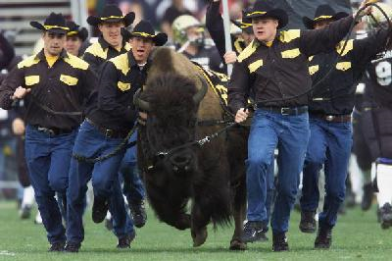

Well, as many of you know, college football is about to start another season. I'm a big fan, but I think we need to change one thing about the game. We need to get the live mascots off of the field and sidelines. Let me give you a few examples to illustrate my concerns.

My greatest one just might be this big fella in the picture above. That's "Ralphie the Buffalo" from Colorado University. He runs out on the field with the football team. Fortunately enough for Colorado's team, Ralphie is in front of the team. But my question is, what is in front of Ralphie? At least the camera man, right? Who else? The other team, running out from the opposite direction? The Colorado band playing the fight song? Cheerleaders? The fans in the stands? I mean, what if Ralphie gets out of control? Look at the faces of the guys trying to keep Ralphie under control. Do they look confident at the moment and in control of the situation? HECK, NO!!!!! Is this REALLY SAFE????

Moving on. Another large animal. "Bevo," from the University of Texas. Big ole stinkin' steer sitting at the back of the end zone in Austin, Texas. He is being taunted by a very large field of lush, green, grass, for over three hours. Is this a good idea? I mean, what if
Bevo just snaps, figures he's had enough, and breaks free for a feeding frenzy of nearly 200 football players and loads of lush grass? Then, what?

The livestock doesn't have to be large to be dangerous. Consider my school's fixed wing mascot, a fighting Gamecock. God made these birds to fight from the get-go; "see another one of me, and I'll fight to the death." A noble spirit but let's not be goofy, here. I saw a sideline reporter hold a mirror up in front of our live Gamecock once, on live TV. "Big Spur" saw himself and, wow, poor mirror. Not a good idea. Stupid reporter.

Even more common, domesticated, household animals are unsafe. Consider the famed, bulldog named, "UGA," from the University of Georgia. Part of his legend is biting an Auburn player and he's bitten others. Is this what you want on your athletic budget . . . "Liability costs for mascot's maulings?"

Then there is LSU that has a live Tiger caged in front of the visitor's locker room, I think, maybe even a bear or two here and there at other schools. Hey folks, it's a football stadium; a zoo for crazy, half-drunk people, not a zoo for animals. At least Auburn let's its animal out of the cage. Old War Eagle flies around the whole, dad-gum stadium! How many things could go wrong there! Every time I see 'em fly, I want to say, "Swoop down, grab UGA by the collar, and you two get the heck out of there! Fly! Fly, for freedom!"

But it's not just the animals you have to worry about; there’s some live humans, too! The USC Trojans have a guy on a white horse, running around with a sword in his hand (anyone else driving around LA with a weapon like that, would be pulled over and arrested). Florida State has a Seminole that throws a flaming spear on the 50 yard line before the game starts (obvious fire hazard at the least). West Virginia has a mountaineer that shoots a gun randomly in the air like he's at an Arab wedding. The Oklahoma Sooners drive their 'Boomer Sooner' out on the field after each OU touchdown . . . common folks . . . get your 100 year old station-wagon off of the field! This ain't no Sonic drive-thru!

But anyway, you get my point. So, if you are a serious fan that regularly attends games where there are live animals, or irresponsible humans, dangerously wielding weapons while trying to represent your school, send your local athletic director a letter, expressing your concerns. That way, we can all be much safer, especially our children!

At least we can all be thankful that Alabama has never found a live elephant to prance in their confines.

All for school spirit . . . .within reason.

I have kept these excerpts from Brian’s blogs related to electric football and football in general, but first and foremost, Brian is a fellow Christian and brother in Christ. He has a lot more to say about spiritual matters and following Jesus. Check out his other writings here:
http://mcamusings.blogspot.com/

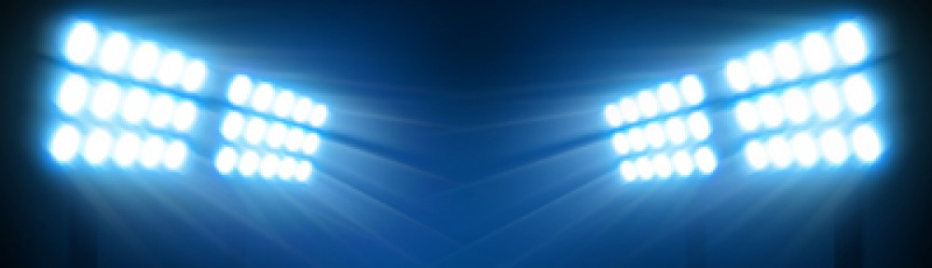
In the Lights

17

The World League of American Professional Football (WLAPF)

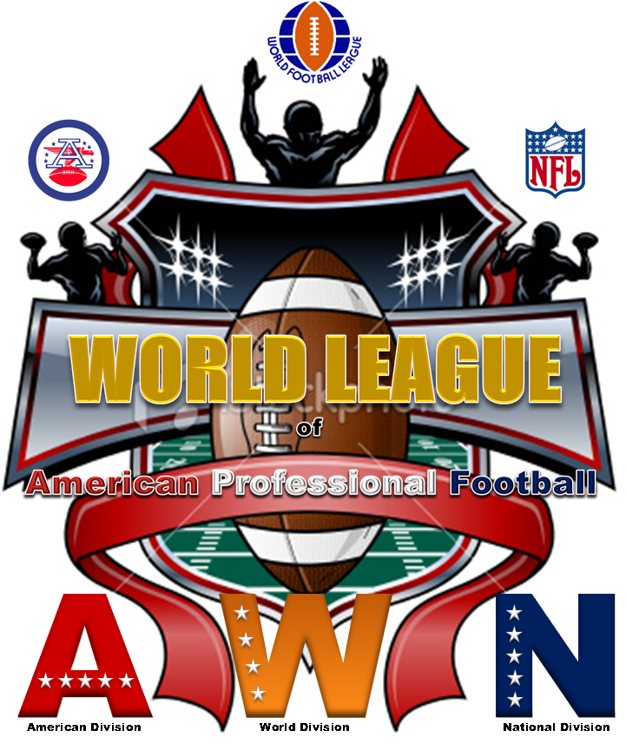

Owned and operated by SCPC Commissioner Chris LeMay, the WLAPF celebrates the Championship teams of the 1966 – 1969 AFL, NFL and the 1974 WFL.

In 1966 the American Football and National Football Leagues agreed to a merger with a championship game being played between the league’s champions, the SUPER BOWL, effectively ending a 6 year war between the 2 leagues. They would continue to play regular season games as separate leagues for the remainder of the decade with a final merger taking place for the 1970 season.

Originally known as the AFL – NFL World Championship game, the first two games were played between the Green Bay Packers, Champions of the NFL in 1966 and 1967, and the
Kansas City Chiefs (1966 AFL Champions) and the Oakland Raiders (1967 AFL Champions). Super Bowl III pitted the 1968 New York Jets against the 1968 Baltimore Colts. In 1969, the Kansas City Chiefs won the AFL and the Minnesota Vikings won the NFL and the right to play in Super Bowl IV.

Other teams that played in the AFL and NFL championship games of 1966 – 1969 were the Buffalo Bills (AFL 1966), the Houston Oilers (AFL 1967), the Dallas Cowboys (NFL 1966 and 1967), and the Cleveland Browns (1968 and 1969). The Oakland Raiders, after winning the AFL Championship in 1967, also played in the 1968 and ’69 games.

In 1974, the NFL again faced competition from the World Football League. The WFL completed one season of play with the Florida Blazers and Birmingham Americans playing in World Bowl I.

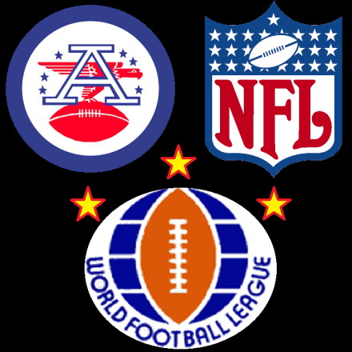
The WLAPF started out as the AFL vs. NFL vs. WFL Championship Series with games simply being recreations and replays of the first 4 Super Bowls and World Bowl I. Then it went into a series of replays of the AFL and NFL Championship games. The next round of games were “What if …” Super Bowls with the winners of the championship games playing in “What if … Super Bowl I – IV”

Round 4 games were “What if … AFL/NFL vs. WFL World Championship of American Professional Football Championship Games with the winners of the “What if … Super Bowls playing the Florida Blazers in World Bowl II – V and the losers playing the Birmingham Americans in Playoff Bowls 1 – 4.

After completing these games two more WFL teams were added. The Memphis Southmen and the Southern California Sun. These were 2 playoff teams form the original 1974 WFL season.
18

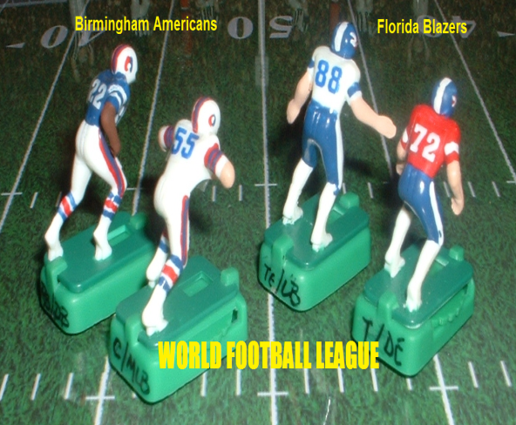
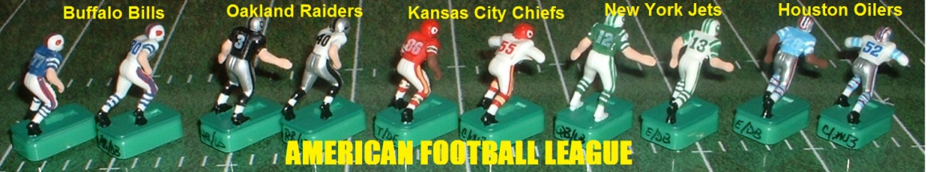

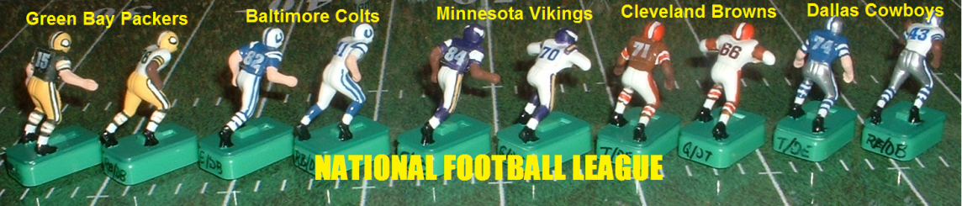

Here is how the first season shaped up:

AFL vs. NFL vs. WFL Championship Series

American Football League Championships
1966 Kansas City Chiefs vs. Buffalo Bills
1967 Houston Oilers vs. Oakland Raiders
1968 Oakland Raiders vs. New York Jets
1969 Kansas City Chiefs vs. Oakland Raiders

National Football League Championships
1966 Green Bay Packers vs. Dallas Cowboys
1967 Dallas Cowboys vs. Green Bay Packers
1968 Baltimore Colts vs. Cleveland Browns
1969 Cleveland Browns vs. Minnesota Vikings
World Championship Game AFL vs. NFL
January 15, 1967
Kansas City Chiefs vs. Green Bay Packers
AFL vs. NFL World Championship Game
January 14, 1968
Green Bay Packers vs. Oakland Raiders
Super Bowl 1969 World Championship Game
January 12, 1969
New York Jets vs. Baltimore Colts
Super Bowl 1970 World Championship Game
January 11, 1970
Minnesota Vikings vs. Kansas City Chiefs

World Football League Championship
World Bowl I
December 5, 1974
Birmingham Americans vs. Florida Blazers

Schedule
Week 1 Original World Bowl and Super Bowl Replays

World Bowl One
Florida Blazers vs. Birmingham Americans (H)
Florida 30
Birmingham 0

Super Bowl 1
1966 AFL vs. NFL World Championship Game
Kansas City Chiefs vs. Green Bay Packers (H)
Kansas City 17
Green Bay 13

Super Bowl II
1967 AFL vs. NFL World Championship Game
Green Bay Packers vs. Oakland Raiders (H)
Green Bay 17
Oakland 24

Super Bowl III
1968 AFL vs. NFL World Championship Game
New York Jets vs. Baltimore Colts (H)
New York 21
Baltimore 17

19

Super Bowl IV
1969 AFL vs. NFL World Championship Game
Minnesota Vikings vs. Kansas City Chiefs (H)
Minnesota 0
Kansas City 13

Record W L T PS PA SCPC Points
Kansas City Chiefs (AFL) 2 0 0 30 13 12
Florida Blazers (WFL) 1 0 0 30 0 9
Green Bay Packers (NFL) 0 2 0 30 41 9
Oakland Raiders (AFL) 1 0 0 24 17 6
New York Jets (AFL) 1 0 0 21 17 6
Baltimore Colts (NFL) 0 1 0 17 21 4
Minnesota Vikings (NFL) 0 1 0 0 0 13 3
Birmingham Americans (WFL) 0 1 0 0 30 1
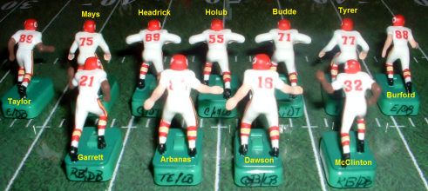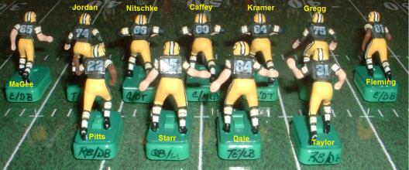

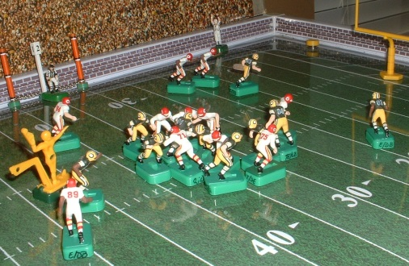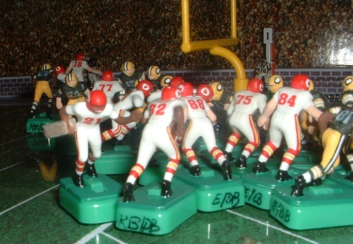

Week 2 Original AFL and NFL Championship Replays

1966 AFL Championship
Kansas City Chiefs @ Buffalo Bills
Kansas City 22
Buffalo 27

1966 NFL Championship
Green Bay Packers @ Dallas Cowboys
Green Bay 14
Dallas 9

1967 AFL Championship
Houston Oilers @ Oakland Raiders
Houston 43
Oakland 14

1967 NFL Championship
Dallas Cowboys @ Green Bay Packers
Dallas 26
Green Bay 0

1968 AFL Championship
Oakland Raiders @ New York Jets
Oakland 13
New York 21

1968 NFL Championship
Baltimore Colts @ Cleveland Browns
Baltimore 20
Cleveland 27

1969 AFL Championship
Kansas City Chiefs @ Oakland Raiders
Kansas City 9
Oakland 20

1969 NFL Championship
Cleveland Browns @ Minnesota Vikings
20
Cleveland 17
Minnesota 20 OT
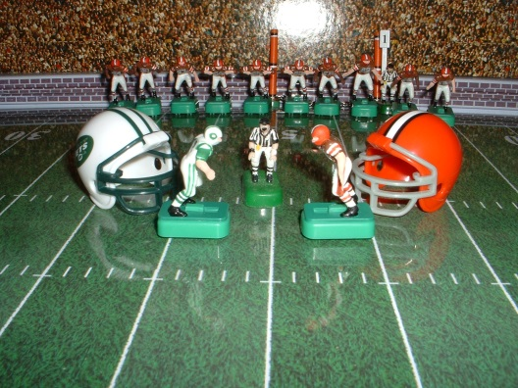

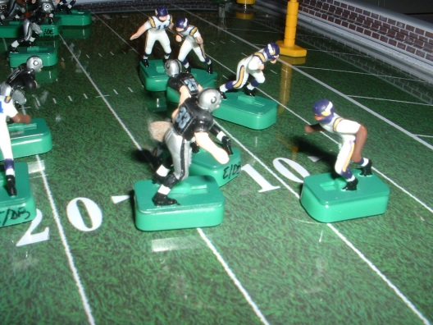

Record W L T PS PA SCPC Points
Oakland Raiders (AFL) 2 2 0 71 90 20
Kansas City Chiefs (AFL) 2 2 0 61 60 19
Green Bay Packers (NFL) 1 3 0 44 76 16
Dallas Cowboys (NFL) 1 1 0 35 14 13
New York Jets (AFL) 2 0 0 42 30 12
Cleveland Browns (NFL) 1 1 0 44 40 10
Florida Blazers (WFL) 1 0 0 30 0 9
Minnesota Vikings (NFL) 1 1 0 20 30 9
Baltimore Colts (NFL) 0 2 0 47 41 8
Houston Oilers (AFL) 1 0 0 43 14 7
Buffalo Bills (AFL) 1 0 0 27 22 6
Birmingham Americans (WFL) 0 1 0 0 30 1

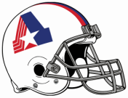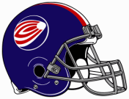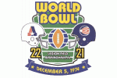

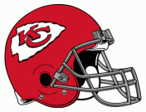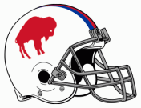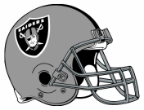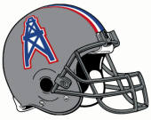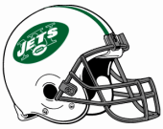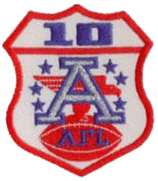

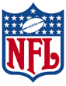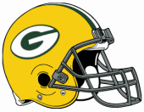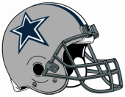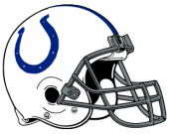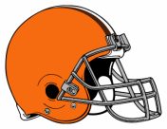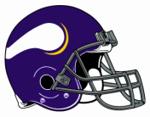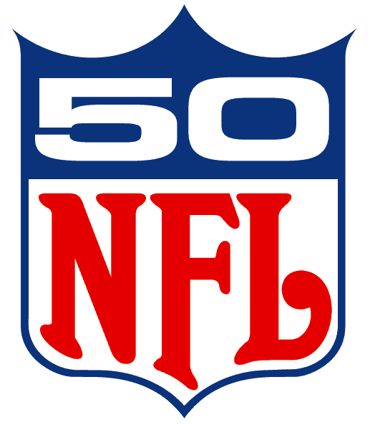

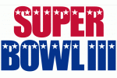

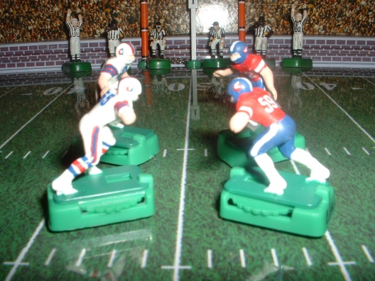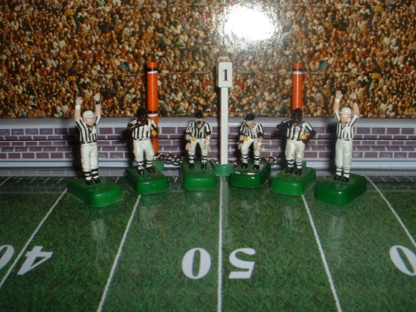

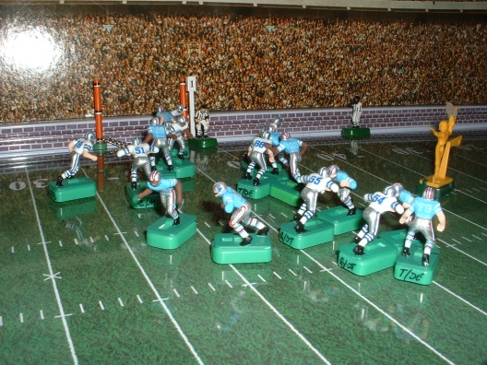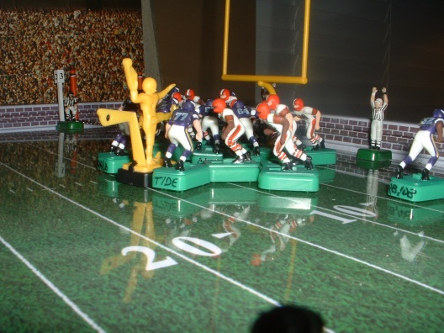

Week 3 “What if…” Super Bowls
1966 AFL vs. NFL World Championship Game
Buffalo Bills vs. Green Bay Packers
Buffalo 7
Green Bay 13

1967 AFL vs. NFL World Championship Game
Dallas Cowboys vs. Houston Oilers
Dallas 20
Houston 13

1968 AFL vs. NFL World Championship Game
New York Jets vs. Cleveland Browns
New York 20
Cleveland 15

1969 AFL vs. NFL World Championship Game
Minnesota Vikings vs. Oakland Raiders
Minnesota 23
Oakland 17 OT

Record W L T PS PA SCPC Points
Oakland Raiders (AFL) 2 3 0 88 113 24
Green Bay Packers (NFL) 2 3 0 57 83 22
Kansas City Chiefs (AFL) 2 2 0 61 60 19
New York Jets (AFL) 3 0 0 62 45 18
Dallas Cowboys (NFL) 2 1 0 55 27 18
Minnesota Vikings (NFL) 2 1 0 43 47 15
Cleveland Browns (NFL) 1 2 0 47 60 14
Houston Oilers (AFL) 1 1 0 56 34 11
Buffalo Bills (AFL) 1 1 0 34 35 10
Florida Blazers (WFL) 1 0 0 30 0 9
Baltimore Colts (NFL) 0 2 0 47 41 8
Birmingham Americans (WFL) 0 1 0 0 30 1

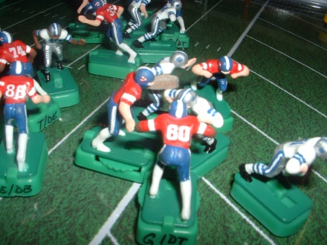
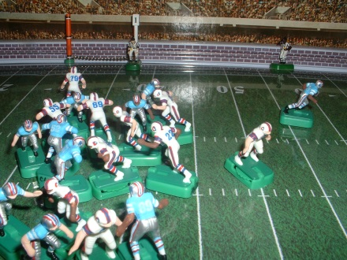

Week 4 “What if…” AFL / NFL vs. WFL World Championship of American Professional Football Games

WORLD BOWL II
NFL Green Bay Packers vs. WFL Florida Blazers (WFL Rules)
Green Bay Packers 22
Florida Blazers 6

Playoff Bowl 1
WFL Birmingham Americans vs. AFL Buffalo Bills (AFL Rules)
Birmingham Americans 7
Buffalo Bills 18

WORLD BOWL III
NFL Dallas Cowboys vs. WFL Florida Blazers (WFL Rules)
Dallas Cowboys 51
Florida Blazers 30

Playoff Bowl 2
WFL Birmingham Americans vs. AFL Houston Oilers (AFL Rules)
Birmingham Americans 3
Houston Oilers 17

WORLD BOWL IV
AFL New York Jets vs. WFL Florida Blazers (WFL Rules)
New York Jets 32
Florida Blazers 29

Playoff Bowl 3
WFL Birmingham Americans vs. NFL Cleveland Browns (NFL Rules)
Birmingham Americans 7
Cleveland Browns 49

WORLD BOWL V
AFL Kansas City Chiefs vs. WFL Florida Blazers (WFL Rules)
Kansas City Chiefs 23
Florida Blazers 22

Playoff Bowl 4
WFL Birmingham Americans vs. NFL Minnesota Vikings (NFL Rules)
Birmingham Americans 7
Minnesota Vikings 20

Record W L T PS PA SCPC Points
Green Bay Packers (NFL) 3 3 0 79 89 29
Florida Blazers (WFL) 1 4 0 117 128 27
Kansas City Chiefs (AFL) 3 2 0 94 88 24
Oakland Raiders (AFL) 2 3 0 88 113 24
New York Jets (AFL) 4 0 0 94 74 23
Dallas Cowboys (NFL) 3 1 0 101 57 23
Minnesota Vikings (NFL) 3 1 0 63 54 22
Cleveland Browns (NFL) 2 2 0 96 67 22
Houston Oilers (AFL) 2 1 0 73 37 18
Buffalo Bills (AFL) 2 1 0 52 42 17
Birmingham Americans (WFL) 0 5 0 24 134 12
Baltimore Colts (NFL) 0 2 0 47 41 8
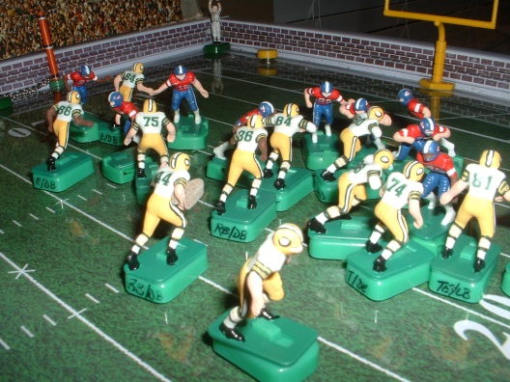
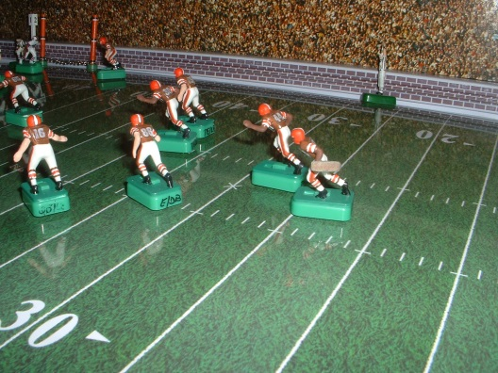

21

The 3 leagues basically used the same “American Standard Football” rules. But each had other rules that made their styles of plays unique to each other. The differences are listed below:
22

NFL Rules
- Goal Posts on the Goal Line
- Kickoffs from the 40 yard line
- 1 point conversions by run, pass or kick
- Missed Field Goals return to opponents 20 yard line
- Regular season games may end in a tie
- Postseason games will play “Sudden Death” overtime
AFL Rules
- Same as NFL
- 2 point conversion by run or pass
- 1 point conversion by kick
WFL Rules
- Goal Posts on the End Line
- Kickoffs from the 30 yard line
- Touchdowns worth 7 points
- 1 point "Action Point” by run or pass from the 2 ½ yard line after a touchdown
- Receivers one foot in-bounds for a completion (receiver’s base must have 1 front corner in field of play)
- Bump and run coverage inside 3 yards only ( Engaged receivers pass eligible except inside 3 yards from the line of scrimmage)
- Missed field goals returned to the line of scrimmage or the 20-yard line, whichever is farthest from the goal line
- A player in motion is allowed to move toward the line of scrimmage before the snap, as long as he is behind the line of scrimmage at the snap.
- Punt returners prohibited from using the fair catch, although the covering team may not come within 5 yards of the kick returner until he catches the ball.
- Overtime in the regular season is one fixed 15-minute period, divided into two halves of 7½ minutes (6 plays from scrimmage), each starting with a kickoff by one of the teams. The complete overtime is always played; there is no "sudden death" feature. For the post season, if game is still tied at the end of this overtime period, then regular “sudden death” overtime rules will apply.

The AFL vs. NFL (1966 – 1969) vs. WFL (1974) Championship Series Rules

I. SCORING

The AFL and NFL only played intra – league preseason exhibition games during the years of 1967 – 1969, in which the rules of the NFL were used to prepare the AFL teams for the eventual merger of the two leagues. The 4 AFL vs. NFL World Championship Games were also played using the NFL’s rules.

The only difference between the 2 leagues’ rules was in scoring, where a 2 – point conversion try (or PAT – point after touchdown) was allowed. This was a rule taken from the college rule book in which the team executing a successful conversion try by run or pass from the line of scrimmage (the opponent’s 2 yard line) was awarded 2 points. This rule was eventually adopted by the NFL in 1994.

In 1968, the 2 leagues, in their preseason intra – league exhibition games, experimented with a “compromise” rule in which PAT’s by kicking were not allowed, but instead had to be attempted by run or pass from the opponents 2 yard line. The scoring team was awarded 1 point for this successful conversion try. This rule was abandoned following the 1968 preseason and never tried again.

In 1974, the WFL revived this “compromise” rule, calling it the “action point”, by awarding 1 point to the team successfully executing a conversion try attempt by run or pass from the opponent’s 2 ½ yard line. Touchdowns in the WFL counted as 7 points, instead of the standard 6 points in the AFL and NFL, so a team scoring a touchdown and successful conversion try in the WFL could score a maximum total of 8 points on each possession of the ball.

The Scoring rules of the designated “home” team will be used for all AFL vs. NFL vs. WFL CS games.
23

• AFL/NFL @ WFL (WFL Rules)
• AFL/WFL @ NFL (NFL Rules)
• NFL/WFL @ AFL (AFL Rules)

II. THE FIELD

The standard American football playing field size of 100 yards in length by 53 1/3 yards in width, with 10 yard end zones at each end of the field, was used by all three leagues during the years of 1966 – 1969 and 1974.

• The “New MIGGLE Model # 620” game board will be used for all AFL vs. NFL vs. WFL CS games.

In the AFL and NFL, goal posts were placed on the goal line. The WFL placed the goal posts on the end line, a move also made by the NFL in 1974.

• AFL/NFL designated “home” games will place the goal posts at the goal line. (AFL/NFL Rules)
• WFL designated “home” games will place the goal posts at the end line. (WFL Rules)

III. UNIFORM COLORS

The AFL and NFL typically wore their dark colored jersey uniforms at “home” and white jersey uniforms for “away” games. The choice was made by the “home” team. In 1964, the Dallas Cowboys began to wear white at home. In the first 4 Super Bowl games, the designated “home” team was required to wear their colored jersey uniforms.

The WFL required their “home” teams to wear white jersey uniforms.
For all “What if …” Super Bowls, Super Bowl “Replays” and the World Bowl I “Replay”, teams will wear the uniform colors worn in the actual historical game.

For all 1966 – 1969 AFL and NFL Championship “Replays”, teams will wear the uniform colors worn in the actual historical game.

For all “What if …” AFL vs. NFL vs. WFL World Championship of American Professional Football Championship Games (WORLD BOWL II – V), the AFL/NFL team will wear white jersey uniforms and the WFL Florida Blazers will wear dark colored jersey uniforms

For all Playoff Bowls 1 – 4, the WFL Birmingham Americans will wear white jersey uniforms and the AFL/NFL team will wear dark colored jersey uniforms.

For subsequent AFL vs. NFL vs. WFL CS regular season games, teams will wear their pre-determined “designated” home team uniforms (to be chosen before the season begins).

For subsequent WORLD BOWLS (VI - ???) the designated “home” team will wear dark colored jersey uniforms and the designated “away” team will wear white jersey uniforms.

After completing the first four rounds of the AFL vs. NFL vs. WFL Championship Series games I started playing a season format of games under the new name World League of American Professional Football.
24

WORLD LEAGUE

of
American Professional Football

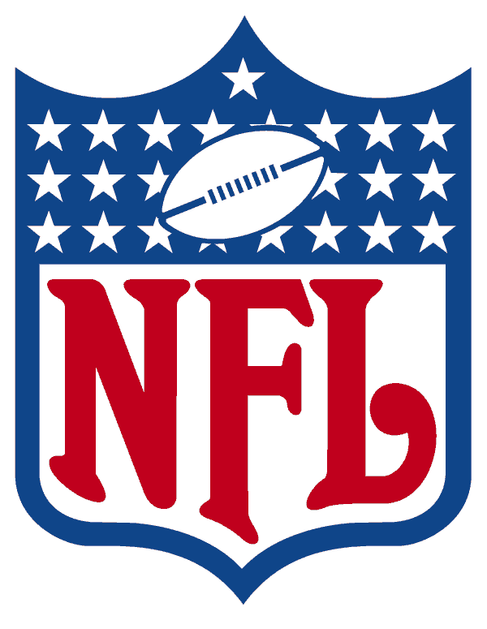
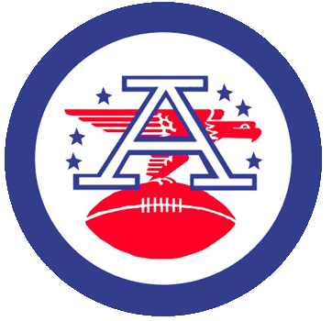
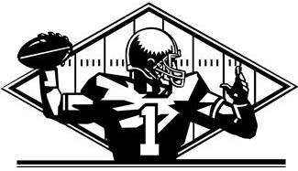

WLAPF

WORLD LEAGUE of American Professional Football

World Football League
Birmingham Americans
Florida Blazers
Memphis Southmen
Southern California Sun

American Football League
Buffalo Bills
Houston Oilers
Kansas City Chiefs
New York Jets
Oakland Raiders

National Football League
Baltimore Colts
Cleveland Browns
Dallas Cowboys
Green Bay Packers
Minnesota Vikings

And even got so far as to start writing some rules:

WORLG LEAGUE of American Professional Football

Miniature Electric Football Solitaire League

The World League of American Professional Football is a league of miniature electric football game play that combines the rules of the American Football League, the National Football League, and the World Football League into one unique brand of American football played by the professional leagues of the 1960’s and 1970’s.

The AFL, NFL and WFL

The American Football League and the National Football League as played during the years of 1960 to 1969 were virtually the same as they had been played in the NFL since 1933.

Prior to 1933, professional football had been played using the rules of college football. In 1933 the NFL adopted rules that moved the goal posts from the end line at the back of the end zone to the goal line, the inbounds line are added with all plays beginning on or inside the hash marks, the forward pass is legalized from anywhere behind the line of scrimmage, a touchback occurs on any punt that hits the

opponents goal posts before being touched by any player of either team, and if a ball that is kicked from behind the goal line hits the goal posts, and rolls back out of the end zone or is recovered by the kicking team scores a safety.

The American Football League was formed in 1959 and began playing in 1960. The rules of the AFL were the same as the NFL except that the AFL adopted the 2 point-conversion rule that had been used in college football since the 1950’s.

In 1966, the AFL and NFL agreed to a merger with an AFL-NFL World Championship Game (later the Super Bowl) to be played following the 1966 seasons. The 2-point conversion was eliminated for the 4 Super Bowl games prior to the AFL-NFL merger and for the post AFL-NFL merger years and did not appear in the NFL rules again until 1994.

The World Football League was organized in October of 1973, The WFL had several important rules differences from the NFL of that era, and many were eventually adopted by

the older league:
- Touchdowns were worth 7 points, instead of 6.
- Conversions were called "Action Points" and could only be scored via a run or pass play (as opposed to by kick as in other football leagues), and were worth one point. The ball was placed on the two-and-a-half -yard line for an Action Point. This rule was a revival of a 1968 preseason experiment by the NFL and AFL.
- Kickoffs were from the 30-yard line instead of the 40. Before 1974, NFL teams kicked off from the 40; starting in 1974, the NFL moved its kickoffs back to the 35, and twenty years later, the kickoff line was pushed back to the 30. (Beginning with the 2011 season, kickoffs in NFL games were again placed at the 35.)
- Receivers needed only one foot in bounds for a legal pass reception, instead of two feet in the NFL.
- Bump-and-run pass coverage was outlawed once a receiver was 3 yards beyond the line of scrimmage. The NFL adopted this rule in 1978, with a 5-yard bump zone.
- The goalposts were placed at the end line (the back of the end zone). Starting with the 1974 season, the NFL also moved its posts back to the end line to curb the then-growing dominance of placekickers.
- Missed field goals were returned to the line of scrimmage or the 20-yard line, whichever was farther from the goal line. The NFL also adopted this rule for its 1974 season, then replaced the line of scrimmage with the point of the kick in 1994. Before this rule, missed field goals were (if unreturned) touchbacks, with the ball placed at the 20-yard line.
25

- A player in motion was allowed to move toward the line of scrimmage before the snap, as long as he was behind the line of scrimmage at the snap. This rule had never been used at any level of American football.
- Punt returners were prohibited from using the fair catch, although the covering team could not come within 5 yards of the kick returner until he caught the ball.
- Penalties for offensive holding and ineligible receiver downfield were 10 yards, instead of 15. Several years later, these became 10-yard penalties. The NFL made this rule change in 1977. Still later, the ineligible receiver penalty was changed to 5 yards (with loss of down).
- The WFL's original overtime system was like nothing used in any form of American football before or since, Overtime in the regular season was one fixed 15-minute period, divided into two halves of 7½ minutes, each starting with a kickoff by one of the teams. The complete overtime was always played; there was no "sudden death" feature. In 1975, the WFL changed its overtime to the 15-minute sudden-death period, which the NFL adopted in 1974 and still uses today.

Official Game Play Rules and Regulations

The following are the “Official Game Play Rules and Regulations” of the WORLD LEAGUE of American Professional Football (WLAPF). These rules and regulations combine the rules of the AFL and NFL as played in 1966 – 1969 and the WFL as played in 1974.

Miniature electric football game play simulates as closely as possible the actual game play of American football. In all instances of interpretation, the actual rules of football will take precedence.

Table of Contents
Rule 1. The Field
Rule 2. The Ball
Rule 3. Definitions
Rule 4. Game Timing
Rule 5. Players and Equipment
Rule 6. Free Kicks
Rule 7. Scrimmage
Rule 8. Forward Pass, Backward Pass, and Fumble
Rule 9. Scrimmage Kick
Rule10. Opportunity to Catch a Kick, Fair Catch
Rule 11. Scoring
Rule 12. Penalties
Rule 13. Overtime and Sudden Death Procedures

Rule 1. The Field
Section 1. Game Board Dimensions
The field (or game board) shall be of any manufacturer or model no. specifically constructed to play the game of miniature electric football and scaled to match that of an

actual American football field of 100 yards in length with 2 10 yard end zones.

Section 2. Markings
The field shall have all markings normally used to delineate an actual football field to include yard lines, side lines, goal lines, end lines, and inbounds lines (or hash marks).

Section 3. Goal
Goal posts scaled to match the game board being used shall be placed on the goal line.

Section 4. 10-Yard Chain, Yard Line and Down Marker
A 10 yard chain scaled to match the game board being used and a line of scrimmage yard line marker and down marker shall be provided.

Rule 2. The Ball
A ball made of foam, felt or leather and specifically designed to be used with the game of electric football shall be provided. The ball will be used for placing in the arm or on the base of the ball carrier for all running plays and for all passing attempts made using the passer/kicker figure.

Rule 3. Definitions
There are specific terms and definitions of terms to describe the action and game play procedures of football and miniature electric football.

These terms and definitions are arranged in alphabetical order and may be used prior to being defined.
26

Section 1. Ball in Play, Dead Ball
The ball is in play or “live” while in the possession of a team during the course of a play or down. A ball is “dead” upon completion of a down and prior to the beginning of the next down.

Section 2. Ball Carrier
The player or figure designated to be the ball carrier and in possession of the ball during the course of a play.

Section 3. Blocking
A player or figure is “blocking” when not in possession of the ball and engaged with another player of the opposing team.

Section 4. Down
Article 1. A down is the period of action that starts when the ball is put into play and ends when the ball is next dead.

A “free kick” down begins with a free kick.

A “scrimmage” down starts with a player of the offensive team in possession of the ball.

A “fair catch kick” down starts with a fair catch kick.

Article 2. A “series of downs” begins with a “first down” and concludes when the offensive team either scores, gains the 10 yards necessary to gain a first down and another series of downs, fails to gain the 10 yards necessary to gain a first down or gives up possession of the ball to the defense during the course of a play.

The offense is allowed 4 downs to gain the 10 yards necessary to retain possession of the ball and a new series of downs.

Section 5. Drop Kick
A drop kick in miniature electric football may be performed by stopping the game board and the forward progress of the ball carrier before he crosses the line of scrimmage, replacing him with a passer/kicker figure and kicking the ball downfield towards the opposing team’s goal line.

Section 6. Fair Catch
A fair catch is the catch and recovery of a free kick or a kick from scrimmage in which the player making the catch and recovery of the kick chooses not to return the kick thereby ending the down.

Article 1. The spot of the ball after a fair catch by the receiving team is the spot on the field directly under the most forward part of the player’s base making the fair catch.

Section 7. Field Goal
A field goal is a kick from scrimmage that crosses the plane of the goal line and goes through the uprights of the goal posts.

A field goal is performed by placing the passer/kicker figure at the spot of the kick and kicking the ball towards the opponent’s goal line.

A field goal may be made by a place kick from behind the line of scrimmage or a drop kick from behind the line of scrimmage.

A field goal may not be made by a punt from behind the line of scrimmage.

Section 8. Foul and Spot of Enforcement

That’s as far as I got. I did manage to play several games, to finish out the SCPC season. The New York Jets finished SCPC Season One going undefeated and defeating Al Dunham’s New Zealand Zombies in Challenge Bowl I by a score of 17 – 14.

For season 2 of the SCPC and the WLAPF, I will be playing a tournament format that will culminate in the AMERICAN BOWL Championship Game. I love participating in the SCPC. It has brought to my solitaire game experience a new excitement that was not there before. It is fun watching my teams move up or down in the rankings. While it will be challenging to get 10 games in for all my teams in this format, I like the tournament style of competition. Five teams have already been eliminated and the Jets have already been defeated once, putting the pressure on them to keep winning, repeat as WLAPF Season 2 Champions and American Bowl I Champions.

Be sure to follow the progress of the WLAPF in the Solitaire Section of the MFCA Forum.

The TOC Season begins with the
Mid States Land Rush
27

November 1 – 3, 2013
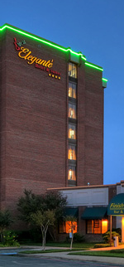
Eleganté Hotel and Suites, Dallas, TX -

The first MFCA TOC event of the year took place this weekend with 25 coaches participating. Barry Stephenson of Plano, Texas won the Land Rush Championship over Charles Lane from Chattanooga, TN. This was the first TOC Championship Game for Barry who also plays in the Lone Star EFL. Barry served as host of the event and is also a member of the MFCA Board of Directors. Congratulations to Barry and thanks to all who participated.

Pool Play Results

Pool A
Barry S 37 Rick Thompson 0
Mark K 6 Khaliq Bey 5
Barry S 7 Mark K 0
Khaliq Bey 28 Rick Thompson 0
Barry S 14 Khaliq Bey 10
Mark Klingbeil 15 Ricky Thompson 7

Pool B
RD 16 Carl Coley 0
Pat Morris 20 Oscar Woodard 14 OT
Oscar Woodard 19 Carl C 3
RD 27 Pat Morris 21 OT
RD 14 Oscar Woodard 7
Pat Morris 14 Carl C 7

Pool C
Pep Woods 28 Chris Chambers 7
David N 13 Jerry M 0
David N 22 Chris Chambers 21
Pep Woods 16 Jerry M 7
Pep Woods 14 David N 10
Jerry M 21 Chris Chambers 7
Pool D
Doug S 22 Lynn S 0
Dru S 13 Logan King 7
Doug S 28 Dru S 7
Logan King 7 Lynn S 0
Doug S 21 Logan King 7
Dru S 21 Lynn S 14

Pool E
MCM Eleganté, Dallas
Don Hudson 21 Earnest C 0
Gary Pate 15 John Oubre 14
Don Hudson 12 John Oubre 0
Gary Pate 17 Earnest C 0
Don Hudson 14 Gary Pate 10
John Oubre 3 Earnest C 0

Pool F & G
Charles Lane 20 Corey J 14 OT
Brandon Woodard 7 Rick Cabel 0
Charles Lane 21 Rick Cabel 7
Brandon Woodard 14 Ira Meechum 7
Brandon Woodard 14 Charles Lane 7
Corey J 6 Ira Meechum 0

The Road to the Championship The Celebration Dinner
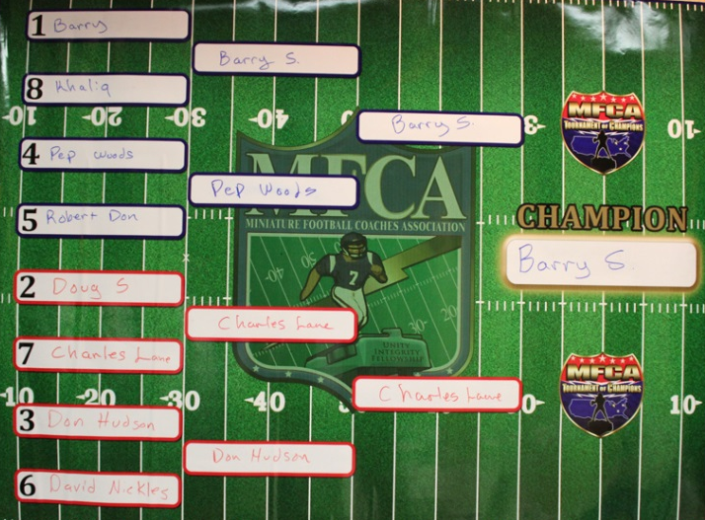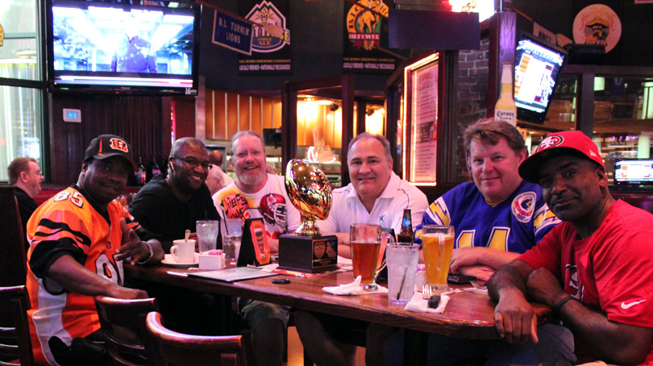

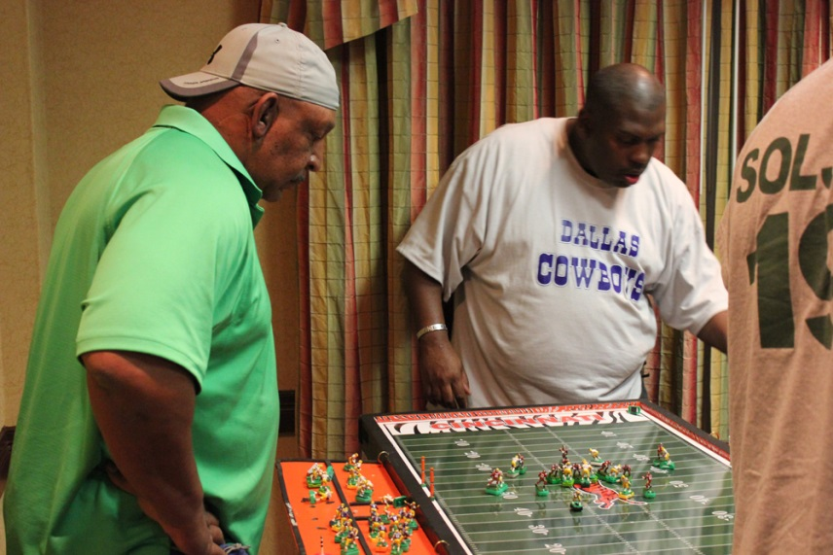
28

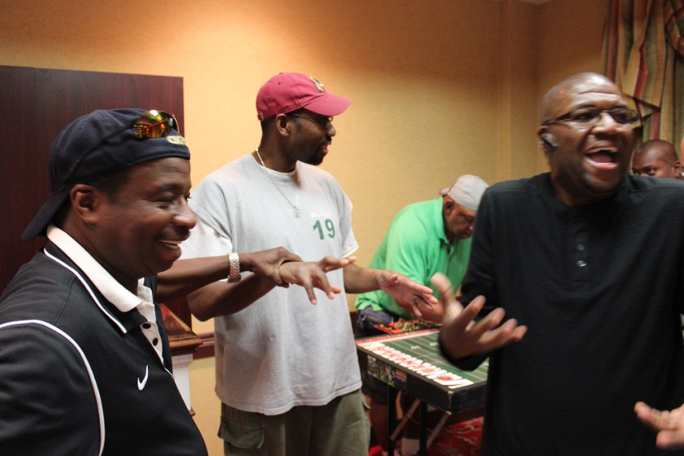

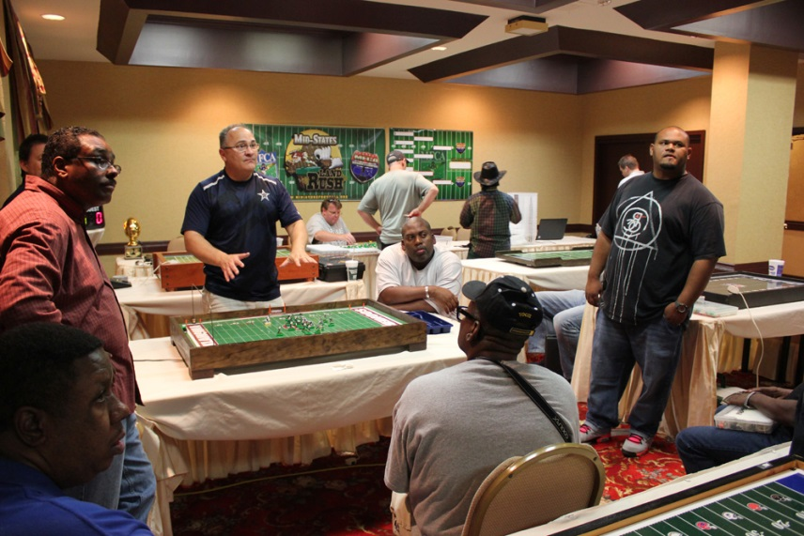
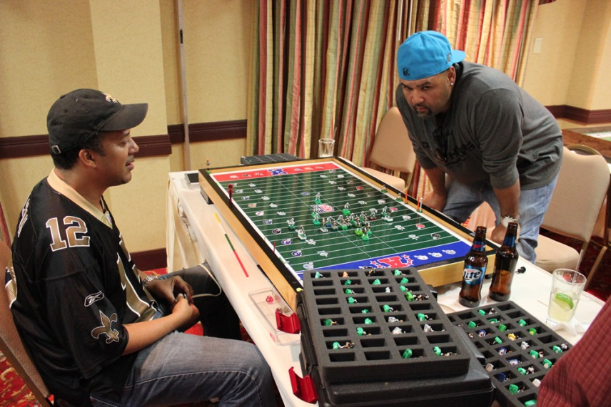

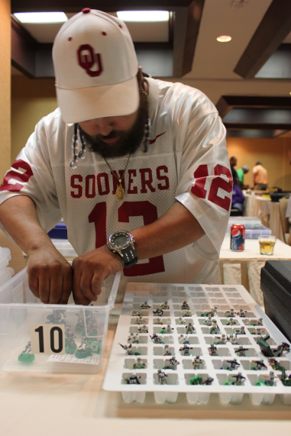
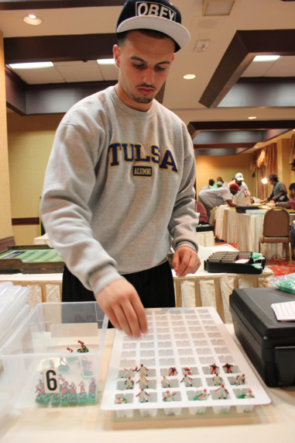
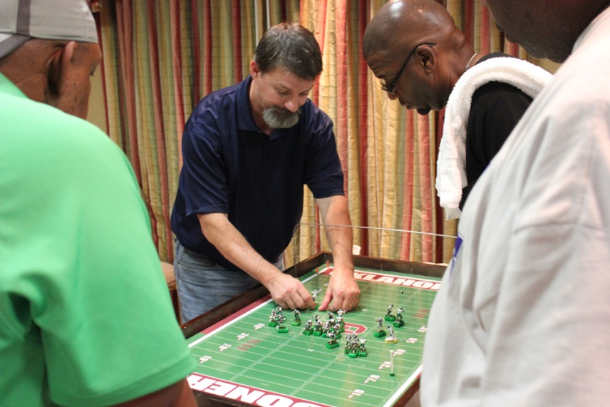

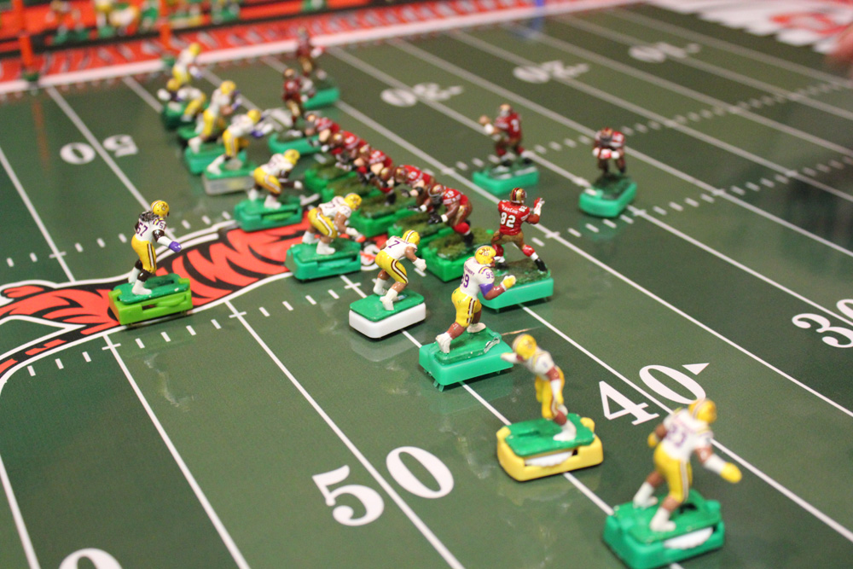

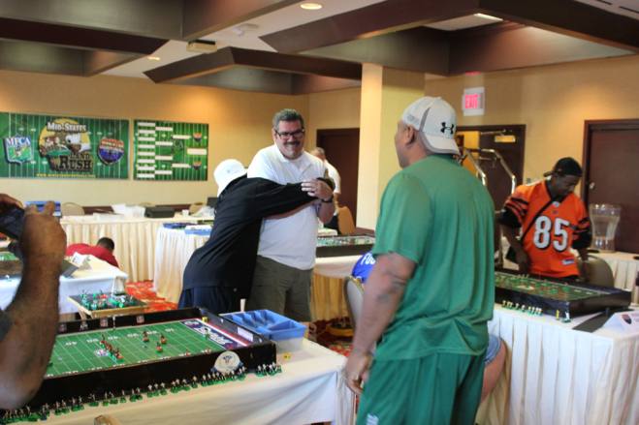
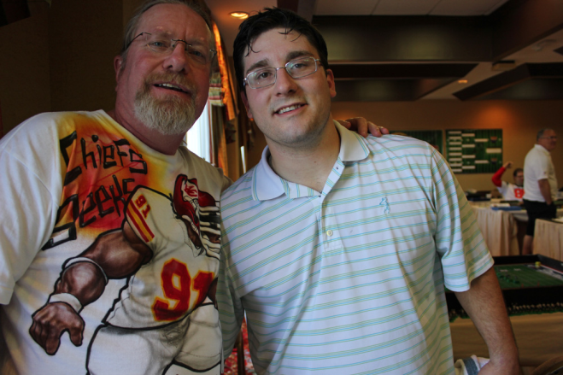

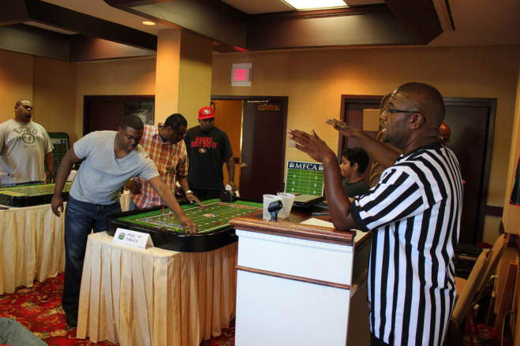
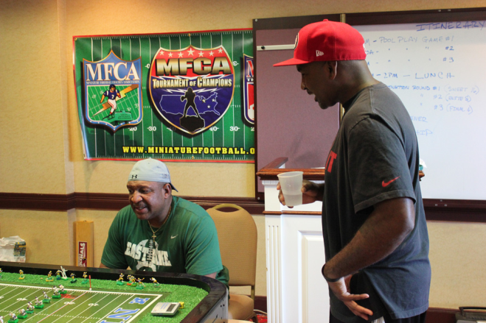

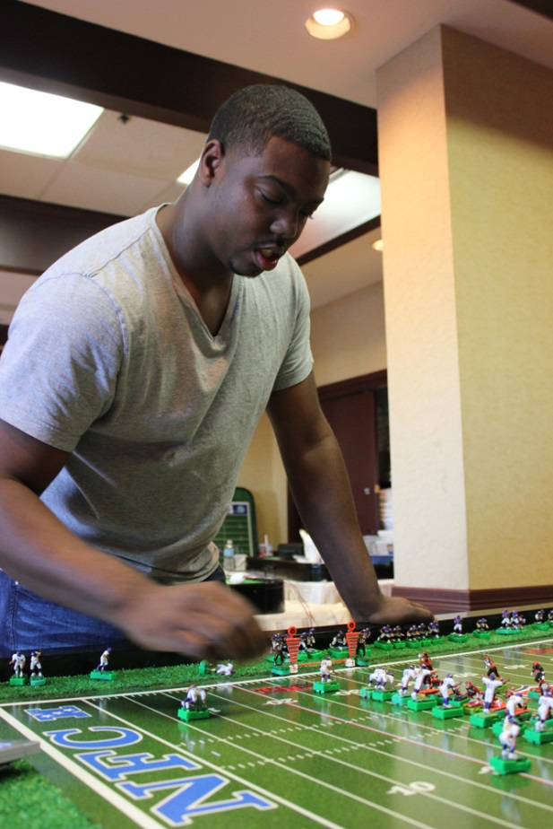
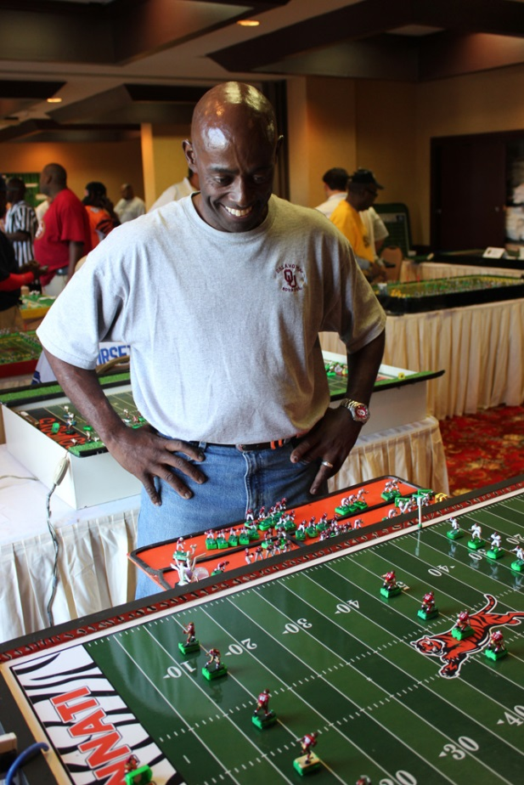

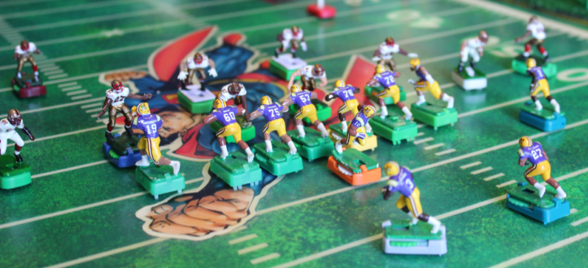
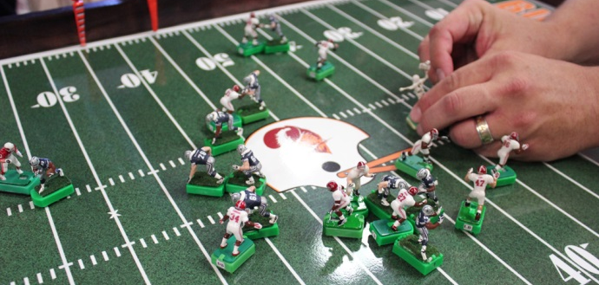

29

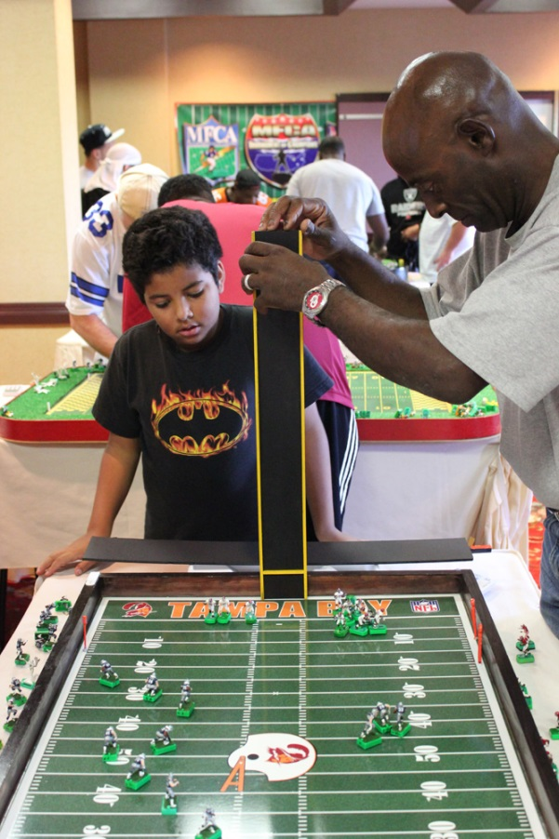
30

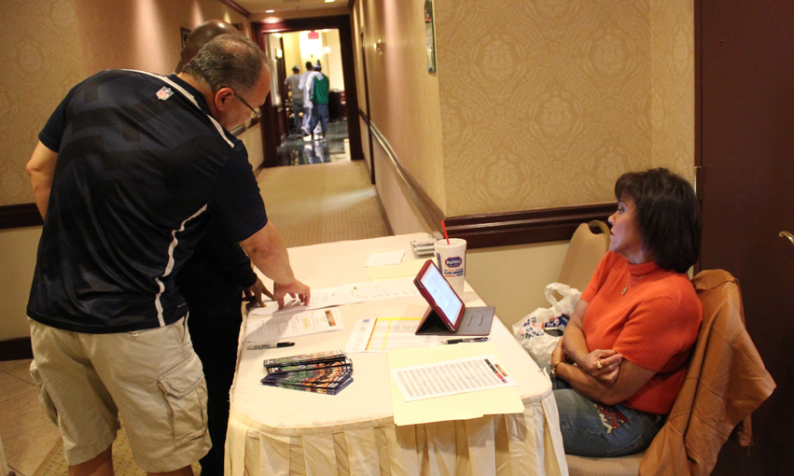
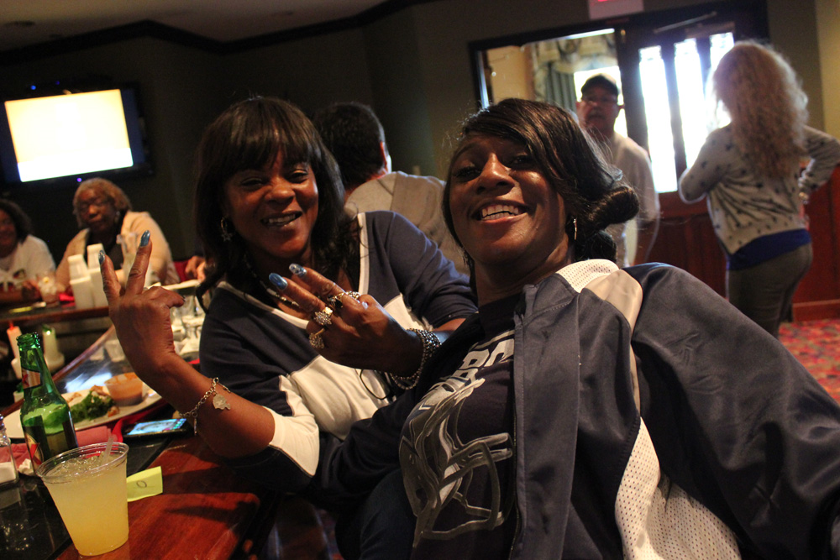
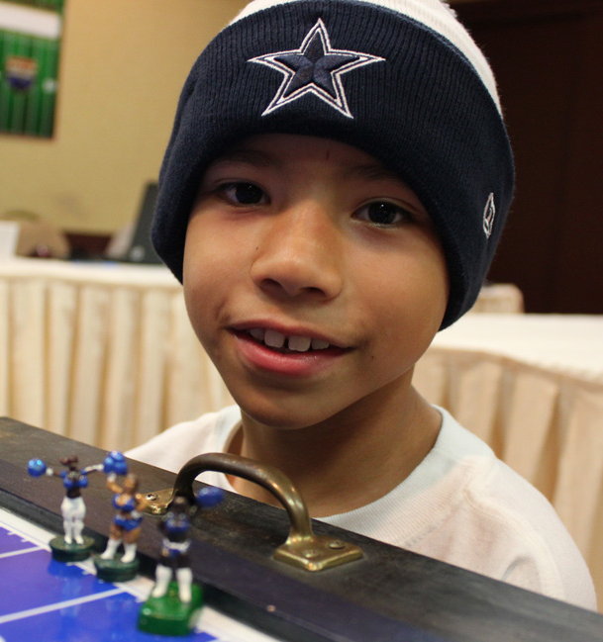
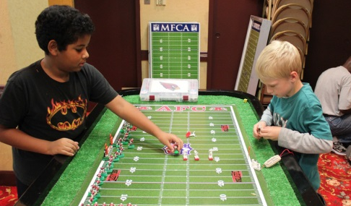
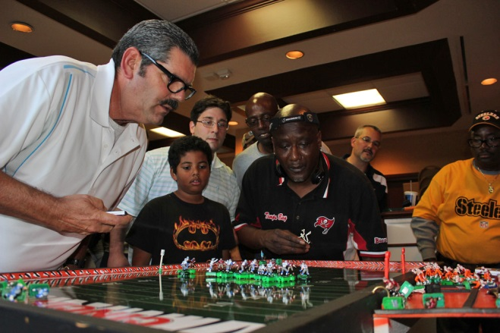
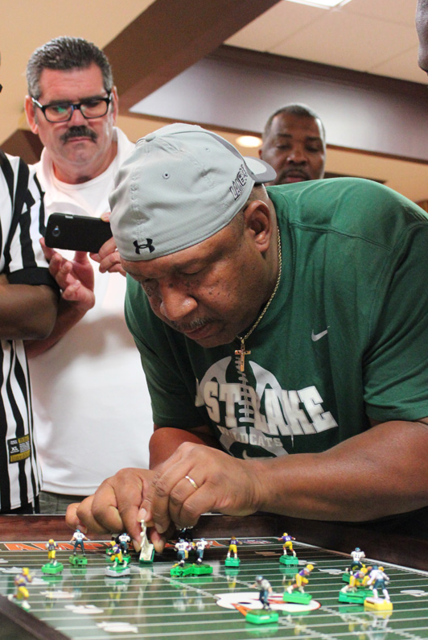
THE CHAMPIONSHIP GAME
31

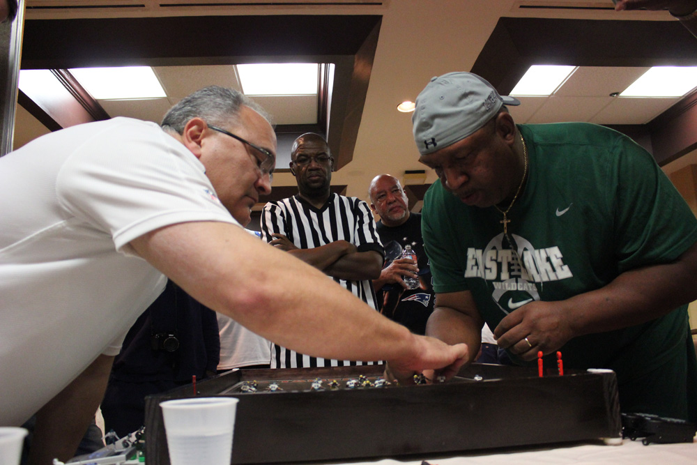
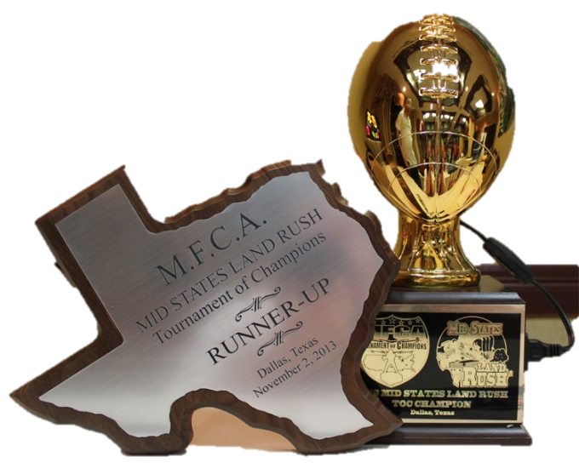
The Championship Game was a clash of two southern “Titans of the Game”,
32

Charles Lane of the MFCA’s South East Region and Barry Stephenson
of the MFCA’s South West Region. Barry was playing with his NFL
Dallas Cowboys and Charles’s team was college football’s LSU Tigers.

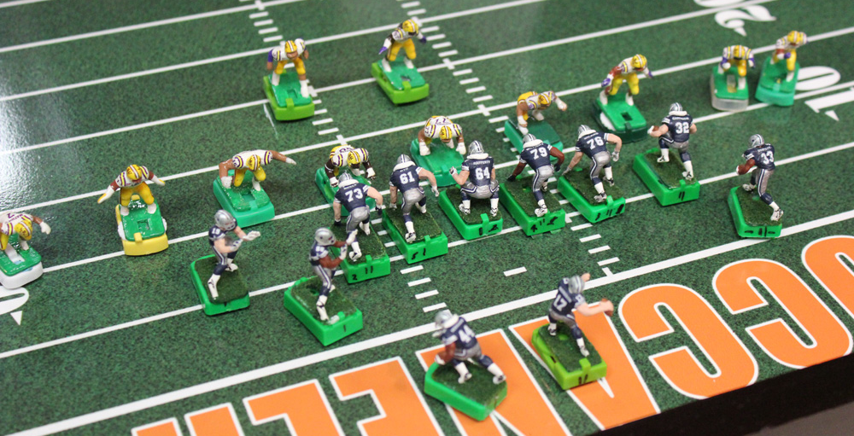

Here is a real time report of the game by Lynn “Weirdwolf” Schmidt as posted on the MFCA Forum:

Saturday Evening 11/2/2013
9:25 PM Amazing first half of play! Charles Lane leads 9-7 at the half. Barry had the first score of the evening on a nice drive. Charles came back with a drive of his own to make it 7-7. Barry's kick returner tripped at his own 5 yard line which resulted in a safety on the next play. 9-7. Charles, with no time on the clock before half. Barry threw a desperation Hail Mary and hits the receiver who has a wide open path to the goal line. Out of nowhere his own man hits the side of the back of the receiver’s base turning him just short of the end zone! (He spiked the ball in celebration a 1/2 yard early.

Stay tuned for a barnburner second half!
9:35 PM Barry just took the lead on a 45 yard field goal with 25 minutes to go. Barry 10-Charles 9.
9:55 PM Another field goal by Barry with 6:00 left. Barry 13-Charles 9.
9:56 PM QB Draw by Charles from his 20 for 80 yards and a TD! Going for 2....
9:58 PM 2 point no good. 1:48 left Charles leads 15-13.
10:01 PM Barry scores on a kickoff return. Charles has one play left. 20-17 Barry.

10:11 PM Your new Land Rush Champion is Barry Stephenson!

Here are some comments from Barry and Charles on their Mid-States Land Rush experience.
33

Just wanted to give a BIG thank you to all who attended the first ever Dallas TOC Land Rush Tourney. It was super fun on many levels.
•Thank you Vance Warren for flying in just to be our Game Warden, it is a thankless job. Any EFL Event is like herding cats and an adult day care all rolled into one. Awesome job and I thank you... You are back at your High School weight and you look amazing and svelte !!!! we are all envious !!
•It was my first Tourney Championship or any for that matter; I have many Brides-Maid titles, but this is my first #1. Finally, I appreciate all the kind words. Each of my last three games came down to the final play...1) If Khaliq's WR doesn't step out of bounds at my 11 as time expires, it's a different weekend for me, 2) If Pep tries for a game winning FG instead of running that final play for a score, then it's a different weekend for me, 3) If my Michael Irvin doesn't return that KO for a last second TD against Charles Lane, it's a different weekend for me... The ticker can only take so much.. My back is killing me.. It is funny to admit I am so sore from playing electric football all weekend, but I am.... Finally, I thought after completing a very long pass to a wide open Calvin Hill as time was expiring in the first half; and then watching him dodge all the LSU defenders only to be turned away by one of my own guys right at the one yard line.... I thought... "here we go again..."
•To Charles Lane, my final opponent.. Is there a better human being who embodies the grace, humility, talent, competitiveness we all aspire to in the EFL world? I think not.... What a game... I always enjoy playing you as I know I will always get your best and highest level of integrity in your play. You Rock!
•Thank you Lynn Weird Wolf for making the trek down again and being the great ambassador and for all the "heavy lifting" you do for our Hobby, another thankless job. There are a few key individuals in our hobby if not for their efforts, this ship would not sail each day.
•Thank you crazy Carl Coley for bringing down all those great fields from OKC and yard markers (I stole one btw).... You are the new mad scientist of the hobby I think.. we love you and want to choke you all at the same time.. but mostly we love you... lol.. you are my brother....
•For the all the Bama guys who made that drive... we will see you back in Bama in May or June for sure !!!! The Tejas bus will be filled again... can't wait...
•Mark Klingbeil - Thanks for making the trip and for changing the landscape of our hobby for the better with your ITZ bases.. If you are not yet a believer, get on board soon... The winning TD sprint KO return down the left sideline with 22 seconds remaining was an ITZ speed base who btw, was the Fastest Man winner at last year’s Cleveland TOC. I have NEVER seen a based player move so fast, ever.. On a side note to you Mark, please bring more than one football to pass with, so if you lose your ball again, you won't go to pieces and tap out again.. haha....
•For all the coaches who came to play, several their first tourney.. thank you.. we had I believe 25 coaches up from 10 in year one of the Land Rush... Awesome.... will need a bigger room in the future.. it was butt in the butt in there playing...
•Really appreciate all the local coaches from all three Dallas leagues to who came out either to play or watch... thank you... This event even brought out the infamous Robert "RD" Don from retirement...
•Next TOC Event is the Wounded Warriors Tourney Hosted by BOD Chairman, Jerry McGhee in Lakeland Florida on Valentine's weekend. Jerry also made the trip to play in Dallas. thank you for sharing*. Lol....
I'm still wore out...... whew...... thanks again.....

Barry Stephenson......

What a great time in Dallas, when you think a tournament can't get any better you have a tournament like this one, outstanding. First of all congratulation to Barry for a job well done, it was a joy playing you and I look forward and hope I get a chance to play you again. To my crew from the Deep South that was able to make it, David and Gary you guys did great. To Barry and the guys that put this together, super, super job, to Vance and Wolf, keep doing what you do, it don't get any better. Big ups to Corey, enjoyed playing you, hope we get another chance to face off, Don Hudson what a game, see you soon. There were too many names to name everyone, but to let everyone know I really enjoyed myself, for the ones that were unable to make it, you missed a great time in Dallas. To all my miniature electric football family, let’s keep it going, support these tournaments when you can, it is always big fun. Until next time.

Biglane.

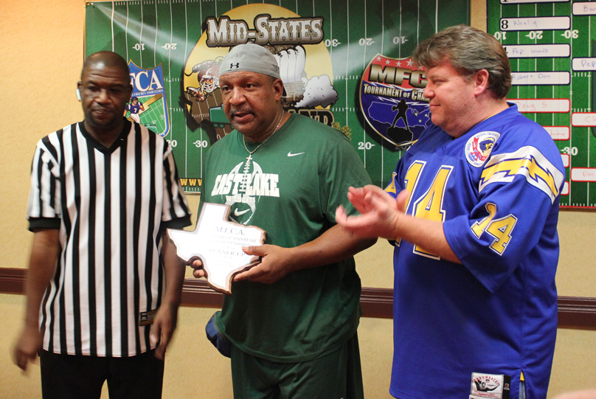

For more great stories, comments and pics from the Mid States Land Rush, be sure to visit the Tailgate Section of the MFCA Forum. All information for this article came from the MFCA Forum and thanks to “Weirdwolf” for posting the pics used in this article.

Next up on the TOC Schedule is the Warrior TOC in Lakeland, FL hosted by Jerry McGhee in February. Be sure to check the MFCA Forum and website for information on this event and if you live in or near this location get out and give your support from the Solitaire Leagues of the MFCA to our MFCA brethren.

The SCPC Season One Trophies
34

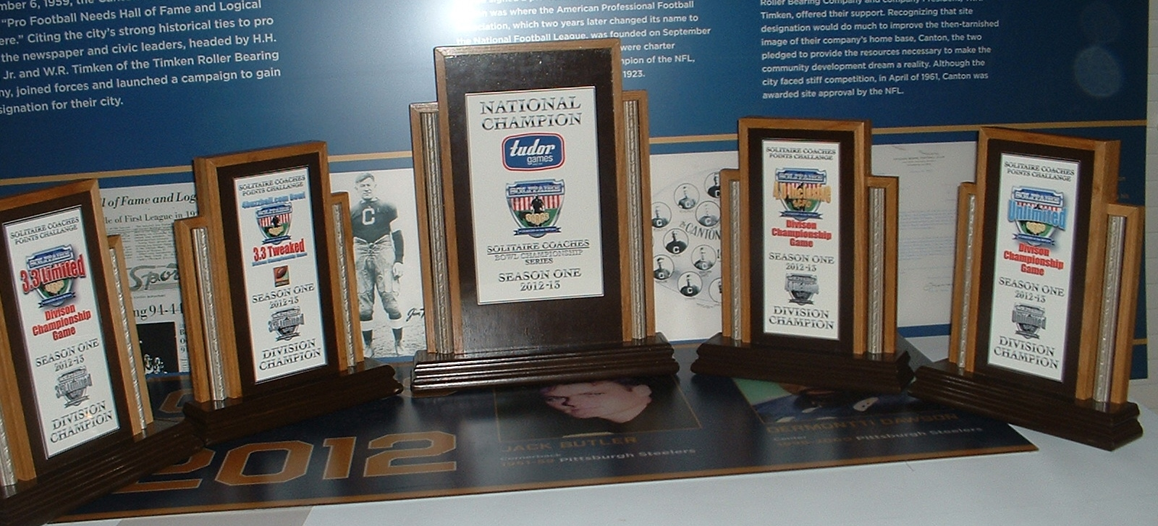

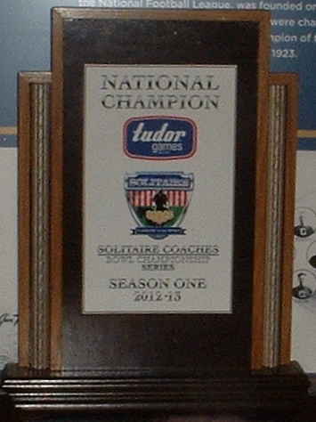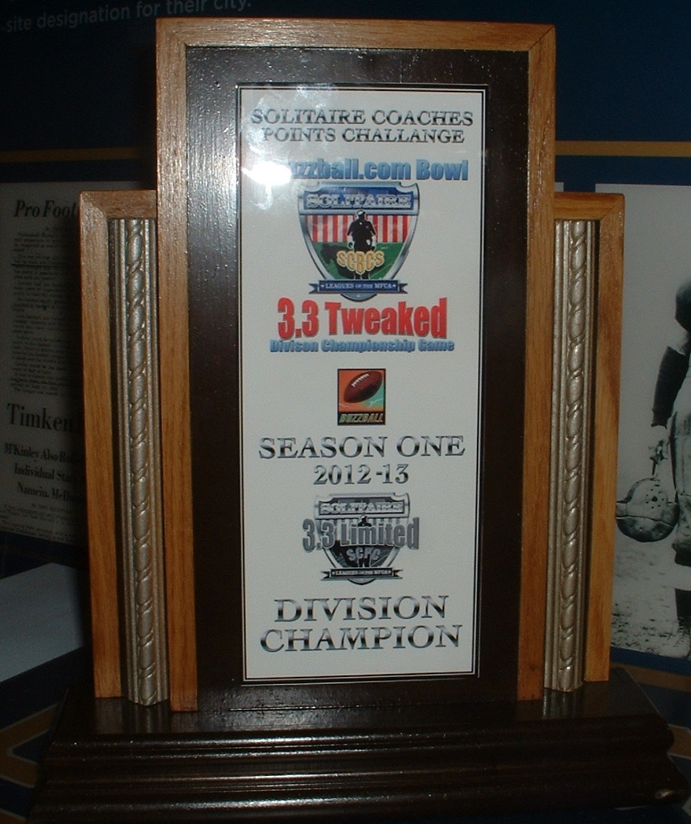

the “TUDOR GAMES” National Championship Trophy

the “4buzzball.com Bowl” 3.3 Tweaked Division Championship Game Trophy
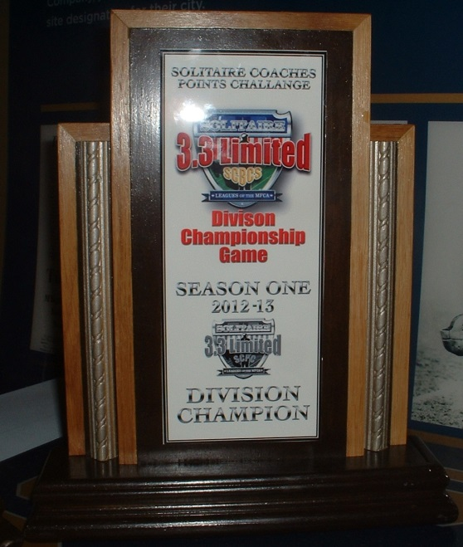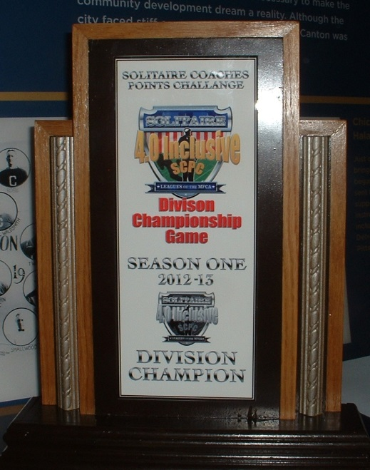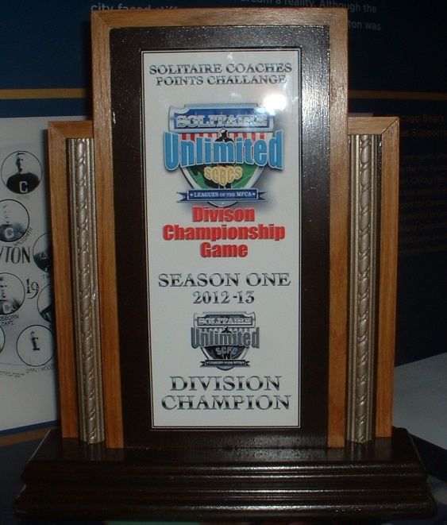
the 3.3 Limited Division Championship Game Trophy
35

the 4.0 Inclusive Division Championship Game Trophy
the Unlimited Division Championship Game Trophy

For Season 2 of the SCPC, Reginald Rutledge and FootballFigures.net has joined the lineup of sponsors for the “UNLIMITED” Division Championship Game.

Anyone interested in sponsoring the remaining SCPC Season 2 “3.3 BOX STOCK” Division Championship Game and “4.0 INCLUSIVE” Division Championship Game trophies should contact the SCPC Commissioner or any member of the SCPC Rules Committee for sponsorship Information. eflfanatic@charter.net

This is a great opportunity for your business or organization to get “free advertising” or for any interested individual to show your support of the “Solitaire Coaches Points Challenge” and the “Solitaire Leagues of the MFCA”.

Season 2 of the SCPC is looking to be very exciting. We already have over 75 games entered and 5 leagues and 6 coaches participating. Derrick Gross is working on improving the reporting and recording systems and overall improvements to the total “SCPC Experience” on the main page of the MFCA Website.

Coaches, hopefully, will soon be able to enter their own game summaries, league information and pictures on their own individual league and team pages.

This will greatly increase the awareness of the SCPC, Solitaire Leagues of the MFCA and the people and coaches who play and enjoy the game and hobby of miniature electric football in a solitaire format. I am also exploring other avenues and venues for making “Solitaire Illustrated” available to the general public through digital and print media. Any and all help or ideas to help accomplish this, is greatly appreciated.

The SCPC Trophies are the design and fabrication of Chris LeMay with the help of stepson Ben Coile, who provided the graphics.

