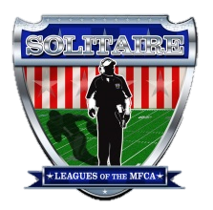
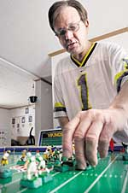
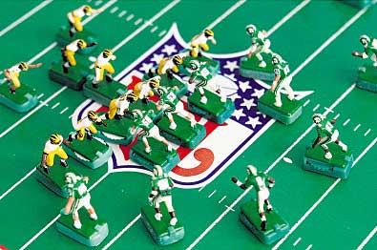
Solitaire Illustrated
Official OnlinePublication of the Solitaire Leagues of the MFCA
Volume 2 Issue 1 November 1, 2013

“wolverine” Brian Wittkop and the
Northern Michigan EFL

From the Desk of the Editor Chris Lemay

Trying out a new look!!!

For the second volume of “Solitaire Illustrated”, I am trying out a new look, more in depth reporting on the SCPC and more content and picks from the “Solitaire Leagues of the MFCA”.

I plan on compiling a week by week record of the SCPC game reporting and a weekly SCPC ranking report. I also hope to report on at least one “Game of the Week”. Most of this information will come from the Solitaire Section of the MFCA Forum so it is important for SCPC participants and other members of the MFCA who play “solitaire” to post as many “game action photos”, “game summaries” and any other information about your leagues and game play that you would like to have others know about on the forum.

Every issue of “Solitaire Illustrated” is available for download by following links on the Main Page of the MFCA Website. I post links to this section on the MFCA “Tailgate Party” section of the forum and on the “Tudor Community” forum and will explore other opportunities to let people outside the MFCA and Tudor Community forums to know what’s going on in the world of Solitaire miniature electric football.

I also plan to do more reporting of the things going on in the MFCA, since we are the only regular publication of the MFCA at this time. The last issue of “Solitaire Illustrated” which reported on the MFCA Convention and The TOC Tournament was very well received by the community as a whole with several well received comments from those who do not regularly play solitaire. That’s very encouraging as I do not know how many people actually read it. ONLY BY YOUR COMMENTS do I know who is reading it and whether it is worth the effort to continue publication. SO PLEASE COMMENT!!!!

At the MFCA Convention I was honored with the LEE PAYNE AWARD. This award is given to individuals who over their lifetime, have exhibited the characters of our motto; unity, integrity and fellowship. These words were created as our motto by Will Travers upon the founding of the MFCA. The person receiving this award should be respected and should be known for their fairness, ethics and good character without reproof and should in every way be the epitome of the model miniature electric football hobbyist. Will was awarded the first Lee Payne award in 2010. Other winners were Frank Johnson in 2011 and Ray Fanara in 2012.
2
`

As I am writing this, I am at Texas A & M working. I will be here until at least the 1st of October and maybe until the end of October. Two weeks prior to coming here, I was just up the road at Baylor University. In between I had the opportunity to attend the Vanderbilt – Ole Miss season opener in Nashville. I have never really been that much of a college football fan but being at these job sites, staying in these college towns and taking part in the pregame hoopla and traditions of college football have given me a greater appreciation for what it means to live in a college town. Seeing the support from the local community and supporters of the athletic programs at these great universities has truly been a blessing.

The opening week of the NFL season is just around the corner. Teams have made their final roster selections for the season and are preparing for the opening games of the year.

High School football season began in Tennessee and most other parts of the country two weeks ago. I went to the first game of my alma mater, Lawrence County High School in Lawrenceburg, TN. They were playing longtime rival, Columbia, TN. Both school’s colors are purple and gold which could explain why my favorite NFL team during my high school years was the Minnesota Vikings. The first half was not going well for my beloved Wildcats, so I took the opportunity to go see my daughter and granddaughter and left at halftime with the score Columbia 21 – Lawrenceburg 7. With the game on the radio on the way to their house, I heard that Lawrenceburg scored on a 2 play 80 yard drive to open the second half and bring the score to within a touchdown. In the hour that I was in the house visiting with them, I was surprised to hear that the game was still on when I got back in my truck to head back to Spring Hill. Lawrenceburg had come back to tie the game at 21 all and was trying a last play field goal to win. They missed the field goal and went to overtime but lost to Columbia in double overtime 34 – 28.

By the time this issue is published football season will be well underway. Much of the excitement of the beginning of the season will have died down or faded away for some teams while others will still have hope for a bowl game or of making the playoffs. The NFL season will just be reaching the midway point but the SCPC will only be into the 9th week of its 45 week season. Where else can you enjoy this much football in one year?!?!?!

3
In this Issue
Page 2 From the desk of the Editor
Page 4 Good Vibrations on the Gridiron
Page 5 In the Lights:
Northern Michigan EFL
Page 8 Brian’s Photo Album
Page 9 College Tradition as big as the “Big House”
Page 11 Boards from the Past
Page 13 The Bopst Show
Page 17 A “Tweaking” Primer
Page 18 75 yard Field Goal attempt, GOOD!!!
Page 19 Solitaire goes “National”
Page 21 Season 2 Division Changes
Page 22 “Solitaire” Electric Football?
Page 23 Seasonal or Tournament?

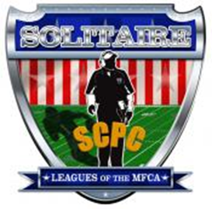
SEASON 2

The MFCA is a not-for-profit organization the purpose of which is to promote the hobby of miniature football and to encourage participation of coaches across the country. The MFCA shall not be responsible for or in any way liable for the content of images, articles or any other information furnished by its advertisers. Said liability to include defamation in any form, copyright, trademark or patent infringement, license violations or other legal theories.

Solitaire Illustrated
Official Online Publication of the Solitiare Leagues of the MFCA
Volume 2 Issue 1 November 1, 2013

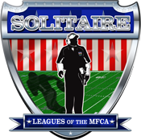

EDITOR
Chris LeMay
CONTRIBUTORS
Solitaire players, coaches and owners of the
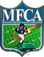

Customer Services
eflfanatic@charter.net

to join the MFCA and the Solitaire Leagues of the MFCA
www.miniaturefootball.org

SCPC RULES COMMITTEE
Commissioner
Chris LeMay
Rules Committee
Derrick Gross, Chairman
Al Dunham
Ed Morgans

The following is a reprint of an article from www.record-eagle.com
4
Good vibrations on the gridiron

Rapid City man wants to form league

By TOM CARR Record-Eagle staff writer

April 5, 2007

RAPID CITY — Brian Wittkop Sr.'s favorite way to enjoy football is to watch plastic players buzz around on a vibrating metal field.

He wants to start an electric football league here, which may lead to the question: Why bother with such a low-tech game in an age where video game football has realistic movement, expert commentary and detailed reproductions of actual stadiums?

"There's a quaintness to this and it's social,” said Wittkop, 48, who belonged to a league when he lived in Monroe.
Brian Wittkop Sr. lines up two teams on one of his electric football fields. Wittkop is trying to start an electric football league.
Record-Eagle / Douglas Tesner

The game's heyday was the 1960s and '70s, when Tudor Games owned the rights. It fizzled during the 1980s but found a smaller, more devoted constituency in the '90s.

Wittkop is among tens of thousands of people who now play it, said Ira H. Silverman, a spokesman for Miggle Toys Inc. of Highland Park, Ill., which sells the sets and accessories online and elsewhere.

"When the Internet came around, guys in Florida, Texas or Michigan started talking to each other about it,” Wittkop said. "I keep in touch with guys all over the country. I have an e-mail list of about 200.”

It's more involved than it seems at first glance. Some of the bases that the plastic athletes stand on have dials built in that may be changed between plays. The more basic ones can still be manipulated by cutting or bending the prongs on the bottom.

"Some people know their guys so well they know how they're going to block and how they're going to run,” Wittkop said. "It isn't just a guy twirling around like people think it is.”

People can buy a classic board with two teams for $50 from the Miggle Toys Inc. Web site. And that is just the beginning.
Wittkop has 25 boards, some with team logos in the end zones. He also has players representing all NFL teams filed in plastic organizing boxes. That's on top of 40 college teams, some of which he painted himself and others he bought finished.

Some teams have painted-on old-time uniforms. The Tampa Bay Buccaneers, for example, are decked out in their old orange uniforms and in their current pewter and red colors.

Some of his teams no longer exist, including the Houston Oilers and the Orlando Thunder of the World Football League, which is now NFL Europe.
"You can go as nuts as you want with them,” he said. "Some people put a crowd in the stands and everything.”

Wittkop has gone to conventions in major cities all over the U.S. that have their own playoffs and championships.

Wittkop's wife Patty "tolerates” his hobby, he said. "She thinks it's a little immature, but there's a lot worse things I could be doing,” he said.

When Wittkop moved to Rapid City after retiring from operating a glass shop because he's on kidney dialysis, he had to drop out of the Monroe County Electric Football League. He's now putting up some fliers to see if he can find others in northern Michigan who are enthused or curious about the vibrating gridiron.

Brian’s Michigan Wolverines lines up against his Michigan State Spartans.

In Season One of the SCPC, Brian’s Michigan Wolverines won the Unlimited Division Regular Season Championship and the Unlimited Division SCBCS Championship Game against his University of Minnesota Golden Gophers.

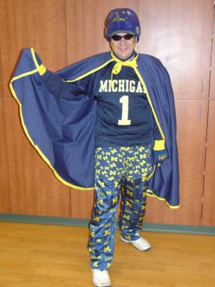
Brian was a late comer to the SCPC not joining until Week 22. Brian’s league, the Northern Michigan Electric Football League, has been in operation since 2004 (operated as the Monroe County EFL prior to 2004)

Brian operates a website that chronicles his league with records stats videos and pics.

Be sure to visit his website http://nmefl.webs.com/
aka “wolverine”

In the Lights
5

Northern Michigan Electric Football League
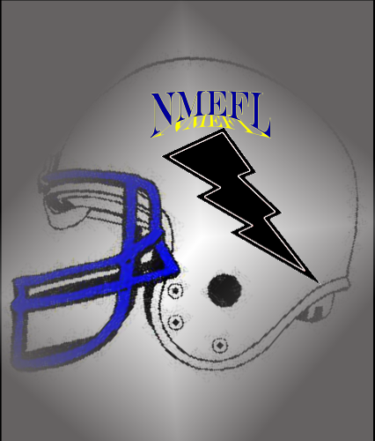
Owned and operated by Brian Wittkop, Sr., the NMEFL is a college solitaire league featuring the original teams of the Big Ten. Illinois, Indiana, Iowa, Michigan, Michigan State, Minnesota, Northwestern, Ohio State, Purdue, and Wisconsin, all teams with rich college football traditions.

For Season 2 of the SCPC, Brian will be adding Nebraska and Penn State to recreate the current Big Ten Conference alignment of 2 divisions, the Legends and the Leaders. The winners of each division will play in the CHERY BOWL Championship Game. This replaces the FLORAL BOWL, Brian’s NMEFL Championship Game since 1984.

Here’s how the NMEFL finished in the Final Season 1 Rankings of the SCPC.

#3 MICHIGAN WOLVERINES Unlimited
GAME # DATE OPPONENT GP W/L SCORE POINTS POINTS GSBP DBP QWB SCORED ALLOWED
GAME 1 03-14-13 Notre Dame 1 0 28 – 7 4 3 0 0 4
GAME 2 03-20-13 Arkansas 1 W 28 – 0 4 4 0 0 0
GAME 3 03-31-13 Kansas State 1 W 21 – 6 3 3 0 0 0
GAME 4 04-27-13 Oklahoma 1 W 35 – 3 4 4 0 0 0
GAME 5 05-08-18 Northwestern 1 W 24 – 21 3 1 0 0 16
GAME 6 05-18-13 Indiana 1 W 33 – 10 4 3 0 0 16
GAME 7 05-25-13 Wisconsin 1 W 28 – 7 4 3 0 0 2
GAME 8 06-2-13 Illinois 1 W 28 – 10 4 3 0 0 8
GAME 9 06-9-13 Iowa 1 W 35 – 6 4 3 0 0 12
GAME 10 06-30-13 Purdue 1 L 21 – 22 3 1 0 0 0
BOWL 08-03-13 Minnesota 1 W 34 – 21 4 1 0 0 20
TOTALS 11 10 - 1 41 29 0 0 78
SCPC TOTAL 159

#6 UNIVERSITY OF MINNESOTA GOLDEN GOPHERS Unlimited
GAME # DATE OPPONENT GP W/L SCORE POINTS POINTS GSBP DBP QWB SCORED ALLOWED
GAME 1 03-05-13 Oklahoma State 1 W 24 – 0 3 4 0 0 0
GAME 2 03-23-13 Syracuse 1 W 17 – 11 2 2 0 0 0
GAME 3 04-04-13 Auburn 1 W 28 – 14 4 2 0 0 0
GAME 4 04-21-13 Kansas State 1 W 17 – 7 3 3 0 0 0
GAME 5 05-02-13 Wisconsin 1 W 10 – 7 1 3 0 0 2
GAME 6 05-18-13 Michigan State 1 W 15 – 10 2 3 0 0 8
GAME 7 05-23-13 Ohio State 1 W 17 – 14 2 2 0 0 14
GAME 8 06-08-13 Purdue 1 W 24 – 17 3 2 0 0 6
GAME 9 06-16-13 Northwestern 1 W 28 – 17 4 2 0 0 16
GAME 10 06-29-13 Indiana 1 W 28 – 17 4 2 0 0 16
BOWL 08-03-13 Michigan 1 L 21 – 34 3 0 0 0 0
TOTALS 11 10 - 1 31 25 0 0 62
SCPC TOTAL 129

#13 INDIANA HOOSIERS Unlimited
GAME # DATE OPPONENT GP W/L SCORE POINTS POINTS GSBP DBP QWB SCORED ALLOWED
GAME 1 03-12-13 Florida State 1 W 21 – 10 3 3 0 0 0
GAME 2 03-19-13 UNC 1 W 21 – 10 3 3 0 0 0
GAME 3 03-28-13 UCLA 1 W 16 – 6 2 3 0 0 2
GAME 4 04-23-13 Wake Forest 1 W 31 – 10 4 3 0 0 0
GAME 5 05-11-13 Michigan State 1 W 35 – 21 4 1 0 0 8
GAME 6 05-18-13 Michigan 1 L 10 – 33 1 0 0 0 0
GAME 7 05-20-13 Northwestern 1 W 21 – 14 3 2 0 0 16
GAME 8 06-04-13 Wisconsin 1 W 35 – 10 4 3 0 0 2
GAME 9 06-16-13 Illinois 1 W 13 – 7 2 3 0 0 8
GAME 10 06-29-13 Minnesota 1 L 17 – 28 2 0 0 0 0
TOTALS 10 8 - 2 28 21 0 0 36
SCPC TOTAL 9

#16 OHIO STATE BUCKEYES Unlimited
GAME # DATE OPPONENT GP W/L SCORE POINTS POINTS GSBP DBP QWB SCORED ALLOWED
6
GAME 1 03-03-13 Clemson 1 w 28 – 10 4 3 0 0 0
GAME 2 03-16-13 Penn State 1 W 14 – 7 2 3 0 0 0
GAME 3 04-02-13 Miami 1 W 16 – 10 2 3 0 0 0
GAME 4 04-21-13 LSU 1 W 21 – 10 3 3 0 0 0
GAME 5 04-30-13 Purdue 1 W 20 – 17 3 2 0 0 12
GAME 6 05-16-13 Iowa 1 W 20 – 17 3 2 0 0 12
GAME 7 05-23-13 Minnesota 1 L 14 – 17 2 2 0 0 0
GAME 8 06-02-13 Northwestern 1 L 14 – 20 2 1 0 0 0
GAME 9 06-16-13 Michigan State 1 L 10 – 23 1 1 0 0 0
GAME 10 06-30-13 Illinois 1 W 35 – 7 4 3 0 0 8
TOTALS 10 7 - 3 26 23 0 0 32
SCPC TOTAL 91

#26 PURDUE BOILERMAKERS Unlimited
GAME # DATE OPPONENT GP W/L SCORE POINTS POINTS GSBP DBP QWB SCORED ALLOWED
GAME 1 03-07-13 Virginia Tech 1 W 14 – 7 2 3 0 0 0
GAME 2 03-30-13 Notre Dame 0 L 7 – 17 1 2 0 0 0
GAME 3 03-30-13 Tennessee 1 W 17 – 10 2 3 0 0 0
GAME 4 04-23-13 USC 1 W 10 – 7 1 3 0 0 2
GAME 5 04-30-13 Ohio State 0 L 17 – 20 2 1 0 0 0
GAME 6 05-16-13 Illinois 1 W 31 – 21 4 1 0 0 8
GAME 7 05-24-13 Iowa 0 L 24 - 25 3 0 0 0 0
GAME 8 06-8-13 Minnesota 0 L 17 – 24 2 1 0 0 0
GAME 9 06-13-13 Wisconsin 1 W 21 – 10 3 3 0 0 2
GAME 10 06-30-13 Michigan 1 W 22 – 21 3 1 0 0 20
TOTALS 10 6 - 4 23 18 0 0 32
SCPC TOTAL 83

#30 MICHIGAN STATE SPARTANS Unlimited
GAME # DATE OPPONENT GP W/L SCORE POINTS POINTS GSBP DBP QWB SCORED ALLOWED
GAME 1 03-07-13 Ole Miss 1 W 21 – 7 3 3 0 0 0
GAME 2 03-17-13 Notre Dame 1 L 10 – 14 1 2 0 0 0
GAME 3 04-02-13 Penn State 1 W 28 – 21 4 1 0 0 0
GAME 4 04-21-13 UCLA 1 L 7 – 14 1 2 0 0 0
GAME 5 05-11-13 Indiana 1 L 21 – 35 3 0 0 0 0
GAME 6 05-18-13 Minnesota 1 L 10 – 15 1 2 0 0 0
GAME 7 05-25-13 Illinois 1 L 28 – 31 4 0 0 0 0
GAME 8 06-06-13 Iowa 1 W 24 – 7 4 3 0 0 12
GAME 9 06-16-13 Ohio State 1 W 23 – 10 3 3 0 0 14
GAME 10 06-29-13 Northwestern 1 L 20 – 21 3 1 0 0 0
TOTALS 10 4 - 6 27 17 0 0 26
SCPC TOTAL 80

#32 NORTHWESTERN WILDCATS Unlimited
GAME # DATE OPPONENT GP W/L SCORE POINTS POINTS GSBP DBP QWB SCORED ALLOWED
GAME 1 03-02-13 Miami 1 W 19 – 7 3 3 0 0 0
GAME 2 03-19-13 Oklahoma 1 W 21 – 14 3 2 0 0 0
GAME 3 03-28-13 Florida 1 W 14 – 7 2 3 0 0 0
GAME 4 04-07-13 Alabama 1 W 15 – 13 2 2 0 0 0
GAME 5 05-08-13 Michigan 1 L 21 – 24 3 1 0 0 0
GAME 6 05-14-13 Wisconsin 1 W 24 – 10 3 3 0 0 2
GAME 7 05-20-13 Indiana 1 L 14 – 21 2 1 0 0 0
GAME 8 06-02-13 Ohio State 1 W 20 – 14 3 2 0 0 14
GAME 9 06-16-13 Northwestern 1 W 17 – 28 2 0 0 0 0
GAME 10 06-29-13 Michigan State 1 W 21 – 20 3 1 0 0 8
TOTALS 10 8 - 2 26 18 0 0 24
SCPC TOTAL 78

#49 ILLINOIS FIGTING ILLINI Unlimited
GAME # DATE OPPONENT GP W/L SCORE POINTS POINTS GSBP DBP QWB SCORED ALLOWED
GAME 1 03-12-13 Washington 1 L 14 – 17 2 2 0 0 0
GAME 2 03-24-13 Georgia 1 W 17 – 10 2 3 0 0 0
GAME 3 04-06-13 Wake Forest 1 W 24 – 18 3 1 0 0 0
GAME 4 04-24-15 Georgia Tech 1 L 14 – 24 2 1 0 0 0
GAME 5 05-07-14 Iowa 1 W 17 – 14 2 2 0 0 12
GAME 6 05-16-13 Purdue 1 L 21 – 31 3 0 0 0 0
GAME 7 05-25-13 Michigan State 1 W 31 – 28 4 0 0 0 8
GAME 8 06-02-13 Michigan 1 L 10 – 28 1 0 0 0 0
GAME 9 06-16-13 Indiana 1 L 7 – 13 1 2 0 0 0
GAME 10 06-30-13 Ohio State 1 L 7 – 35 1 0 0 0 0
TOTALS 10 4 - 6 21 11 0 0 20
SCPC TOTAL 62

#52 IOWA HAWKEYES Unlimited
GAME # DATE OPPONENT GP W/L SCORE POINTS POINTS GSBP DBP QWB SCORED ALLOWED
GAME 1 03-02-13 Georgia 1 W 17 – 7 2 1 0 0 0
GAME 2 03-16-13 Texas 1 W 21 – 17 3 2 0 0 0
GAME 3 04-04-13 Arkansas 1 W 14 – 7 2 3 0 0 0
GAME 4 04-25-13 Florida State 1 W 10 – 7 1 3 0 0 0
GAME 5 05-07-13 Illinois 1 L 14 – 17 2 2 0 0 0
GAME 6 05-16-13 Ohio State 1 L 17 – 20 2 1 0 0 0
GAME 7 05-24-13 Purdue 1 W 25 – 24 4 1 0 0 12
GAME 8 06-06-13 Michigan State 1 L 7 – 24 1 0 0 0 0
GAME 9 06-09-13 Michigan 1 L 6 – 35 1 0 0 0 0
GAME 10 06-29-13 Wisconsin 1 W 22 – 17 3 2 0 0 2
TOTALS 10 6 - 4 21 15 0 0 14
SCPC TOTAL 60

#97 WISCONSIN BADGERS Unlimited
GAME # DATE OPPONENT GP W/L SCORE POINTS POINTS GSBP DBP QWB SCORED ALLOWED
GAME 1 03-05-13 USC 1 L 3 – 14 0 2 0 0 0
GAME 2 03-23-13 Arizona 1 W 19 – 7 3 3 0 0 0
GAME 3 04-06-13 Colorado 1 L 13 – 14 2 2 0 0 0
GAME 4 04-27-13 Oregon 1 L 6 – 13 1 2 0 0 0
GAME 5 05-02-13 Minnesota 1 L 7 – 10 1 3 0 0 0
GAME 6 05-14-13 Northwestern 1 L 10 – 23 1 1 0 0 0
GAME 7 05-25-13 Michigan 1 L 7 – 28 1 0 0 0 0
GAME 8 06-04-13 Indiana 1 L 10 – 35 1 0 0 0 0
GAME 9 06-13-13 Purdue 1 L 10 – 21 1 1 0 0 0
GAME 10 06-29-13 Iowa 1 L 17 – 22 2 1 0 0 0
TOTALS 10 1 - 9 13 15 0 0 0
SCPC TOTAL 38

7

Brian’s Photo Album

8

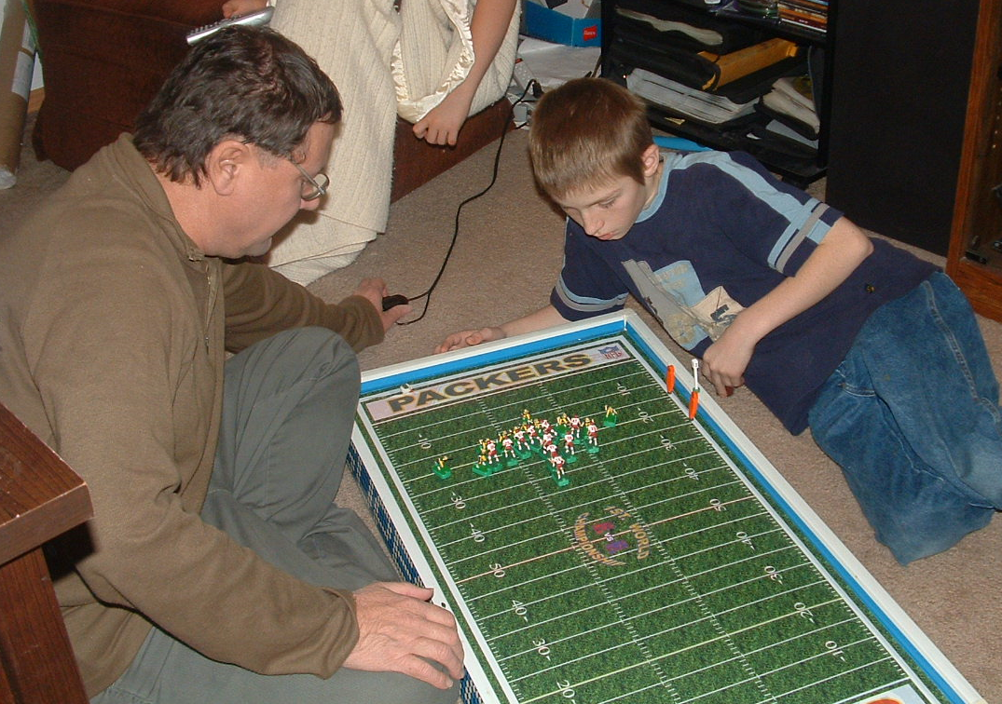

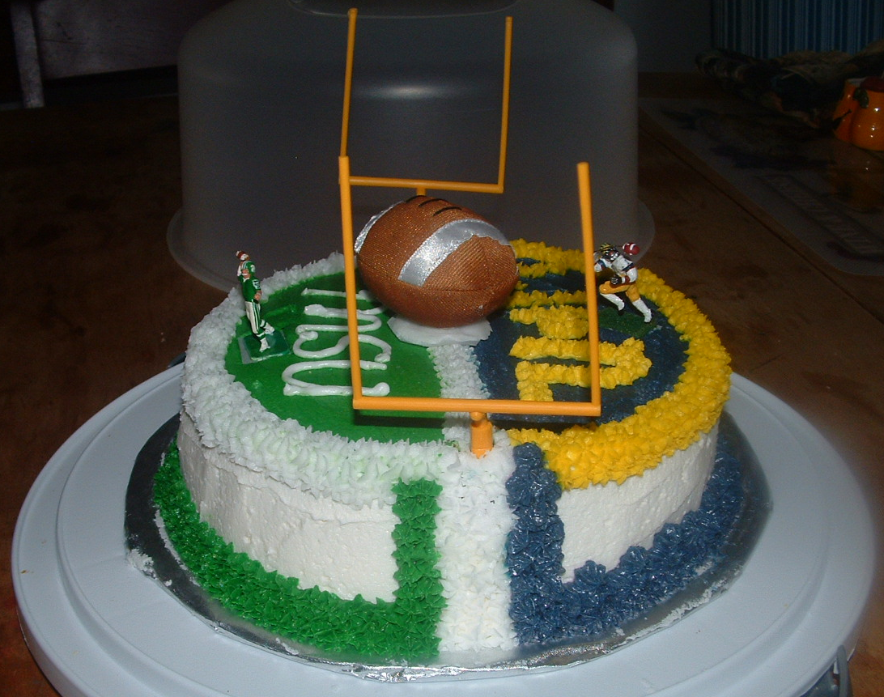

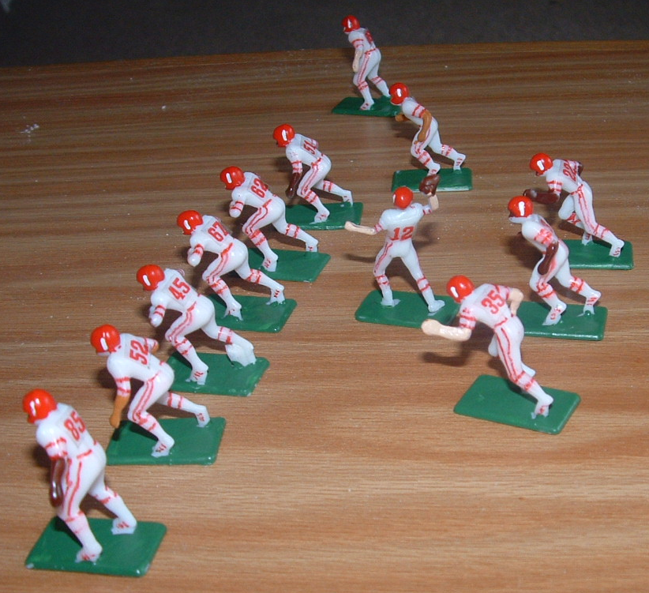

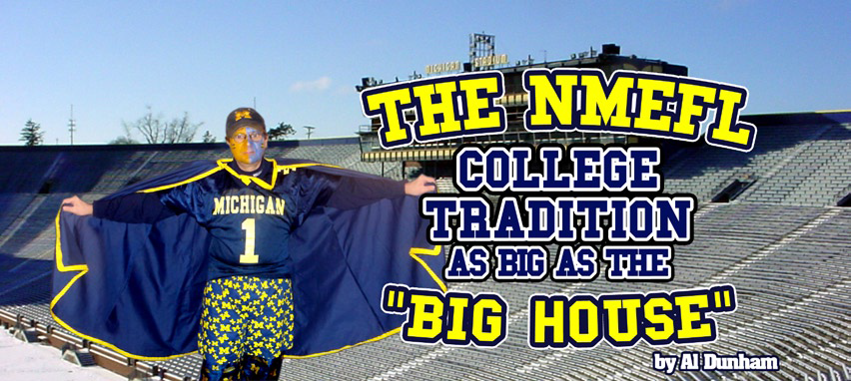
Reprint from “The Tweak” Spring 2008 Issue 4
9

A
s the cold wind whips snow and the northern lights glow, the college electric football action heats up in the northern Michigan area. The Northern Michigan Electric Football League, run by Brian D. Wittkop Sr. is ready for its 25th season as a league in one form or another. The NMEFL story starts back in 1971, when Brian started playing with six other kids in the Monroe, Michigan area after school, in the TSEFL (Town Site EFL), “It was a pro league and you had 2 teams you would play with. I was the Browns and the 49ers. I was able to get the Browns to the championship game, but lost 3 years straight to Duane Pfund,” said Brain.

After the TSFL stopped play in 1975, Brian put away his set and collection of all 28 NFL teams and his life went on… high school,
college, marriage… then kids. In 1984 Brian found his old teams and game board while moving into a new home. A month later he got together with some friends after church and started playing again. “The guys and I had so much fun we decided to have a league,” says Wittkop. “So, we ordered some figures and painted them into our favorite college teams. The guys would come over and we’d play till midnight or later on 2 sets, have pizza, beer and just have a blast. We called the league the BFL (Brian’s Football League) because we played at my house and I loaned out the teams. “The league went on for five great years until 1990. In that year, two men moved and two had to take on night jobs. The league became a solitaire league.
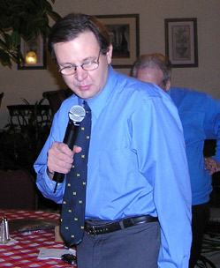
When 1992 rolled around Brian’s two sons, Brian Jr. and Christopher, started learning the game. They, along with their friend Mike Boberg, started a mini league on Monday nights and it became a college league. “The highlight of that time was when we played the Michigan- Ohio State game right at Michigan stadium. I knew someone at the athletic department and I called and told them what I wanted to do. We went to Ann Arbor and played the game right in front of the scoreboard at the U of M stadium. Brian Jr. (BJ) was Ohio State and Chris was Michigan. We had former Wolverine Marc Ramirez play the part of referee, and Michigan won 9 to 3”, Wittkops states proudly. Sadly, the boys lost interest after three years and it became a solitaire league once again.

In 1999 the league got some new recruits at the Monroe Glass Company where Brian was vice president. There were 4 or 5 guys that got interested in the game when Brian was building his monster board. One thing led to another and they joined the BFL. “This was a lot of fun,” Wittkop says. “We would stick around the shop after work and play on the monster board and two Super bowl sets, make snacks and kid each other and have fun. Part of what made it great was my son Chris would be in it too. That reincarnation of the league went on until 2004 when Brian’s kidneys failed and he was placed on dialysis. In the summer of 2004 Brain moved to northern Michigan in the Traverse City area to be near his oldest son, Brian Jr., who had moved to northern Michigan a couple of years earlier.
Brian Wittkop receives the 2008
“Good Vibrations” award during
the Miggle Convention

The league continued as a father son league and today, Brain is still trying to find recruits. He has been featured in the Traverse City Record Eagle (the local paper) and in January he made the local news on television. The league has 46 teams that play 8

games. 16 teams make the playoffs and the 2 finalists face off in the Floral Bowl. Brian hopes to add 2 to 4 teams a year. The league has its own website and a chat board where you can talk about electric football, real football or just chat in general.
10

The highlight of that time was when we played the Michigan-Ohio State game right at Michigan stadium.
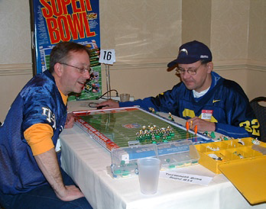
The NMEFL has some unique rules and off-season changes that they use. First is the QB. “We let the QB run. He may drop back to pass and, if no one is open, he may run up to the line of scrimmage. The play is stopped before he crosses the line of scrimmage to pass and then, if no one is still open, he may run. Of course, when he stops, the defense may adjust any unengaged men,” states Brian. Also, the NMEFL has a rather fun way to try to bring parity to the other teams. After the season is over each team has “seniors” that graduate and their bases are then removed and they are put into a shoe box with all the bases from the other 45 teams. Then, each team picks out new bases for their “freshmen”. Some teams may get more of the better bases than others. This is because some teams play iron man football and some teams play 22 men football, while there are four teams that have 30 or more men play. Teams that play iron man will get to pick between 1 to 4 bases, while teams that play 22 men football have a chance to get between 8 to12 bases. The more bases you pick, the better your chance to get some of the “great” bases.

The NMEFL / BFL has had 23 champions and has kept a season going since 1984. As Brian says, “I hope to get more guys to play, even if it means getting my grandkids to play.” He is now in the process of teaching the older of the next generation of Wittkops to play. “Wouldn’t it be great if some of the Wittkop grandchildren would keep it going after I’m gone?”
History of the Floral Bowl

1984 Michigan Wolverines 28 Alabama Crimson Tide 24 (Played at Monroe, MI - Jan 1, 1984) no season

1985 Michigan Wolverines 35 Tennessee Vols 21

1986 Tennessee Vols 31 UCLA Bruins 21

1987 Michigan Wolverines 28 Michigan State Spartans 14

1988 Michigan Wolverines 52 Hawaii Rainbow Warriors 28

1989 Texas A&M Aggies 23 Florida State Seminoles 21 (Played at Toledo, OH)

1990 UCLA 17 LSU 7 (Played at Jackson, MI)

1991 Indiana Hoosiers 22 Kansas State Wildcats 21

1992 Michigan Wolverines 28 Penn State Nittany lions 17

1993 Michigan Wolverines 35 LSU Tigers 10

1994 Michigan Wolverines 31 Nebraska Cornhuskers 17

1995 Texas A&M Aggies 17 Ohio State Buckeyes 0 (Played at Toledo, Ohio)

1996 Florida Gators 28 Ohio State Buckeyes 13

1997 Michigan Wolverines 35 Notre Dame Fighting Irish 7 (played at Cleveland, Ohio)

1998 Florida State Seminoles 32 Penn State Nittany Lions 14

1999 Penn State Nittany Lions 17 Notre Dame Fighting Irish 14 (Played at Washington DC)

2000 Michigan Wolverines 31 Miami (FLA) Hurricanes 21 (played at Canton, Ohio)

2001 Michigan Wolverines 17 Georgia Bulldogs 15 (played at Memphis, TN)

2002 Alabama Crimson Tide 28 UCLA Bruins 21 (Played at South Bend, IN)

2003 Alabama Crimson Tide 21 Penn State Nittany Lions 17 (Played at Deerfield, IL)

2004 Michigan Wolverines 28 Notre Dame Fighting Irish 14 (Played at Pittsburgh, PA)

2005 Notre Dame Fighting Irish 22 Alabama Crimson Tide 17

2006 LSU Tigers 23 Michigan State Spartans 20

2007 Michigan Wolverines 35 Wisconsin Badgers 16 (Played at Novi, MI)

2008 Michigan Wolverines 28 LSU Tigers 26

2009 USC Trojans 24 Ohio State Buckeyes 17

2010 Auburn Tigers 24 Iowa Hawkeyes 14

2011 Minnesota Golden Gophers 17 Stanford Cardinals 7

2012 Michigan Wolverines 24 U. N. Carolina Tar Heels 7

2013 Michigan Wolverines 31 Notre Dame Fighting Irish 14

gone but not forgotten...
Boards of the Past
Coleco, Gotham & Munro
By Brian Wittkop--
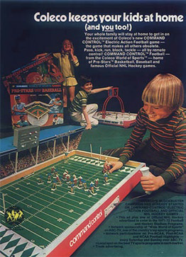
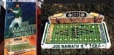
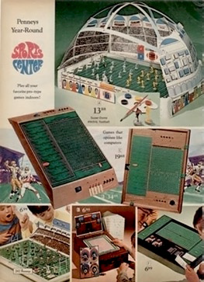

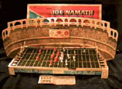

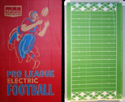

Top to Bottom - Joe Namath Munro
Game board, Joe Namath Gotham
Board, Gotham Pro League Game board.
Above - Coleco advertisement showing the Command Control version of their Electric Football Game board.
Above – Mid ‘70s JC Penney advertisement showing various electric football games available at the time.

Most miniature football coaches that have been around long enough know all about the Tudor and Miggle companies, who helped bring about the electric football revolution in the late 1960’s. Although most know about Lee Payne and his “Fab Five” figures that have become the standard for the hobby today, few are familiar with the smaller one man companies, that were also a big part of the hobbies rise in popularity.
11

There was a time when there were other companies bidding for your electric football dollar. They were the Gotham Pressed Steel company, the Coleco company, and the Munro company. Not only did they each have their own electric football boards, figures and bases, each company also made them to their own scale, though they were very similar in size.

Coleco - leather, pigskin and cabbage...

Let’s travel back in time and examine all three companies. First, we’ll take a quick look at the Coleco company. Coleco was founded in 1932 by Maurice Greenberg as the Connecticut Leather company. Originally, it just made shoe leather for other companies, but in the fifties moved into making leather craft kits as well. In the late fifties and early sixties they ventured into manufacturing plastic wading pools and games. Eventually the leather part of the company was sold off and Coleco moved to Canada. In the very early seventies they began to produce a line of sports related games. The table hockey games were the most popular, but so too, were the table basketball and, of course, electric football.

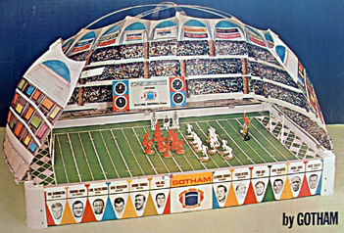
The Coleco electric football games were fiberboard sets with plastic figures that were cut at the middle and were pushed together. The legs of all the players were the same, while the tops were two different poses. The quarterback was a large plastic molded piece. It used a small magnetic square football that, when passed, stuck (hopefully) to the metal on the base. The field goal posts were on the goal line as was the rule in the early seventies.
12

Coleco made three sets. The large #5785 model, the smaller #5765, plus the highly collectable Canadian set that had two fifty yard lines just like in the CFL. A couple of years later Coleco introduced a new concept called command control. This was a magnetic arm under the board that gave you control of one player. The only problem was when you pulled on the control arm, you would wipe out everything on the board. By 1977 Coleco gave up on electric football and turned its efforts into the increasingly popular video game field. They became a top producer in the very first and held video games of their time, with handheld baseball, football and bowling. In 1982 they became the first company to mass produce what was to become one of the most iconic toys of its time, the Cabbage Patch Dolls. Unfortunately, the success of the doll sales wasn’t enough to stem the losses from their failed video venture and in 1988 filed for bankruptcy. The following year Hasbro purchased all of Coleco’s assets.

Gotham gives it a go...

Next is the Gotham Pressed Steel company. This company was based out

of Brooklyn, New York…sound familiar? They started in 1938 as a tin toy company making many of the highly prized tin, wind- up toys that go for high dollar on eBay today. In the 1940’s they branched out into pinball machines. As the fifties rolled around they expanded into the board game market, and in the early 60’s Gotham got into the electric football business. Like Coleco, they made a fiberboard set, but, unlike Coleco, Gotham made one piece molded players in four different poses. Gotham players came unpainted with a thin, metal plate that went over the base. Each player had a name tag that displayed the player’s name, number and team he played for. Gotham was the first electric football company to get NFL licensing when the model #1500 came out in 1963 with NFL logos around its metal frame .As with Coleco, the goal posts were on the goal line.

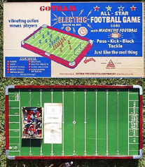
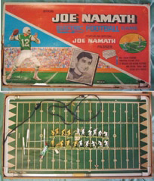
In 1965, Gotham came out with the Big Bowl game G150GS. This set had a two tiered cardboard stadium that went around three quarters of the board. In 1967 Gotham lost its NFL licensing to Tudor and tried to come up with other ideas to entice young football fans. They turned their attention to the NFL Players Association and struck a deal. With NFLPA licensing in hand, they signed up some of the biggest names of the day. Joe Namath, Dick Butkus and Roman Gabriel each had their own game with their face right on the package! In 1971 Gotham tried to take
over the electric football industry once and for all and came out with what would be its biggest seller. The Superdome was basically the regular field with a cardboard “dome” around

the field. Though it sold well, sadly, it did not stave off Tudor and its growing popularity. By 1976 Gotham was out of the game.

Another Canadian, eh?...

The last of the other electric football companies was Munro. Like Coleco, they were based out of Canada. In 1973 the Munro company came out with their own version of a Joe Namath game, and also released the Day/Night game that had the largest field ever produced (until Miggle’s deluxe board). It was 25” by 40” and had a double decker grandstand with flood lights that would light the field. The players were on a base that was similar to Coleco’s, but with a TTC type dial that was built in. This dial had all four prongs built into it. As a result, it was possible to make the men move sideways, as well as backwards, a feature that many of today’s coaches look for. By 1977 all three companies had pulled out of the electric football business and left Tudor in the clear. While not in business anymore, the nostalgia for Gotham, Coleco and Munro games is still with the electric football community as many coaches started their EF career with one of these fine games.

Today, all of us in our 30, 40 and 50’s look back at these board games in wonder. Although Tudor and Miggle survived the tide of the video game era in the 1980’s…we must not forget the boards of the past that were a big part of some of our childhoods.

This article first appeared in the “The Tweak”, Issue 8, Spring 2009.

The Bopst Show
11

Chris Bopst, who brought us the Electric Football Game Art Show, authors a blog on rvanews.com using electric football to chronicle the Washington redskins and the NFL. Below is a sample of his work taken from http://rvanews.com/author/chrisbopst.

Redskins vs. Raiders: Victorious in Oakland

After going down 0-14, The Redskins score 24 unanswered points to get their first win of the season.
September 30, 2013; 8:12 AM • by Chris Bopst
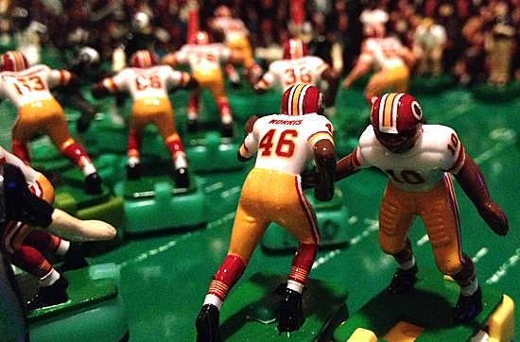
This season, the Redskins losing had almost become as certain as Eric Cantor calling Barrack Obama a socialist. Well, maybe not with that absolute certainty, but still: the team had not won a game.
Through three games, the defense had given up the most yards (1,464) since 1951 when the New York Yanks gave up 1,494 to opposing offenses (the Red Strader coached team finished the season 1-9-2). The offense wasn’t much better. They couldn’t move the ball, they turned the ball over, and they made stupid mistakes. Not surprisingly, their yin and yang of porous sieve and timid flaccidity has kept renditions of Hail To The Redskins to a minimum this year.
Going into Oakland yesterday, the Skins needed to play against the Raiders and not against themselves.
And that was the first thing they did. After trading opening offensive ineptitudes, the Raiders scored the first points of the game recovering a blocked Seth Rocca punt in the end zone. It was an inauspicious start; the Skins have been outscored 67-21 in the first half this season.
Victory is always possible for the person who refuses to stop fighting. Napoleon Hill

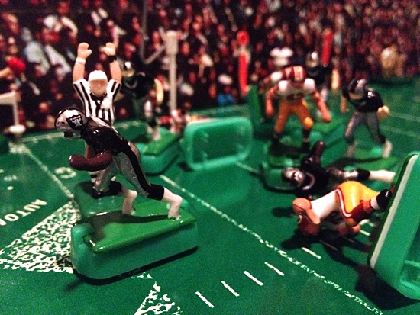
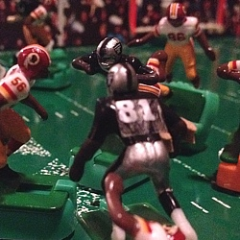
Adding to the dread, after another failed Redskins’ offensive series, back-up Raiders quarterback Matt Flynn (filling in for concussed starter Terrelle Pryor) led the team on a leisurely 10-play, 80-yard touchdown drive before the end of the first quarter. As my favorite Polish-born American football place kicker Sebastian Janikowski made the score 14-0 to the roaring approval of the black hole, my wife and daughter walked into the house.

“Are the Redskins winning daddy?”
“No baby, they are losing”
Jeremy Stewart recovered Rashad Jenning’s blocked punt of in the end zone to make the score 6-0 early in the first quarter.

Neither of us were surprised.
Tight End Mychal Rivera catches an 18-yard TD pass from Matt Flynn to put the Raiders up 13-0.

13

On the next Skins drive, Griffin led a no huddle offense that showed promise. Things were clicking, and a crisp selection of runs and passes had the Raiders on their heels. On 2nd-and-4 at the Raiders’ 4-yard line, the drive got sidetracked when Griffin was flagged for intentional grounding–pushing them back to the 18. Pierre Garcon almost made up for it with a beautiful catch and run, but they had to settle for a 25-yard John Potter field goal. The drive–easily one of the best of the season–was run too well to only walk away with three points.
12
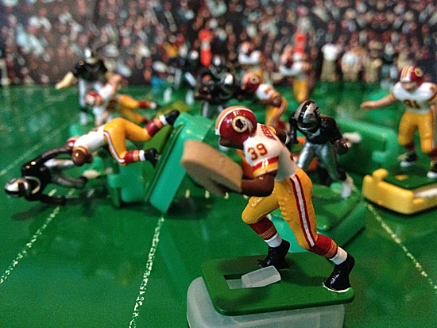
At that point, I didn’t know the Redskins defense wouldn’t let the Raiders score another point.

With momentum neutralized by the field goal concession, the defense took the field needing to stop the Raiders. On 3rd-and-5 on Oakland’s 43, David Amerson stepped in front of a Matt Flynn pass intended for Denarius Moore and got the six the offense couldn’t get. His first and the Redskins’ third interception return for a touchdown this year, the interception invigorated the team. It was the most important play in the game. After that, Matt Flynn didn’t play like he was trying to win, he played like he was trying not to lose.

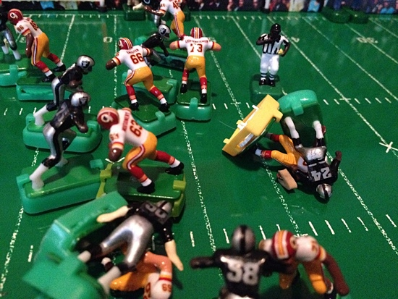
On their next drive, the Skins moved the ball as they had before. On 4th-and-3 at the Raiders 39 with three minutes left in the half, Griffin was sacked by Charles Woodson on a safety blitz that not only stopped the drive, but pushed the Redskins out of field goal range. This was the second straight drive that ended before its time. Going into the half down 10-14, the team had successfully changed the tide of the game even without the points. Raiders went into the half with their starting offensive backfield, running back Darren McFadden and Pro Bowl fullback Marcel Reece, sidelined with injury and their back-up quarterback playing like a backup quarterback. If Woodson doesn’t make the sack on Griffin, the team would have been going into halftime either tied or behind.
A constant struggle, a ceaseless battle to bring success from inhospitable surroundings, is the price of all great achievements. Orison Swett Marden
20-year old rookie cornerback David Amerson scores the Redskins first touchdown of the game on a 45-yard interception return of a Matt Flynn pass early in the 2nd quarter.

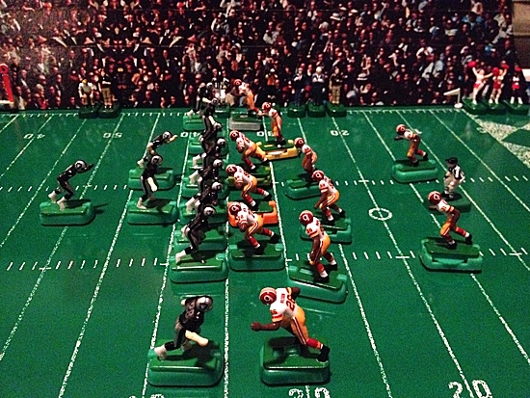
Charles Woodson’s sack of Robert Griffin put an end to the Skins next drive after David Amerson’s TD
The third quarter started off ugly. After the Raiders 2nd 3-and-out, Robert Griffin connected with tight end Logan Paulsen on a 3rd-and-9 deep in their own territory. Logan is stripped of the ball after the catch and the fumble is recovered by the Raiders on the Redskins 42. Like Griffin’s fumble run in last week’s loss to the Lions, the play was systematic of the team’s annoying habit of making it easier for the other team to beat them. It was on the defense to not let the Raiders take advantage of the turnover.
The Redskins start the 2nd half on defense behind 14-10.
14

And that they did. They held the Raiders, and my favorite Polish-born American football placekicker Sebastian Janikowski missed a 52-yard field goal wide left. Unlike previous turnovers this season, the Skins came out unscathed by what could have been a very costly mistake.

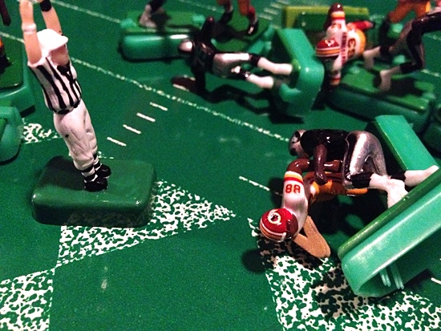
And on their next offensive series, they made sure that the Raiders were the ones to suffer the consequences of failed opportunities.

The offense scored their first touchdown of the day late in the 3rd quarter. Alfred Morris had 29 of his 71 rushing yards of the day on the drive. After a crucial 17-yard catch-and-run by Leonard Hankerson on third down put the Skins on the Raiders 12, Morris injured his ribs on the next play and did not return to the game. The drive ended two plays later with Pierre Garcon’s 5-yard touchdown catch from Griffin.

With the score, the defense could do something they haven’t had the luxury of doing all year: Play the second half with a lead.
Pierre Garcon 5-yard TD pass from Robert Griffin capped a 8-play, 48-yard drive that gave the Redskins their first second half lead of the season with 2:58 left in the 3rd quarter.

15
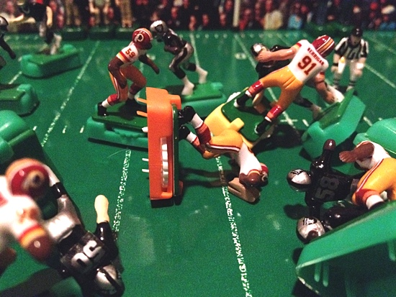
Ryan Keirrigan continued his pro-bowl play this year. In the 4th quarter, he caused Matt Floyd to fumble and the ball was recovered by the Redskins at midfield. For a unit that has been ridiculed for their play, the defense kept the team in the game. They sacked Flynn seven times, caused two turnovers, and scored as many touchdowns as the Raiders offense did (one). For the first time all season, they dominated a team.

The offensive did the rest.

All it took was two Roy Helu Jr. touches to put the game out of reach. The first, a dazzling catch and run, was an instant classic with Helu hurdling a hapless Oakland defender to put the Redskins on the Raiders 14. On the next, he bobbed and weaved the final 14 for the game’s final score.
Ryan Kerrigan’s sack-fumble of Matt Floyd was recovered by Barry Cofield.

With Morris out of the game, Helu contributed 84 total yards (41 rushing, 43 receiving) and the game’s clenching touchdown. With the win, the Skins finally got their first “W” of the season. It came against a weak team playing with a back-up quarterback, but in the NFL, it doesn’t matter who you beat: all that matters is that you beat them. At 1-3, their dismal September is behind them. They go into their bye week on a high note before they travel to Dallas to play the Cowboys on October 13th. Despite their sluggish start, the NFL East remains wide open. The Cowboys, Eagles, and the hapless Giants all lost yesterday, and a win at Dallas will put the Skins one game out of first place in the division.

Bring on Dallas. I like our odds.
16
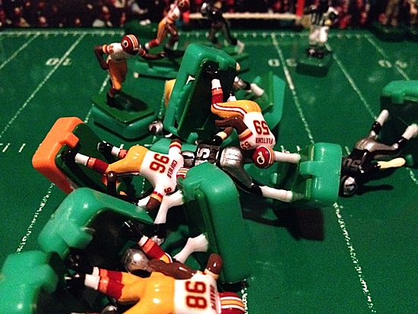
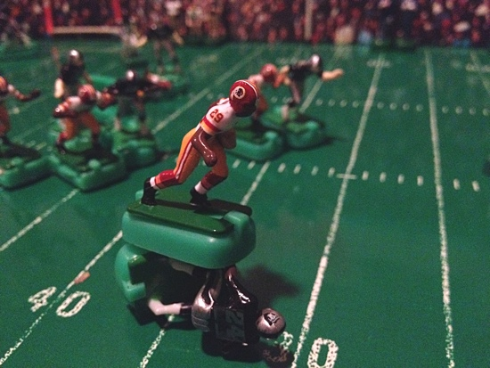
.

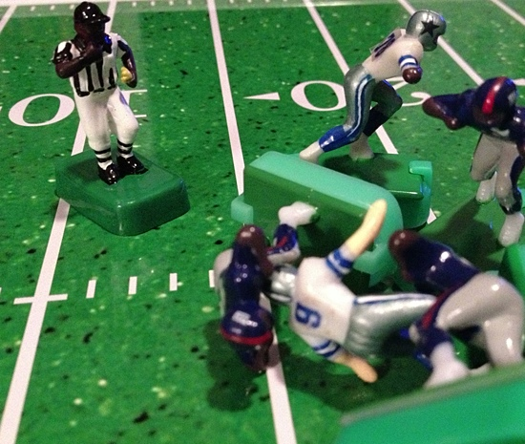
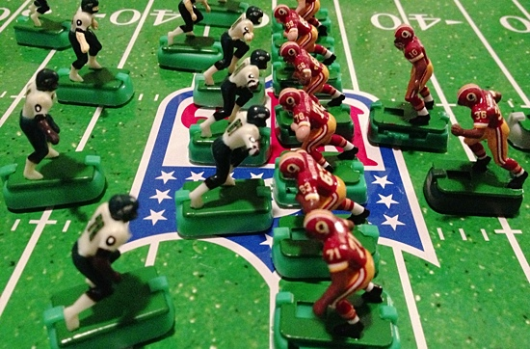
The defense stops Oakland on 4th-and-1 to secure the Redskins first victory of the season with 3:23 left in the 4th.

Roy Helu Jr.’s hurdles a defender after catching a pass from quarterback Robert Griffin III for a 28-yard gain.

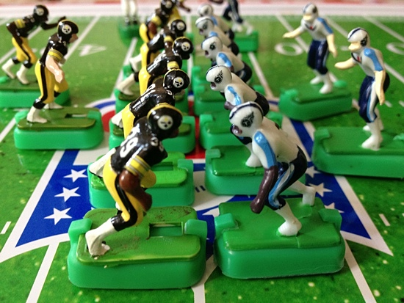

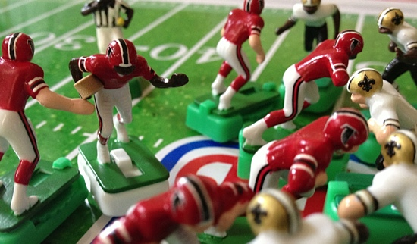

A “Tweaking” Primer
From the Tudor Forum / posted by DrJay (Wally Jabs)
17

Wally Jabs was the first person to use the term “tweak” when talking about manipulating and conditioning the prongs on bases to improve their performance. A long time slot car racer, he used to “tweak” the springs on his cars for speed and control, so it came natural to him, when he began to play miniature football again, to use the term for bases.

First you need to know that you are going to trash some bases. Unfortunately they will be part of the learning process. No matter what base you are working on the fundamentals are the same.

First thing you need to do is see if there is any flash on the bottom of the prong. The new Super Prolines do not have any that I can see. If the base has flash follow the steps to removing flash.

Removing flash with a lighter.
1) What you do here is take a base and hold the lighter under it about one inch (experiment here to see what works for you) away.
2) Position the lighter under one set of prongs (rookie base) or one prong (ttc base).
3) "Flick" the lighter on and off. Do this fast until you develop a feel for this step.
4) Let the prong(s) cool and inspect them
5) See if the flash is removed. If not go to step 3 and repeat the process.
6) After you finish with the first set of prongs proceed on to the next grouping.
7) Repeat this process on the remaining sets of prongs.
8) Test the base.
9) If the base moves forward without bouncing or not moving at all you are on your way.

Removing flash with a candle warmer
1) Placing the base on a candle warmer. Only for second or two.
2) Inspect to see if the flash is removed.
3) Test base

Money shot or the key step to be done with bases that needed to be flashed or not:
This step here one of the keys in the mystery of tweaking bases. Take a pair of good quality smooth jaw duckbill pliers and squeeze the prongs. Using as close to equal pressure squeeze all four sets of prongs with the pliers. What this step does is to make the prong more supple by flattening it.

How you squeeze, how much pressure you use, where you squeeze the prong that is the art of base tweaking. Over time and with experimenting you will develop your own methodology.

This is the next step in tuning.
1) If a base is turning to the left the prongs on that side of the base are shorter.
2) Likewise if the base is turning to the right the prongs are shorter on the right side.
3) To fix this problem, just lengthen the prongs on the side to which the base is turning.
4) You can do this either by gently pulling on the prong. Or flattening them more, which will typically make the prong longer.
5) Always work on the one set of prongs at a time. And always work first on the prong(s) that appear to be shorter.
6) A good way to check the prongs is to put the base on a flat surface and eyeball them.
6) Test the base after each pull/flatten until you get the desired results.
7) Be patient! Test after every step!

I hope this helps!

75 yard Field Goal attempt, GOOD!!!

In the rules of football, no limit is set from where a field goal kick may be attempted, so why in electric football do most rules only allow for a maximum 63 yard field goal to be attempted?
18

NFL Rules define a field goal as; “kicking the ball from the field of play through the plane of the opponent’s goal by a drop kick or a place kick either:
(a) From behind the line on a play from scrimmage; or
(b) During a fair catch kick

It further clarifies the rule as follows:

Section 4 Field Goal
Article 1 Successful Field Goal. A field goal is scored when all of the following conditions are met:
(a) The kick must be a placekick or dropkick made by the offense from behind the line of scrimmage or from the spot of a fair catch (fair catch kick). If a fair catch kick is awarded outside the inbounds line, the spot of the kick is the nearest inbounds line.

In the history of professional football, the longest successful field goal attempt is 63 yards-3 times- (65 yards in a preseason game) , but in all of recorded football history there have been 8 instances of field goals being made longer than 63 yards with 69 being the longest.

However the longest field goal attempt by a NFL kicker is 76 yards which did fall way short but it was also kicked into the wind making the chance of it being made even more remote.

SO WHY ARE ONLY 63 YARD ATTEMPTS ALLOWED IN ELECTRIC FOOTBALL???

The current MFCA TOC Rule Book states: “The maximum field goal attempt that can be attempted is 63 yards.” The TudorCON 14 2014 ELECTRIC FOOTBALL WORLD CHAMPIONSHIPS OFFICIAL RULES specify: “A field goal may only be attempted when the offense has achieved or passed the opponent’s 45-yard line.”

A review of several other league and tournament rules also set 63 yards as the maximum distance from which a field goal may be attempted.

In my arsenal of TTQB/Kickers, I have three kickers – one for regular kicking and punting, one for onside kicks, and one for kicking field goals. In a recent practice session, I was able to consistently kick field goals of over 100 yards (with the TTQB placed at the back of the end zone and the goal posts on the goal line). In recent solitaire games I have allowed several field goal attempts over 60 yards with the longest being 66 yards and a 100% completion rate.

Realistically, very few kickers can kick a field goal of 60 yards or more with any accuracy and since 63 yards is the longest that any NFL kicker has successfully kicked a field goal is why 63 yards has been established as the maximum length of a field goal attempt in electric football.
105 yds

I would suggest that it should be raised to 65 yards or even 70 yards to keep it more realistic. But if you want to follow the rules of real football, there should be no limits!!!

Solitaire goes “National”
19
Like most of us, Corey “National” Johnson, MFCA Hall of Famer and Commissioner of the Philadelphia EFL, played solitaire as kid.

W
hen I had my solitaire league, I started with 6 teams and it eventually grew to all 28. I found my old stat box. Brought it to Cleveland but never sat it out during the HOF ceremony. Anyways, I used the index cards from my mom’s job. Most of the info was entered using a typewriter. Lol.

I would draw the team logos for the teams. The earliest stats I found was from 1981 and continued ‘til 1986.That was around the time I put my men away for Nintendo & Tecmo Bowl. I still have all the teams with most of their original bases. When I got back into the hobby I started from scratch. Here are a few pics of the box and some of the team sets.

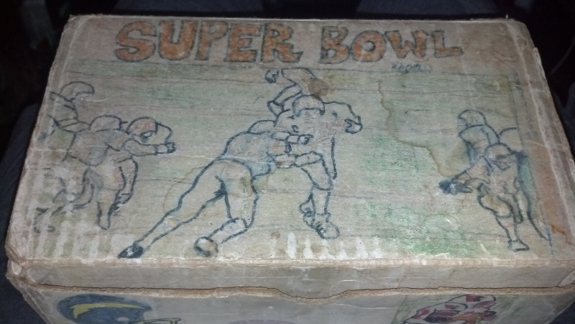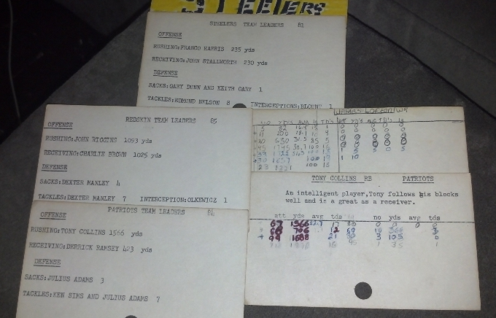

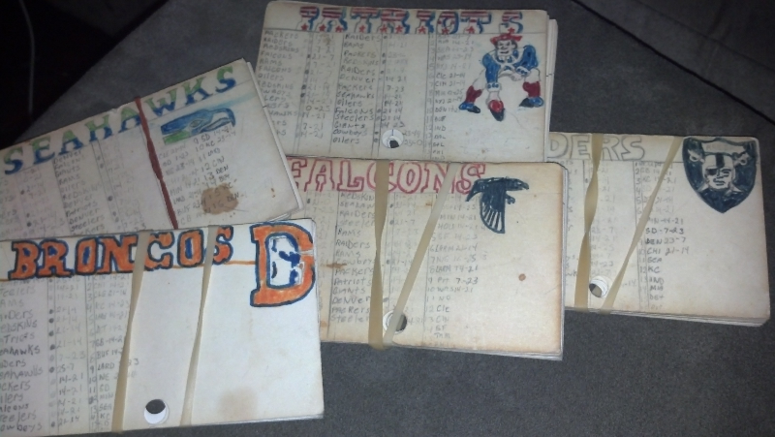

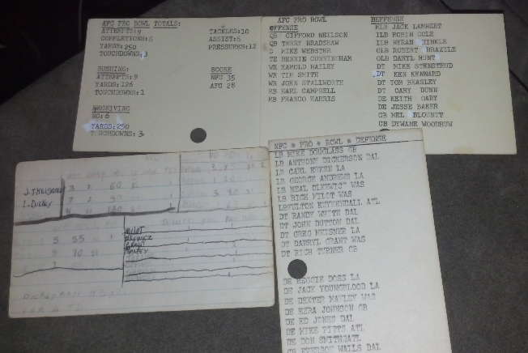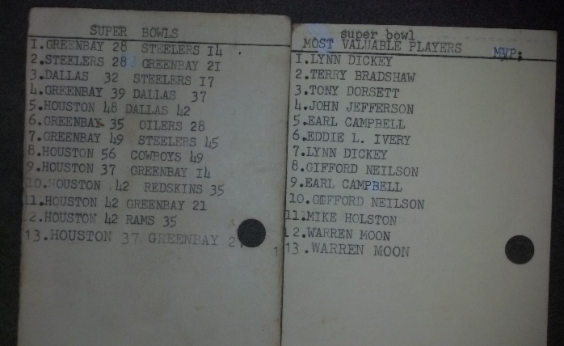

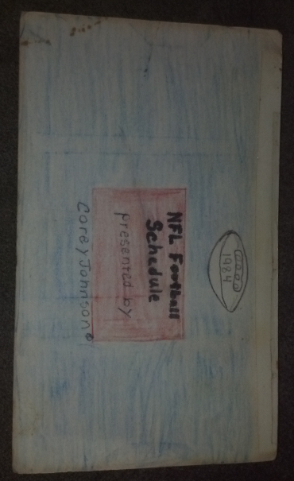

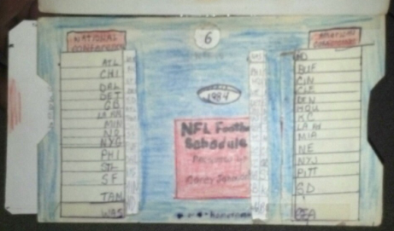

Oilers were always my best team. Packers were real good too. Then came Dickerson and he single handedly re-wrote all my rushing records. That blue schedule thing was a sliding schedule. I saw one that came with my Sports Illustrated subscription.
20

I have always been deep into EF. When you take those younger years and add them with the time that I have gotten back into our game....there is nothing else I have been doing more in my lifetime.

I didn't even know there was a name for what I was doing as a youngster. I would just play. My rules were caveman like compared to now. Much more technique now.

What's really cool is that all those teams are still numbered with the players from the 70's & 80's. You guys have some great stuff going on in this section of our forum and I have a great respect for the solitaire coaches. It must be special to just enjoy the game. No cheating. No arguing. No waiting for someone who is running late. Just playing. I remember those days.

The SCPC Changes Divisions for Season 2
21
For Season 2 of the “Solitaire Coaches Points Challenge” the division names have changed to better define the type of figures that owners are using.

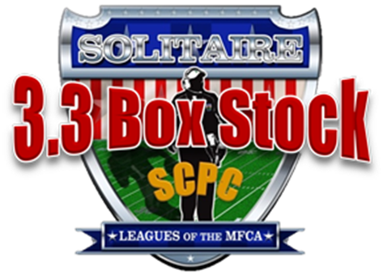
This division was formerly the “3.3 Limited” Division. This division represents teams that are made up of figures and bases that for the most part are unchanged from the manufacturer. Figures still have original paint or may be custom painted and detailed with decals, face mask, chin straps, etc. Bases are used as is or may be slightly tweaked to improve strength, speed and direction. No additional weight is added to the figure or base and overall weight is 3.3 grams or less.

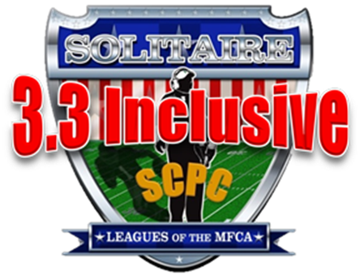
This division now replaces the “3.3 Tweaked” Division. Teams consist of figures that may or may not have been changed from their original poses, highly detailed and / or customized. Weight has been added to some figures in the form of lead tape, putty, or other forms but still maintain a 3.3 gram limit. Bases have been heavily tweaked to improve strength, speed and direction.

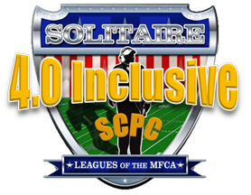
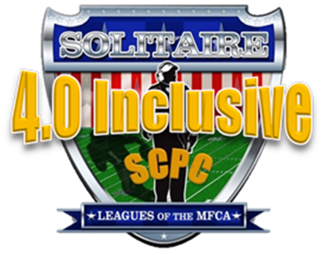
This division remains unchanged. Teams consist of figures that may or may not have been changed from their original poses, highly detailed and / or customized. Weight has been added to some figures in the form of lead tape, putty, or other forms are limited to 4.0 grams. Bases have been heavily tweaked to improve strength, speed and direction.

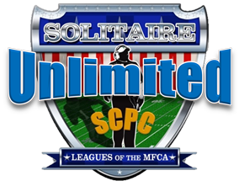
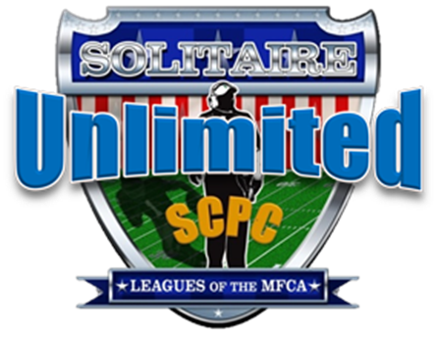
This division also remains unchained and represents teams that are made up of highly detailed and customized figures and bases that have been heavily tweaked. The overall weight of the figure and base is unlimited.

If anyone has any questions regarding what division to assign their teams to, please contact a member of the SCPC Rules Committee.

“Solitaire” Electric Football?

I often get asked “What is ‘solitaire’ electric football?”
22

Well the best way I can think of to describe it is – “electric football played by a single person acting simultaneously as coach of both the offensive and defensive teams on the playing field”.

A little wordy, I guess, but then most definitions are.

As a kid, like most of us, I spent hours in the floor of my bedroom playing electric football. I had a league that grew from six to ten teams and played a series of 10 seasons over a period of about 4 years before the game wound up under the bed and eventually into the closet where it never saw the light of day again.

Why did I choose to play this way? I don’t remember my older brother wanting to play that much, most of my friends were busy with other activities and I was always kind of a loner anyway. I guess I just enjoyed creating my own “fantasy” football league to enjoy in my own way.

When I got back into the game as an adult, I never dreamed of anyone else still playing the game but with the internet I soon discovered there were others “out there” – many my same age – who were still playing the game “solitaire” style.

I also discovered that “solitaire” electric football leagues were also being played as “brother vs. brother” -Mark and Bill Klingbeil – and “father vs. son” – Brian Wittkop and his sons and grandsons - or just “friend vs. friend”.

But what classified these types of leagues as “solitaire”?

Although not technically “solitaire” the one thing they had in common was multiple teams (2 or more) owned by one or both of the coaches.

So when we created the “Solitaire Coaches Points Challenge” (SCPC) we decided to allow leagues where games were played by two coaches but were played using multiple teams owned by one or both coaches.

Last year we had several games played this way with Derrick Gross and his son Owen and this year we have the CFL-E League with Pat Heward and Big Al Martin.

However the ultimate “Solitaire” league is the “Mail Order Football League” aka the “Postal League”.
This is a league featuring multiple coaches and multiple teams where coaches mail their teams out to other coaches to use in playing games. This is a true “solitaire” league in that the games are still played by one coach acting as coach of both teams. This is the league that inspired the creation of the SCPC and is the best way to participate in the SCPC and offers the most opportunities to earn bonus points in the SCPC.

So whether you play true “solitaire”, brother vs. brother, father vs. son, friend vs. friend or “Postal League”, we hope that you will participate in the SCPC Season 2. This season is already shaping up to be more exciting than the first.

Seasonal vs. Tournament Leagues
23
In solitaire electric football, most coaches choose to use seasonal game play formats for their leagues, this is perhaps the most traditional way to play but there are a number of coaches who have begun using tournament formats to play their games.

SEASONAL LEAGUES

Seasonal leagues are good if you have a reasonable number of teams and a fair amount of time to complete a full season of games. Depending on the number of teams you have you can choose to play a season of home and away games with each team or a round robin season of games where each team plays each other team in the league at least once. Or you may choose to duplicate the colleges and pros and play a set number of games each season with postseason playoff games or bowl games.

As an example if you have a league of 12 teams and you want to play 10 games with each team, to complete the season you would be playing 10 “weeks” of 6 games for a total of 60 games. If you can complete 3 games a week, it would take a total of 20 weeks to complete the season. Then depending on how your league is set up and how many teams you want to participate in the postseason could add another 2 to 3 rounds of playoffs and 5 or more games.

For someone wishing to duplicate the entire NFL season with all 32 teams would mean playing a total of 256 games and, following the current postseason of the NFL, an additional 11 games. If you can play at least one game a day it would still take over 36 weeks to complete a full season.

TOURNAMENT FORMATS

For coaches who have a large number of teams and want to play a minimum number of games using all their teams, tournament formats have become very popular. Tournaments can be played as double elimination or single elimination and are a good way to complete several seasons in a short amount of time.

Again using the NFL as a an example, to complete a season would only take playing 31 games in a single elimination tournament and a minimum of 16 more games if using a double elimination format.

SEASONAL OR TOURNAMENT?

Since the SCPC allows a maximum of 10 games per team to be entered into the SCPC rankings, leagues that are able to complete 10 game seasons with all their teams have a better chance of having more teams eligible for the SCPC postseason bowl games (if they are able to win 6 or more games).

Depending on how teams perform in a tournament format could limit the number of teams that are able to complete 10 games or are able to win 6 games to become bowl eligible.

So which should you choose? It really doesn’t matter. What matters is that you choose a way that is fun, entertaining and gives you the most enjoyment of playing the game. And hopefully you will choose to participate in the SCPC and have a chance to play or have one of your teams eligible to participate in one of the SCPC’s SCBCS postseason bowl games and compete for the SCPC Season 2 NATIONAL CHAMPIONSHIP!!!

SCPC Season 2 Game Reports
24

Season 2 of the SCPC is well under way with over 50 games reported at press time. So far this season, we have 6 coaches participating and 61 teams registered. Al Dunham’s WMLMF is into the second week of his 2013 – 2014 season, Ed Morgan’s ECFA has completed his Big 8 Conference games and is starting an SEC season. New comer Andy MacLaughlin ‘s league features current and past teams of the NFL, and my WLAPF has started an American Bowl Double elimination tournament that is already into the third round of games with 3 teams already eliminated.

We have our first ever Canadian and 2 coach league with Pat Heward and Big Al Martin featuring teams of the CFL and NFL.

2013
Week 1 (9/1 – 9/7)
Game Date Played Division Winning Team / Owner Losing Team / Owner Played By Final
001 9/1/2013 3.3 Tweaked Hawaiian Fire Lizards / Al Dunham Cherokee Nation / Al Dunham Al Dunham 31-10
** (We need to change the Limited to Box Stock or whatever it was that we are calling it) **
002 9/2/2013 3.3 Tweaked Midwest Mennonites / Al Dunham San Francisco Flaming Fairies / Al Dunham Al Dunham 49-42
003 9/3/2013 3.3 Box Stock Iowa State Cyclones / Ed Morgans Kansas Jayhawks / Ed Morgans Ed Morgans 28-20
004 9/6/2013 3.3 Inclusive Kansas City Super Sumos /Lynn Schmidt Battlin' Bozos of Battle Creek / Al Dunham Al Dunham 42-28
(On semi-permanent loan to me)
005 9/6/2013 3.3 Box Stock 2012 Atlanta Falcons / Andy McLaughlin 2012 New Orleans Saints / Andy McLaughlin A. McLaughlin 10-7
006 9/7/2013 3.3 Inclusive Three Mile Island Toxic Waste/Al Dunham Egypt Ra / Al Dunham Al Dunham 27-17
007 9/7/2013 3.3 Box Stock Missouri Tigers / Ed Morgans Colorado Buffaloes / Ed Morgans Ed Morgans 27-24

Week 2 (9/8 – 9/14)
Game Date Played Division Winning Team / Owner Losing Team / Owner Played By Final
008 9/8/2013 3.3 Box Stock 1970 Detroit Lions / Andy McLaughlin 1970 Los Angeles Rams / Andy McLaughlin A. McLaughlin 16-14
009 9/10/2013 3.3 Box Stock Nebraska Cornhuskers /Ed Morgans Oklahoma State Cowboys / Ed Morgans Ed Morgans 27-24
010 9/12/2013 3.3 Box Stock Oklahoma Sooners / Ed Morgans Kansas State Wildcats / Ed Morgans Ed Morgans 10-3
9/13/2013 3.3 Box Stock 1972 Redskins / Andy McLaughlin 1970 Philadelphia Eagles / Andy McLaughlin A. McLaughlin 21-20
011 9/13 2013 3.3 Inclusive Hamilton Tiger-Cats / Pat Heward San Antonio Texans / Big Al Martin Pat Heward 21-7
Big Al Martin
012 9/12/2013 3.3 Inclusive Kalamazoo Killer Bees / Al Dunham South Park Cows / Al Dunham Al Dunham 35-28
013 9/14/2013 3.3 Inclusive Canadian Sasquatch / Al Dunham Munich Moon Sharks / Al Dunham Al Dunham 38-21

Week 3 (9/15 – 9/21)
Game Date Played Division Winning Team / Owner Losing Team / Owner Played By Final
014 9/18/2013 3.3 Box Stock 2012 Atlanta Falcons / Andy McLaughlin 1989 San Francisco 49ers / Andy McLaughlin A. McLaughlin 17-14
015 9/18/2013 3.3 Box Stock Colorado Buffaloes / Ed Morgans Kansas Jayhawks / Ed Morgans Ed Morgans 16-12
016 9/19/2013 3.3 Inclusive Arctic Tundra / Al Dunham Munich Third Reich / Al Dunham Al Dunham 42-21

Week 4 (9/22 – 9/28)
Game Date Played Division Winning Team / Owner Losing Team / Owner Played By Final
017 9/21/2013 3.3 Inclusive That 70's Rams Team / Al Dunham London Union Jacks / Al Dunham Al Dunham 28-14
018 9/22/2013 3.3 Box Stock Iowa State Cyclones / Ed Morgans Nebraska Cornhuskers / Ed Morgans Ed Morgans 37-34
019 9/25/2013 3.3 Box Stock Missouri Tigers / Ed Morgans Oklahoma Sooners / Ed Morgans Ed Morgans 20-10
020 9/25/2013 3.3 Inclusive Cleveland Cadavers / Al Dunham New Zealand Zombies / Al Dunham Al Dunham 21 14
021 9/26/2013 3.3 Inclusive Dallas Cowboys / Big Al Martin Montreal Alouettes / Pat Heward CFLer Big Al Martin 28-21 Pat Heward
022 9/27/2013 3.3 Inclusive Pacific Sharks / Al Dunham Weirdwolf's Werewolves / Al Dunham Al Dunham 21-17

Week 5 (9/29 – 10/5)
Game Date Played Division Winning Team / Owner Losing Team / Owner Played By Final
023 9/30/2013 3.3 Box Stock Florida Blazers / Chris LeMay So. California Sun / Chris LeMay Chris LeMay 15-9
024 9/30/2013 3.3 Box Stock Kansas State Wildcats / Ed Morgans Oklahoma State / Ed Morgans Ed Morgans 28-21
025 10/2/2013 3.3 Box Stock Kansas State Wildcats / Ed Morgans Colorado Buffaloes / Ed Morgans Ed Morgans 30-28
026 10/3/2013 3.3 Inclusive Toronto Argonauts / Pat Heward Shreveport Pirates / Big Al Martin Pat Heward 21-14
Big Al Martin
027 10/3/2013 3.3 Inclusive London Union Jacks / Al Dunham Three Mile Island Toxic Waste / Al Dunham Al Dunham 42-35
028 10/5/2013 3.3 Inclusive Cleveland Cadavers / Al Dunham Egypt Ra / Al Dunham Al Dunham 41-28

Week 6 (10/6 – 10/12)
Game Date Played Division Winning Team / Owner Losing Team / Owner Played By Final
029 10/6/2013 3.3 Box Stock Birmingham Americans / Chris LeMay Memphis Southmen / Chris LeMay Chris LeMay 10-0
030 10/7/2013 3.3 Inclusive Weirdwolf's Werewolves / Al Dunham Munich Moon Sharks / Al Dunham Al Dunham 35-34
031 10/7/2013 3.3 Box Stock Memphis Southmen / Chris LeMay So. California Sun / Chris LeMay Chris LeMay 6-3
032 10/8/2013 3.3 Box Stock Buffalo Bills / Chris LeMay Houston Oilers/ Chris LeMay Chris LeMay 15-14
033 10/10/2013 3.3 Box Stock Clevleand Browns / Chris LeMay Baltimore Colts / Chris LeMay Chris LeMay 9-3
034 10/11/2013 3.3 Box Stock Green Bay Packers / Chris LeMay Minnesota Vikings / Chris LeMay Chris LeMay 10-6
035 10/11/2013 3.3 Inclusive Battlin' Bozos of Battle Creek / Al Dunham Hawaiian Fire Lizards / Al Dunham Al Dunham 37-34
036 10/11/2013 3.3 Box Stock 1980 Atlanta Falcons / Andy McLaughlin 1988 Los Angeles Rams / Andy McLaughlin A. McLaughlin 20-14

Week 7 (10/13 – 10/19)
Game Date Played Division Winning Team / Owner Losing Team / Owner Played By Final
037 10/13/2013 3.3 Box Stock Minnesota Vikings / Chris LeMay Baltimore Colts / Chris LeMay Chris LeMay 14-6
038 10/13/2013 3.3 Inclusive That 70's Rams Team / Al Dunham Cherokee Nation / Al Dunham Al Dunham 38-21
039 10/17/2013 3.3 Inclusive Midwest Mennonites / Al Dunham South Park Cows / Al Dunham Al Dunham 44-7
040 10/17/2013 3.3 Box Stock Iowa State Cyclones / Ed Morgans Oklahoma State Cowboys / Ed Morgans Ed Morgans 24-17
041 10/19/2013 3.3 Inclusive San Francisco Flaming Fairies / Al Dunham Kansas City Super Sumos / Lynn Schmidt Al Dunham 35-28

Week 8 (10/20 – 10/26)
Game Date Played Division Winning Team / Owner Losing Team / Owner Played By Final
042 10/22/2013 3.3 Inclusive Kalamazoo Killer Bees / Al Dunham Arctic Tundra / Al Dunham Al Dunham 32-28
043 10/23/2013 3.3 Box Stock Kansas Jayhawks / Ed Morgans Missouri Tigers / Ed Morgans Ed Morgans 21-6
044 10/24/2013 3.3 Box Stock 1972 Miami Dolphins / Andy McLaughlin 2012 Atlanta Falcons / Andy McLaughlin A. McLaughlin 24-21
045 10/25/2013 3.3 Inclusive Pacific Sharks / Al Dunham New Zealand Zombies / Al Dunham Al Dunham 28-27
046 10/26/2013 3.3 Box Stock Clevelenad Browns / Chris LeMay Dallas Cowboys / Chris LeMay Chris LeMay 22-10

Week 9 (10/27 – 11/2)
Game Date Played Division Winning Team / Owner Losing Team / Owner Played By Final
047 10/27/2013 3.3 Box Stock Houston Oilers / Chris LeMay Oakland Raiders / Chris LeMay Chris LeMay 13-9
048 10/27/2013 3.3 Inclusive Canadian Sasquatch / Al Dunham Munich Third Reich / Al Dunham Al Dunham 35-10
049 10/27/2013 3.3 Box Stock New York Jets / Chris LeMay Kansas City Chiefs / Chris LeMay Chris LeMay 14-9
050 10/28/2013 3.3 Box Stock Mississippi Rebels / Ed Morgans Arkansas Razorbacks / Ed Morgans Ed Morgans 17-7
051 10/30/2013 3.3 Box Stock Florida Blazers / Chris LeMay Memphis Southmen / Chris LeMay Chris LeMay 12-6
052 10/30/2013 3.3 Box Stock Calgary Stampeders / Patrick Heward Edmonton Eskimos / Al Martin Pat Heward 28-21
053 10/30/2013 3.3 Box Stock Mississippi Rebels / Ed Morgans TCU Horned Frogs / Ed Morgans Ed Morgans 13-10
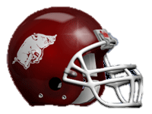
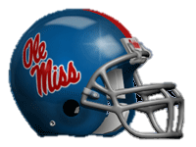

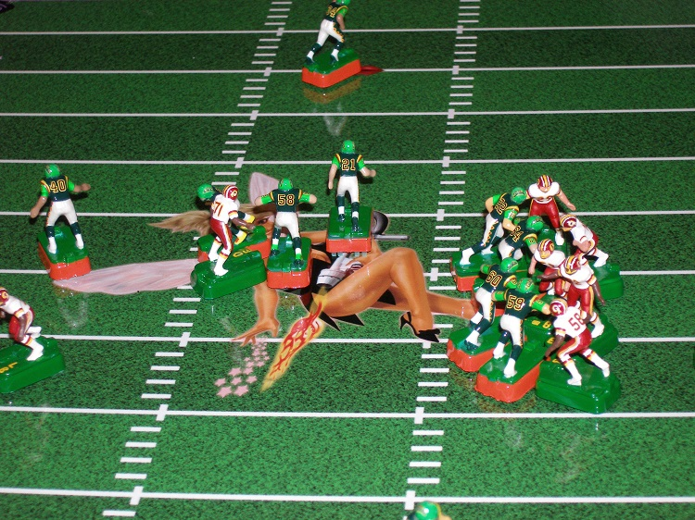

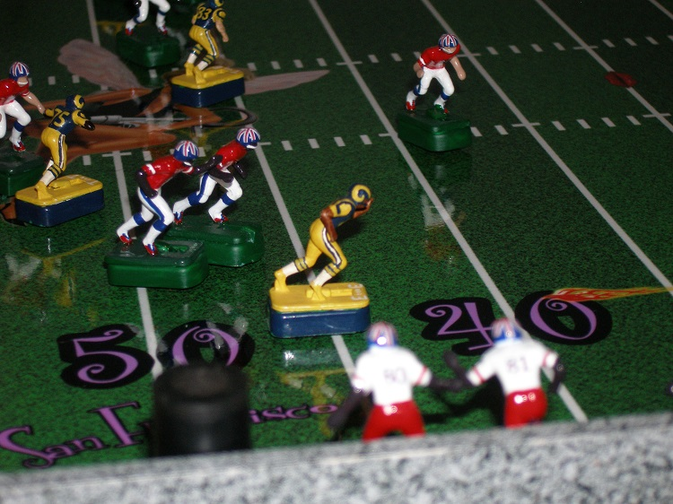

25
